**SIM University**

**School of Science and Technology**



**Simulink Modeling of SiNGLE Channel GPS (Global Positioning System) Receiver**

Student : N0707027 (PI no.)

SUPERVISOR : WILSON OON

Project Code : JUL2009/ENG/01

A project report submitted to SIM University

in partial fulfilment of the requirements for the degree of

Bachelor Engineering of Electronics

May 2010

# ABSTRACT

In this decade, Global Positioning System (GPS) has been widely utilised by many communication devices for commercial purposes. The GPS gadgets are getting more advanced and complicated as the technology progresses. In order to follow up with the industry and get hand on, a study onto the software model development will be helpful in getting a deeper knowledge of GPS. During the past few years a lot of efforts have been exerted to make the inner working of the GPS receiver visible, clear and easy to learn and modify either on the level of software or hardware.

Software-based GPS receiver will assist many of us to analyze GPS signal that would not have been possible using conventional GPS receivers. SIMULINK modeling software is used in the implementation of such receiver, thereby introducing a new look for the SDR technology that can be accomplished via a graphical user interface environment.

The aim of this project is to develop a single channel GPS receiver model using SIMULINK. The implementation will consist of GPS signal simulator, acquisition, partial tracking. The GPS signal simulator emulates the function of a satellite which constantly transmits GPS L1 frequency. This signal contains a coarse acquisition (C/A) code and a navigation data message. Parallel code phase search acquisition as one of the three acquisition methods is chosen for identifying the correct carrier and C/A code for demodulation. Once the acquisition determines coarse value of the visible satellite signal, the tracking model will refine the frequency and remove the carrier. Decoding the C/A code in the code tracking will be the future work.

This report will cover on the objectives of the project, literature review of GPS and project management aspects. The main focus will be on the researching on the GPS topic, model development, implementation and testing of the GPS receiver. Finally, topic such as conclusions, recommendations, critical review and reflections of this project will be discussed. A user guide to run the SIMULINK models is enclosed at Appendix A.

# ACKNOWLEDGEMENT

First and foremost, I would like to offer my sincere gratitude to my tutor, Dr. Wilson Oon, for his encouragement, patience, guidance and support throughout the project. Even though my progress in research was slow and results were scant, he never ceased to inspire me and encourage me to preserve on.

Next, I would like to thank my friends in UniSIM for their support and practical suggestions towards this project. They have made my learning experience in UniSIM a pleasant and enriching one.

I would also like to thank my manager and colleagues for their support and encouragement throughout my curriculum in UniSIM.

There are many people to who directly or indirectly help me in completing my project. My special thank and appreciation to everyone especially to my cell group’s friends who consistently praying for me during the final part of my studies.

Lastly, my deepest appreciation goes out to my family and loved ones, who have shown great care and concern during the entire development of the project. With their understanding and moral support, I was able to have the strength to persevere on.

**TABLE OF CONTENTS**

ABSTRACT 2

ACKNOWLEDGEMENT 3

CHAPTER ONE 10

1. INTRODUCTION 10

1.1 Background and Motivation 10

1.2 Overall Objective 11

1.3 Scope 11

1.3.1 Comprehending GPS technology 12

1.3.2 Choice of programming language 12

1.3.3 System implementation 12

1.4 Outline of Report Structure 13

CHAPTER TWO 14

2. PROJECT MANAGEMENT 14

2.1 Project Plan 14

2.2 Project Management 14

2.3 Proposed Approach And Method To Be Employed 15

2.4 Risk Management 16

CHAPTER THREE 17

3. REVIEW OF LITERATURE 17

3.1 Review of Global Positioning System (GPS) Technology 17

3.2 What is GPS? 20

3.3 Elements of GPS 21

3.4 How does GPS work? 25

3.5 Concepts and Principles used in GPS Technology 27

3.5.1 Trilateration 27

3.5.2 Doppler Shift 29

3.6 Overview of Satellite system 30

3.6.1 Satellite Orbits 30

3.6.2 NAVSTAR 32

3.6.3 GLONASS 32

3.6.4 GALILEO 34

3.6.5 Chinese COMPASS systems 35

3.7 Overview of GPS Signal 36

3.7.1 GPS Frequency 36

3.7.2 GPS Signal Structure 37

3.7.3 Structure of GPS Navigation Data 38

3.7.4 Precision (P(Y)) Code 39

3.7.5 GPS Signal Generation 40

3.8 Overview of Software-Defined GPS Receivers (SDR) 41

3.9 Overview of CDMA systems 43

3.9.1 Access Scheme 43

3.9.2 Coding 43

3.9.3 Direct Sequence Spreading Spectrum (DSSS) 44

3.10 GPS Application 45

3.10.1 Military 45

3.10.2 Personal navigation 45

3.10.3 Vehicle tracking systems 45

3.11 MATLAB/SIMULINK application 46

CHAPTER FOUR 47

4. SYSTEM DEVELOPMENT 47

4.1 System Overview 47

4.2 System Architecture 48

4.2.1 Simple Transmitter Simulator Architecture 48

4.3 Simple Receiver Simulator Architecture 50

CHAPTER FIVE 52

5 SYSTEM DESIGN CONSIDERATIONS 52

5.1 GPS Transmitter 52

5.2 Coarse/Acquisition (C/A) code 53

5.2.1 Overview 53

5.2.2 Pseudo Random Noise (PRN) Sequence 53

5.2.3 Gold Sequence 54

5.2.4 C/A Code Generator 55

5.2.5 C/A Code Generation 56

5.2.6 C/A Code Phase Assignment 58

5.3 Navigation Data 59

5.3.1 Overview 59

5.3.2 Navigation Data Generation 59

5.4 Precision (P/Y) code 62

5.4.1 Overview 62

5.4.2 Precision code Generation 62

5.5 Modulation 63

5.5.1 Overview 63

5.5.2 Mixer/Local Oscillator Implementation 63

5.5.3 BPSK Modulation 64

5.6 Correlation Properties 64

5.7 Combining the signal components in GPS Transmitter 65

5.8 GPS Receiver 66

5.9 Data Acquisition 66

5.9.1 Serial Search Acquisition 67

5.9.2 Parallel Frequency Space Search Acquisition 68

5.9.3 Parallel Code Phase Search Acquisition 70

5.9.4 The Selection of Acquisition Search 71

5.10 Demodulation 72

5.10.1 Overview 72

5.10.2 Carrier Tracking 73

5.10.3 Code Tracking 76

5.11 Factors Affecting GPS Accuracy 78

CHAPTER SIX 79

6 SIMULINK MODEL DEVELOPMENT FOR GPS TRANSMITTER 79

6.1 GPS Transmitter in SIMULINK model implementation 79

6.1.1 Pre Initialization 79

6.1.2 Result on C/A code generation for Transmitter 87

6.1.3 Result on Navigation data generation for Transmitter 91

6.2 Result on P(Y) code generation for Transmitter 96

6.3 Result on carrier generation for Transmitter 97

6.4 Integrating the components for Transmitter 98

6.5 System Testings and Results 100

CHAPTER SEVEN 103

7 SIMULINK MODEL DEVELOPMENT FOR GPS RECEIVER 103

7.1 GPS Receiver in SIMULINK model implementation 103

7.2 Parallel code phase search acquisition 103

7.3 Modeling Testing and Results 108

7.4 Carrier tracking implementation 109

CHAPTER EIGHT 111

8 PROBLEMS AND DISCUSSIONS 111

8.1 Accuracy of GPS data 111

8.2 Compatibility Considerations 111

8.3 Many types of data 112

8.4 Correct usage of Sampling time 112

CHAPTER NINE 113

9 CONCLUSIONS AND RECOMMENDATIONS 113

9.1 Conclusions 113

9.2 Recommendations and Future Work 113

CHAPTER TEN 114

10 CRITICAL REVIEWS AND REFLECTIONS 114

REFERENCES 115

APPENDIX A 119

User Manual for running SIMULINK models 119

APPENDIX B 125

B.1 M-Files : initSettings.m 125

B2 M-Files : insignal_sfunc.m 127

B.3 M-Files : oscillator_sfunc.m 130

B.4 M-Files : caCodesTable.m 133

B.5 M-Files : generateCaCodes.m 135

B.6 M-Files : fft_sfunc.m 137

B.7 M-Files : ifft_sfunc.m 139

B.8 M-Files : acquire2_sfunc.m 141

B.9 M-Files : Run_Reciver.m 146

APPENDIX C 147

SIMULINK model File for PRN 01 to PRN 32 147

APPENDIX D 179

GANTT CHART 179

APPENDIX E 180

E1 Meeting Log #01 180

E2 Meeting Log #02 181

E3 Meeting Log #03 182

E4 Meeting Log #04 182

E5 Meeting Log #05 183

E6 Meeting Log #06 183

E7 Meeting Log #07 184

E8 Meeting Log #08 184

E9 Meeting Log #09 185

E10 Meeting Log #10 185

# CHAPTER ONE

# INTRODUCTION

## Background and Motivation

The United States Navstar **G**lobal **P**ositioning **S**ystem (GPS) has been in operation since 1994. This system involves a constellation for 24 satellites revolving around the Earth transmitting code-division multiple access system (CDMA) signals on 1.57542 GHz for civilian ranging purpose with appropriate ground receivers. The successful operation of the GPS system has opened a slew of Personal and Vehicular navigation Gadgets from standalone Device such as Garmin GPS receiver to GPS receiver embedded in handphone such as Nokia 6220 Personal Navigator. All the gadgets and devices appeared as a hardware component where GPS software algorithm is not revealed. Understanding the technology behind the hardware will require some studies. The software modelling is a visualization of the entire system that is a good approximate representation of the real item that is being built.

For many years, engineers, scientists and other professional who build complex structures or systems have been creating model of what they build. In all cases, a model serves as an abstraction and visualization on any system development

Software-defined radios (SDR) have been around for more than a decade. SDR is a rapidly evolving technology that is getting enormous recognition and is generating widespread interest in the receiver industry. SDR technology can demonstrate and emulate segments of the GPS signal environment for detailed analysis. The open architecture and flexible receiver allows development and testing of various applications where dynamic selection of parameters for individual modules is possible. Using software approach can speed up the design process and also reduce costs.

## Overall Objective

The goal is to develop a single channel GPS receiver model using MATLAB/SIMULINK tool.

This project will develop a simulation model that will allow user/(s) to have a platform to simulate the function of a single channel GPS receiver function. The platform will have two sub-models – GPS transmitter and a single GPS receiver. The satellite will be represented by the GPS transmitter model and is designed to simulate GPS data coming from many GPS Satellites. While the model for the GPS receiver will encompass the necessary signal processing sub-models for single channel processing. The project will demonstrate the data acquisition in CDMA based GPS signal and the ways of data tracking so as to allow for data demodulation.

The project gives a general idea of how the methodology of the GPS transmitter and receiver operates where the understanding of GPS technology can be viewed in the flow of the simulation flow. Modelling GPS receiver in MATLAB/SIMULINK has advantage of its modularity, which allows the user to replace the implemented system by the user own architecture. The model in SIMULINK can be built on various block diagrams of different level hardware components. The SIMULINK’s library has sufficient resource to dynamically program to reconfigure the characteristic of the hardware. Because of its individual unit, it is flexible to work on each subsystem of the GPS. After successful testing simulations, it is possible to exchange SIMULINK block to other systems like Xilinx®’s system generation library in order to generate the actual hardware design in Field Programmable Gate Array (FPGA). For further project enhancement, successful modelling of single channel receiver will be possible to duplicate it into multiple channels modelling which resemble the real GPS receiver.

## Scope

This project requires knowledge in various fields/areas in order to develop the system and complete it successfully.

### Comprehending GPS technology

In the GPS technology, satellite transmitter and receiver are the main physical hardware. In order to model them, it is required to have an in depth understanding of the operation and the components within the hardware. Research on signal generation, signal acquisition and signal tracking can help to comprehend the GPS infrastructure system.

### Choice of programming language

As the project requires the development of a program platform to test out the GPS structure, it is important to evaluate the various object programming languages for implementation. MATLAB/SIMULINK was chosen as the software to develop the GPS components. The main reason for the choice is that SIMULINK has a very intuitive user interface combined with its numerous features. SIMULINK is a graphical environment which is able to make the relation between the system modelling, simulation, and implementation clearer and easier to debug because we can put test points anywhere and obtain immediate results.

### System implementation

The implementation is divided into two sections: GPS transmitter and GPS receiver. The system requirement is to implement the designed layout of each individual GPS component. The components are combined and integrated to do functionality test and display graphical result to show the simulation.

### Outline of Report Structure

Fill in later.

# CHAPTER TWO

# PROJECT MANAGEMENT

## Project Plan

In any project, planning is a critical aspect as it ensures the project scope is defined and determines the appropriate methods for completing the project. With proper planning, risks factors and uncertainties will decrease, resulting in optimum outcome.

The work breakdown structure (WBS) of the project is showed in Figure 2-1. It is a guide on defining and grouping the work elements to help in organising and providing the necessary framework in outlining the total work scope of the project.

Signal Generation

(Transmitter)

Global Positioning System (GPS)

GPS

Receiver

Generating

C/A Code/

Gold code

Navigation

data

Generation

Carrier

Tracking

Parallel Code

Phase Search

Acquisition

BPSK

Modulation

Code

Tracking

Generating

P(Y) Code

Level 1

Level 2

Level 3

Figure - : Work Breakdown Structure (WBS)

## Project Management

This project is planned to complete in ten months. A Gantt chart gives an overview schedule of activities that is broken down into phases to serve as a time reference. The chart is a monitoring board that shows the progress of the project.

At the initial planning phase, the activities/tasks were identified and listed out. The time was allocated to implement each activity/task.

For the monitoring phase, the gantt chart timeline was used to identify activities that were behind or ahead of the schedule. Remedial actions were done to rectify problems and ensure the project was able to meet the deadline specified.

The time frame of this project was penned down onto the Gantt chart reflected in Appendix D1. Appendix D2 provides the activities breakdown chart for enhanced the simplicity in viewing. In order to understand the background of the topic, research and literature review were essential to kick start the project. The system design as well as the implementation methodology and approach needed to be conceptualised to fulfil the project scope and requirements. Effort to familiarise with the SIMULINK software has to be grasped in order to develop the GPS receiver. Finally, evaluation will be sought to further improve the software.

## Proposed Approach And Method To Be Employed

The main approach is to pick up the knowledge of GPS system within the quickest time. The study will include the GPS application, the GPS signal structure, Geodetic System GPS signal processing structure and position computation algorithms

This project focuses on the GPS signal scheme that is represented by the spreading sequences/codes. The codes are Coarse/Acquisition codes and encrypted Precision codes (P(Y)).

The GPS model will be implemented using MATLAB/SIMULINK. The GPS model is classified into two sub-models which are GPS transmitter model and single channel GPS receiver model. Each model consists of different components.

The model implementation shall start with the GPS transmitter module. In the progress of the project, some experiments have to be performed to decide on the best method for GPS signal acquisition.

After completing the GPS transmitter implementation, the modelling of single channel GPS receiver model shall be next. Both modules shall integrate to simulate desired results.

There is a flow chart to illustrate the project approach

Integration to simulate results

Understand GPS System

Use MATLAB /SIMULINK

Implement GPS transmitter

Implement GPS receiver

Tests and experiments

Figure ‑2 : Flow chart of project approach

## Risk Management

Risk assessment is performed during the planning so that any risks, potential drawbacks, or unfortunate events could be identified and pre-empt to minimise the probability of them jeopardizing the timely completion of the project. It is a good practice to anticipate the possible risks and have the mitigation steps to react when they arise. Some of the risks identified are as followed:

* High in personal commitments such as career and family and resulted in less time spent for project
* Procrastination of actions which will drag and delay the project plan
* Loss of data e.g. crashing of hard disk or misplacing of data

Project is a commitment and the result is based on how well the work is produced. A level of self discipline and self motivation has to be displayed. Allocation of time for the project is absolutely necessary. Always maintaining a regular check on the Gantt chart and stick to the time frame can prevent procrastination. To protect the data, it is important to save them in a protected environment and constantly create additional back up.

# CHAPTER THREE

# REVIEW OF LITERATURE

## Review of Global Positioning System (GPS) Technology

In the pre-modern history, people used primitive ways to determine positions and helped them in their navigation. There were several techniques that people used to determine their location include navigation using stars, using terrestrial marks as reference, judging the winds for direction and etc. [1] In Greece, the Minoans*a* of Crete*b* are an example of an early Western Civilization that used celestial navigation. Their palaces and mountaintop sanctuaries exhibit architectural features that align with the rising sun on the equinoxes as well as setting of particular stars. The Minoans made sea voyages to the island of Thera and to Egypt and used the locations of particular stars, especially that of constellation Ursa Major*c* to orient the ship in the correct location. All the attempts were imprecise.

Historical people continued to develop instruments that helped in navigation.[2] The first compass was made in China during the Qin dynasty (221 AD - 206 BC) and it was first used for fortune telling. Between 850 and 1050 AD, magnetic compass became common as navigational devices on ship.

[](http://en.wikipedia.org/wiki/File:Model_Si_Nan_of_Han_Dynasty.jpg)

Figure 3-1 : Model of Han Dynasty (206BC – 220AD) south-indicating ladle Chinese compass

*a*The inhabitants of ancient Crete whom we call Minoans, a Bronze Age civilization, flourished from approximately 2700 to 1450 BC

*b*The island of Crete is located in the center of the eastern Mediterranean at the crossroads of Africa, Asia and Europe [http://www.ancient-greece.org/history/minoan.html]

*c*Ursa Major is a constellation visible throughout the year in most of the northern hemisphere. The seven brighest stars of Ursa Major form the asterism, which is useful pointer toward north.

[3] With progression to modern times, the sextant was developed around 1757 as the main instrument for navigation, which measured the elevation angle of a celestial object above the horizon. It made use of the principle of mirrors by bringing into coincidence rays of light received directly from one object and by reflection from the other, to measure the angle between the two objects. In the late 18th century, Harrison came up with a timepiece called a chronometer, which was able to measure longitude. In early World War II, United States developed Long Range Aid to Navigation (LORAN) with a range of 1,200 miles (1,930 km) to play a crucial role in military research and development. It was a terrestrial radio navigation system using low frequency radio transmitter however the hyperbolic approach of LORAN was rather inaccurate due to high propagation errors.

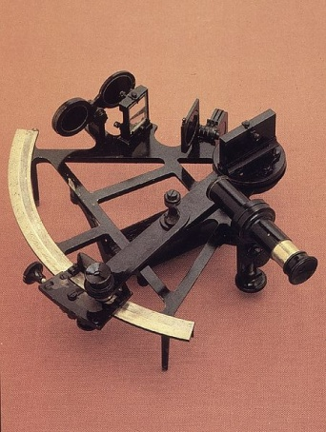 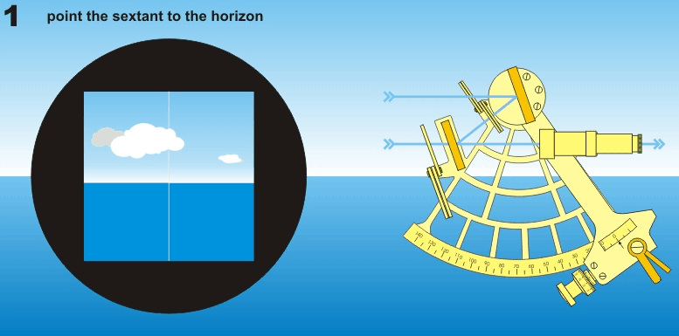

Figure 3-2 : Sextant Figure 3-3 : Using the sextant to measure the altitude of the Sun above the horizon

With continuous advance in technology, “Navy Navigation Satellite System” **NAVSAT**, also known as TRANSIT (a system of 6 satellites circling the earth) was the world’s first operational satellite navigation system conceived in the early 1960s. It made use of the Doppler Effect to yield the satellite’s position and velocity.

[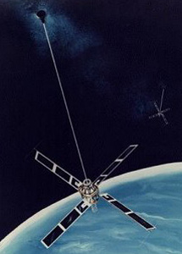](http://en.wikipedia.org/wiki/File:Transit-o.jpg) Figure 3-4 : Operational TRANSIT satellite

The United States Department of Defence (DOD) designed a satellite-based radio navigation called “**Nav**igation **S**atellite with **T**ime **a**nd **R**anging **G**lobal **P**ositioning **S**ystem” (NAVSTAR GPS), which was launched in 1978. It is operated by U.S. Air Force which provides highly accurate navigation information. It was originally designed to enable soldiers and military vehicles, planes, and ships in accurately determining their locations in unknown locations world-wide. However, given the wide array of application that GPS can use in, United States made this technology available for commercial and scientific use in the 1980s. The GPS uses the principle of trilateration, where multiple distance measurements are carried out in order to allow the receiver to calculate a position.

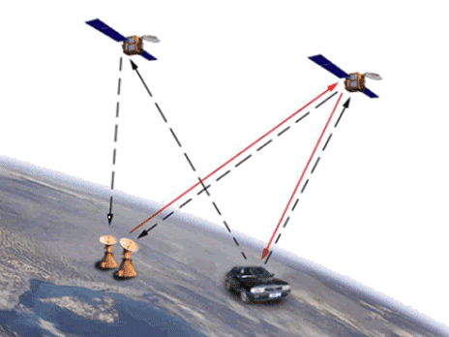

Figure 3-5 : Determine location using satellite.

[4] Another **G**lobal **N**avigation **S**atellite **S**ystem (GNSS) was the GLONASS, deployed by the Soviet Union, as its own global navigation satellite system. Development of the GLONASS began in 1976 and Soviet Union successfully launched the experimental tests in 1982. It also makes use of Frequency Division Multiple Access (FDMA). Unlike GPS, the technology used for GLONASS, did not involve multiple access schemes.

[5] Beidou Satellite Navigation and Positioning System was developed by China as its own regional 3D satellite positioning and communication system (CNSS). China launched the first constellation satellites in 2000. Its purpose is similar to both United State’s GPS and Russia’s GLONASS. However, Beidou uses 2 geostationary satellites and its navigation system is a 2-way range of 2D navigation, where its ground-based central control system calculates the 3D positioning for users. For GPS, it is a passive 1-way pseudo-range 3D navigation, where the GPS receiver calculates its own 3D position. Therefore, the user capacity for Beidou is limited, whereas the user capacity for GPS is infinite. Nevertheless, China has future plans in developing a second version of Beidou which known as Compass which consists of 35 satellites. It is an improvement to the existing satellite system.

The upcoming navigational system is known as Galileo, is currently being built by the European Union (EU) and European Space Agency (ESA). Galileo is intended to provide users with more accurate data, to enhance the coverage of high latitude regions and reduce dependence of the current GPS system. The fully deployed Galileo system consists of 30 satellites that allow positions to be determined more accurately. With the satellites situated in orbits at a greater inclination to the equatorial plane, a better coverage at high latitudes will be attained by Galileo.

## What is GPS?

Global Positioning System also known as GPS uses signals from the satellites in the space to identify the location of an object on Earth. [6] GPS is a constellation of 24 satellites that orbit around the Earth at about 20,200 km, which makes two complete rotations a day. The current location, time and velocity can be determined by a GPS receiver that acquires radio signals transmitted by the satellites. A GPS receiver device such as the one in Figure 3-6 would be use to read the radio signals.

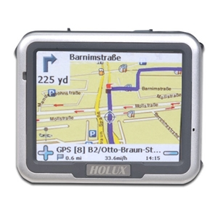The receiver converts the signals from the satellites into information such as:

* Latitude
* Longitude
* Speed
* Elevation etc

Figure 3-6 : GPS Receiver, Holux - GPSmile 52 Plus Touchscreen..

The device program process the information to do navigation, tracking and tracing.

## Elements of GPS

The current GPS consists of three major segments. These are the **space segment** (SS), a **control segment** (CS) and **user segment** (US) as shown in Figure 3-7 and Table 3-1

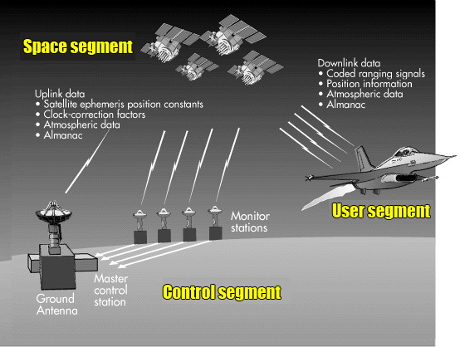

Figure 3-7 : Elements of GPS.

|  |  |  |  |
| --- | --- | --- | --- |
| Segment | Input | Function | Output |
| Space | Navigation message | Generate and transmit code and carrier phase and navigation message | P-Code,  C/A Code,  L1, L2 carrier  Navigation message |
| Control | P-Code Observations,  Time | Produce GPS time,  Predict ephemeris,  Manage space vehicles (SVs) | Navigation message |
| User | Code observation,  Carrier phase observation,  Navigation message | Navigation solution,  Surveying solution | Position, velocity, time |

Table [3-1]. Functions of various segment of GPS. [7]&[8]

The **space segment** comprises of GPS satellites or Space Vehicles (SV) in GPS parlance. They are powered by solar cells that constantly adjust the solar panels toward the sun and the antennas toward Earth. The satellite vehicles (SVs) orbit the earth in six 12 hours (11hrs 58min) orbital planes (four satellites in each plane). They circle the earth twice a day. The six orbits have approximately 55º inclination (tilt relative to Earth’s equator) and are equally spaced, resulting in 60º separation. This constellation ensures that (barring obstructions) a user located anywhere on the globe has a direct line of sight to at least four satellites at any time.

Orbiting at an altitude of approximately 20,200 kilometers about 10 satellites are visible within line of sight.

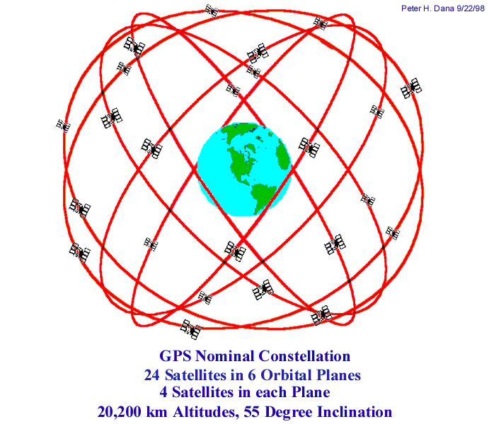

Figure 3-8 : GPS constellation. [9]

Since satellites are not in geosynchronous orbits, the geometric relation between the satellites in view is constantly changing, but predictable, position-estimation accuracy for positions determined from a fixed set of satellites. The SVs emit coded radio signals that a GPS receiver will decode to determine important system parameters.

**Control segment** is responsible for monitoring the health and the status of the space segment. The control segment consists of a system of tracking stations located around the world, including six monitor stations, four ground antennas, and a master control station, as given in Table 3-2. The ground monitoring station measure signals from the SVs that are transmitted to the master control station. The monitor stations receive data (orbits, altitude, location, speed) from the satellites and send this data to the master control station, where it corrects the orbital and clock information known as ephemeris data, and update the satellites via ground antennas. It also prevents the satellites from drifting away and ensures that they orbit within limits. These data are relayed to the ground antennas for transmission to the satellites for broadcast to the user segment.

Table 3-2: Locations of the Components of the Operation Control Segment [10]

Master control station Schriever Air Force Base (formerly Falcon AFB), Colorado Springs, CO

Master control station (backup) Gaithersburg, MD

Monitor station Schriever Air Force Base (formerly Falcon AFB), Colorado Springs, CO

Remote monitor station Cape Canaveral, FL

Remote monitor station Hawaii

Remote monitor station Ascension Islands

Remote monitor station Diego Garcia

Remote monitor station Kwajalein

Ground antenna Cape Canaveral, FL

Ground antenna Ascension Islands

Ground antenna Diego Garcia

Ground antenna Kwajalein

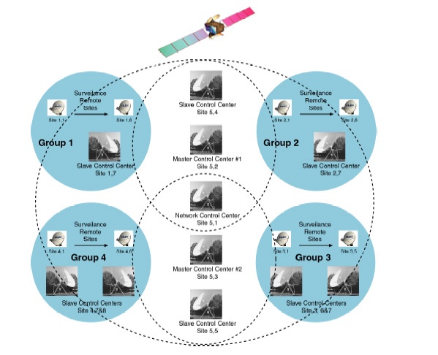

Figure 3-9 : Control segment

**User segment** consists of antennas and receiver-processors that measure and decode the satellite transmissions to provide positioning, velocity, and precise timing information to the user by computing the four dimensions of X, Y, Z (position) and Time. Since the user receiver operates passively (i.e. it does not transmit any signals), the GPS space segment can provide service to an unlimited number of users. Most modern GPS receivers are a parallel multi channels design, typically to have between five and twelve receiver circuits.

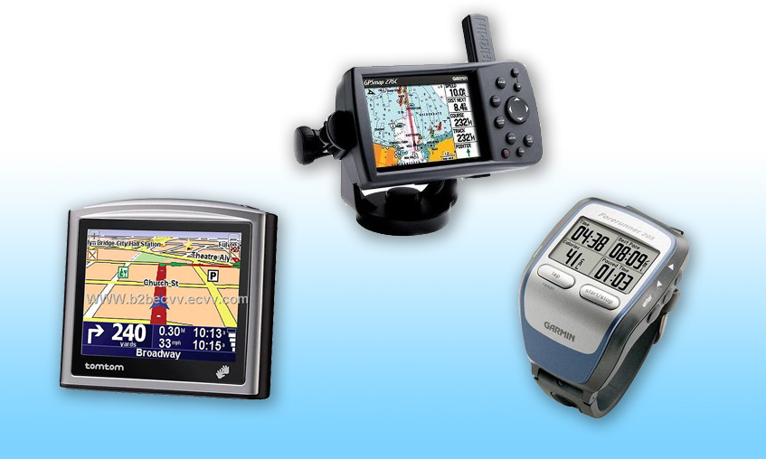

Figure 3-10 : Different type of modern GPS receivers

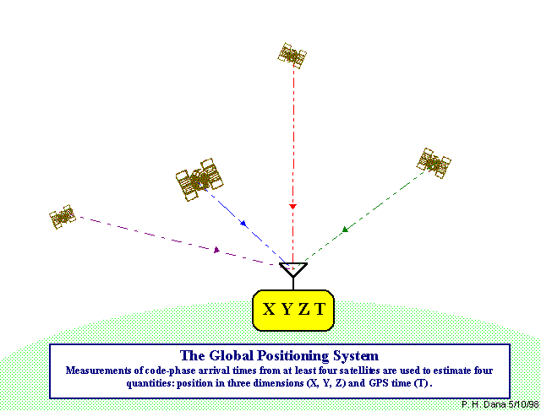

Figure 3-11 : GPS receiver estimates the GPS signal with the lock on four satellites simultaneously

## How does GPS work?

[11] GPS satellites circle the earth twice a day in a very precise orbit and broadcast radio signals (coded information) over to the GPS receivers. The information consists of ephemeris data, almanac data and a pseudorandom code.

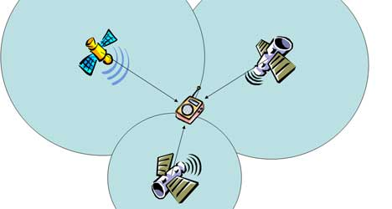

Figure 3-12 : GPS satellites broadcast signals to

Ephemeris data is a set of parameter that has the corrected orbital and clock information which sent from the master control station to the GPS satellites. This data is useable for a few hours and is transmitted as coded information to the GPS receiver to provide its orbital information on the path that the satellite is following as it orbits Earth

Next, almanac data is used to predict which satellites are nearby when the GPS receivers are looking for GPS signals. This data is continuously transmitted by each satellite notifying its state (health) of the satellite constellation, coarse data on every satellite’s orbit, current date and time to the GPS receivers.

With the ephemeris and almanac data, the GPS receiver computes the position of the satellites at all times.

Each satellite has its own unique Pseudo-Random code which mixes with the coded information. Both the satellite and receiver will generate the same code at the same time, and use it to reconstruct the data. However due to delay in signal propagation, the satellite’s signal will lag behind the receiver’s signal when it reaches the earth. This delay is the time travel. Therefore, the distance between the GPS receiver and each satellite can be computed using the following equation:

Distance = Speed x (Travel Time) ; Speed = speed of light (2.98 x 108 (m/s))

The user’s location can be determined by “triangulating” the distances from several satellites to determine the 3-dimensional positioning. This mathematical principle is known as trilateration.

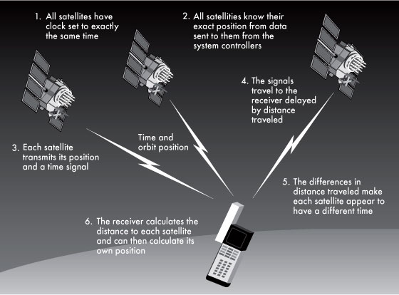

Figure 3.13: How GPS work [12]

## Concepts and Principles used in GPS Technology

### Trilateration

[13] Trilateration is a method of determining the relative positions of objects using the geometry of triangle. The position is determined based on triangulation:

* knowing each satellite position
* knowing difference between distances to each satellite
* using good clock on the receiver side
* adding some error correction

[14] The satellites are used to be the reference point which can get a very accurate and precise location on earth. The measurement of distance requires the use of at least 3 satellites to provide a precise location. GPS receiver takes into account four or more satellites to improve accuracy and provide extra information like altitude of the object. Here is an illustration:

If the distance of satellite A is known to be about 100 km away from GPS device, the GPS device could be on surface of a huge imaginary sphere of 100 km radius around Satellite A.



100KM

Satellite A

Figure 3-14 : Location tracking with satellite A

GPS device locks on to second satellite with the distance of a satellite B is known to be about 150 km. The imaginary spheres of 100 km and 150 km around satellites A and B respectively intersect in a perfect circle.

Figure 3-15 : Area of intersection with 2 Satellites



100KM

150KM

Intersection

Satellite A

Satellite B

If the distance of a third satellite C is known to be about 200 km away from the GPS device, this would narrow down our location by just two points. The imaginary sphere of Satellite C cuts through the circle that is the intersection of the first two spheres. Thus, we can more or less tell our location.



100KM

150KM

Intersection

Satellite A

Satellite B



200KM

Satellite C

Figure 3-16 : Area of intersection with 3 Satellites

### Doppler Shift

[15] The Doppler shift analysis is applied in GPS to determine the speed of the receiver. A GPS receiver-satellite pair is in the Earth’s gravity field and GPS signals travel at the speed of light. The relative displacement of both the motion of the satellite and the receiver are 2 components of the Doppler Effect to be taken into account, which allows identification and time management.

GPS satellite orbits the Earth at a high speed (approximately 3.8 km/s), transmitting electromagnetic wave signals that travel at the speed of light, relatively to a GPS receiver, there is an apparent shift in frequency. If the distance between the satellite and the receiver becomes further, the frequency will decrease. Whereas, the distance between the satellite and the receiver gets nearer, the frequency will increase. Figure 3-17 depicts the example of Doppler shift; the whistle of an approaching train has a higher pitch than normal and the change in pitch can be heard as the train passes.

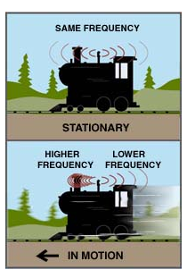

Figure 3-17 : Principle of Doppler shift [16]

## Overview of Satellite system

|  |
| --- |
| Satellite Orbits |
| [17] There is only one main force acting on a satellite when it is in orbit, and that is the gravitational force exerted on the satellite by the Earth. This force is constantly pulling the satellite towards the centre of the Earth.  There are many different types of orbits used for satellite telecommunications. The orbits are sometimes described by their inclination - this is the angle between the orbital plane and the equatorial plane. Geostationary Orbit   Figure 3-18 : Geostationary orbit  The most common orbit used for satellite communications is the geostationary orbit (GEO). This is the orbit described above – the rotational period is equal to that of the Earth. The orbit has zero inclination so is an equatorial orbit (located directly above the equator) and has an altitude of around 36,000 km. The satellite and the Earth move together so a GEO satellite appears as a fixed point in the sky from the Earth.  The advantages of such an orbit are that no tracking is required from the ground station since the satellite appears at a fixed position in the sky. The satellite can also provide continuous operation in the area of visibility of the satellite. |

#### Low Earth Orbit/Medium Earth Orbit

A low earth orbit (LEO), or medium earth orbit (MEO) describes a satellite which circles close to the Earth. Generally, LEOs have altitudes of around 300 – 1000 km with low inclination angles, and MEOs have altitudes of around 10,000 km. A special type of LEO is the Polar Orbit. This is a LEO with a high inclination angle (close to 90degrees). This means the satellite travels over the poles.

|  |  |  |
| --- | --- | --- |
|  |  |  |
|  |  |

Figure 3-19 : Low Earth Orbit (left) and Polar Orbit (right)

Satellites that observe our planet such as remote sensing and weather satellites often travel in a highly inclined LEO so they can capture detailed images of the Earth’s surface due to their closeness to Earth. A satellite in a Polar orbit will pass over every region of Earth so can provide global coverage. Also a satellite in such an orbit will sometimes appear overhead (unlike a GEO which is only overhead to ground stations on the equator). This can enable communication in urban areas where obstacles such as tall buildings can block the path to a satellite.

#### Elliptical Orbits

 Figure 3-20 : Elliptical Orbit

A satellite in elliptical orbit follows an oval-shaped path. One part of the orbit is closest to the centre of Earth (perigee) and another part is farthest away (apogee). A satellite in this type of orbit generally has an inclination angle of 64 degrees and takes about 12 hours to circle the planet. This type of orbit covers regions of high latitude for a large fraction of its orbital period.

### NAVSTAR

[18] Navigation Signal Timing and Ranging Global Positioning System (NAVSTAR) is one of the leading GNSS providers. The 24 current GPS satellites are in the Block II configuration and were launched between 1989 and 1994.

|  |  |
| --- | --- |
| **NAVSTAR GPS**  **Navigation Signal Timing and Ranging Global Positioning System** | |
| **CONSTELLATION   DESCRIPTION** | |
| Number of Satellites | 24 Active, 4 Spare |
| Geometry | 6 planes, 4 satellites each |
| Orbit | MEO - 20,200 km (10,900 nmi) circular, 55° inclination (Block I satellites orbited at 63° inclination) |
| Orbit Period | 12 hours |
| Coverage | Global |
| Initial Operational Capability (IOC) | 1993 December 8 |
| Full Operational Capability (FOC) | 1995 April 27 |
| Managed by: | USAF NAVSTAR GPS Joint Program Office, Space and Missile Systems Center |
| Operated by: | USAF 50th Space Wing |

Table 3-3 : NAVSTAR GPS general information

### GLONASS

The formerly Soviet, and now Russian, GLObal'naya NAvigatsionnaya Sputnikovaya Sistema(GLObal NAvigation Satellite System), or GLONASS, was a fully functional navigation constellation but since the collapse of the Soviet Union has fallen into disrepair, leading to gaps in coverage and only partial availability. The Russian Federation has pledged to restore it to full global availability by 2011.



Figure 3-21 : GLONASS system architecture.

|  |  |
| --- | --- |
| **GLONASS**  **Global'naya Navigatsionnaya Sputnikovaya Sistema Global Navigation Satellite System** | |
| **CONSTELLATION   DESCRIPTION** | |
| Number of Satellites | 24 Active |
| Geometry | 3 planes, 8 satellites each |
| Orbit | MEO - 19,100 km (10,313 nmi) circular, 64.8° inclination |
| Orbit Period | 11 hours 15 minutes |
| Coverage | Global |
| Initial Operational Capability (IOC) | 1993 September 24 |
| Full Operational Capability (FOC) | Operation with restrictions, in the process of restoration and modernization by 2011 |
| Operated by: | Coordination Scientific Information Center (KNITs) |

Table 3-4 : GLONASS general information.[20]

### GALILEO

[21] Galileo is an independent, European, civil satellite navigation system which is being developed for worldwide use. Galileo is designed to make the European Union (EU) independent of the USA's GPS (Global Positioning System) and the Russian Federation's Global Navigation Satellite System (GLONASS). As a joint project of the EU and the European Space Agency (ESA), Galileo will be compatible and interoperable with GPS, but will guarantee independent and reliable usability.

The Nederlands Economisch Institut (NEI) has calculated that if GPS were to fail for just 2 days, Europe would suffer a loss of 220 million euros in the transport sector alone.

According to ESA, Galileo will perform better in finding location within 3 feet (1 meter) compared to 16 feet (five meters) with NAVSTAR GPS. It also offer greater penetration in urban areas and the coverage will improve in northern Europe and other high latitude areas.

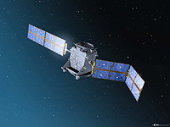Giove A, first Galileo demonstrator is in orbit, marking the very first step to full operability of Europe’s new global navigation satellite system, under a partnership between ESA and the European Commission (EC).

Figure 3-22 : Giove A, the first Galileo in-orbit [22]

|  |  |
| --- | --- |
| **GALILEO**  **The European satellite navigation system** | |
| **CONSTELLATION   DESCRIPTION** | |
| Number of Satellites | 27 Active, 3 active spare |
| Geometry | 3 planes, 9 satellites and 1 spare each |
| Orbit | MEO – 23,222 km circular, 56° inclination |
| Orbit Period | 14 hours 4 minutes |
| Coverage | Global |
| Initial Operational Capability (IOC) | Under construction. Scheduled in April 2011 |
| Full Operational Capability (FOC) | Expects in 2014 |

Table 3-5-1 : Galileo general information[23]

### Chinese COMPASS systems

China is setting up a satellite system to challenge U.S GPS. Compass Navigation Satellite System, or BeiDou 2 is the second generation satellite navigation system capable of providing continuous, real time passive 3D geo-spatial position and speed measurement.

|  |  |
| --- | --- |
| **BEIDOU**  **Compass Navigation Satellite System CNSS** | |
| **CONSTELLATION   DESCRIPTION** | |
| Number of Satellites | 35 Active (Beidou 2 or Compass) |
| Geometry | 3 planes, 9 satellites and 1 spare each |
| Orbit | GEO – 21,500 km circular, 56° inclination |
| Orbit Period | 14 hours 4 minutes |
| Coverage | Area from 70°E to 140°E, and from 5°N to 55°N. Long term goal is to develop global coverage |
| Initial Operational Capability (IOC) | Scheduled in April 2011 |
| Full Operational Capability (FOC) | Under construction. Expects in 2017 |
| Operated by: | Coordination Scientific Information Center (KNITs) |
|  |  |

Table 3-5-2 : Beidou general information.

#### Current technology (Beidou-1)

Unlike the GPS, GLONASS, and Galileo systems, which use medium Earth orbit satellites, Beidou 1 uses satellites in geostationary orbit. This means that the system does not require a large constellation of satellites, but it also limits the coverage to areas on Earth where the satellites are visible. The area that can be serviced is from 70°E to 140°E, and from 5°N to 55°N.

#### Future Plans (Beidou-2 or Compass)

The new system will be a constellation of 35 satellites, which include 5 geostationary orbit (GEO) satellites, for backward compatibility with Beidou-1, and 30 medium Earth orbit (MEO) satellites, that will offer complete coverage of the globe. There will be two levels of service provided; free service for those in China, and licensed service for the military.

Three satellites for Beidou 2 have been launched in early 2007, in early 2009 and in early 2010. In the next few years, China plans to continue setting up the system for global operation from 2017 with 30 satellites. Regional operation within Asia Pacific would be completed with more than 10 satellites in late 2012.

## Overview of GPS Signal

### GPS Frequency

GPS signals are transmitted in UHF band. The UHF band covers the frequency band from 500MHz to 3GHz.

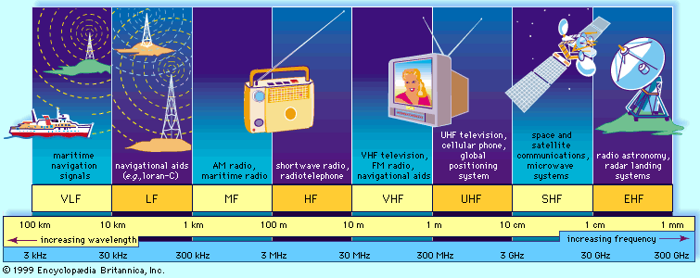

Figure 3-23 : Radio frequency spectrum [24]

All signal components are derived from the output of a highly stable atomic clock. The clocks generate a pure sine wave at a frequency f0 = 10.23MHz, with a stability of the order of 1 part in 1013 over one day. The frequency generated by the clocks is referred to as the **fundamental frequency.**

For the ranging codes and navigation message to travel from the satellite to the receiver, they must be modulated onto a carrier frequency, f0. Multiplying the fundamental frequency f0 by integer factors yields the two microwave L-band carrier waves L1 and L2 respectively (above Figure 3-24). The frequencies of the two waves are obtained as follows:

|  |
| --- |
| L1 = fL1 = f0 x 154 = 1575.42MHz |

|  |
| --- |
|  |

|  |
| --- |
| L2 = fL2 = f0 x 120 = 1227.60MHz |

### GPS Signal Structure

[25] GPS signals have two bands; L1 band frequency is 1575.42 MHz and L2 band frequency is 1227.60 MHz. L1 band has Coarse/Acquisition code (C/A), Precision code (P(Y)) and navigation data. L2 band has only P(Y)-code and navigation data. Table 3-6 shows the characteristics of GPS signal structure.

|  |  |  |  |
| --- | --- | --- | --- |
|  | Coarse/Acquisition (C/A) code | P(Y)-code | Navigation Data |
| Frequency (Chipping rate) | 1.023 MHz (Mbps) | 10.23 MHz (Mbps) | 50 Hz (bps) |
| Length per chip | 293 m | 29.31m | 5950 km |
| Repetition | 1 ms | 1 week | N/A |
| Code type | Gold | Pseudo random | N/A |
| Carrier | L1 | L1, L2 | L1, L2 |
| Feature | Easy to acquire | Precise positioning, jam resistant | Time, ephemeris, HOW |

Table 3-6 : GPS Satellite signals characteristics

C/A code is a sequence of zeros and ones and is unique for every satellite. The code is based on Gold Codes. Two sets of gold codes with different phase tappings are used to generate unique C/A code for every satellite. The C/A code is also called PRN code. PRN code or number is assigned to each satellite based on which PRN code is assigned to a particular satellite. If PRN (C/A) code 1 is assigned to a satellite, then this satellite is named as PRN-1. The properties of C/A codes are that they have the best cross-correlation characteristic. The cross-correlation between any two codes is much lower than auto-correlation of each of the codes. The frequency of the C/A code is 1.023 MHz.

The P(Y) code is encrypted using encryption code and is called Y-code. P(Y)-code is also a sequence of zeros and ones and is generated using a set of Gold Codes. P(Y) code has a frequency of 10.23 MHz.

Navigation data are also a sequence of zeros and ones based at a rate of 50 bits per second. The navigation data structure is defined in the interface control document (ICD) of GPS. The navigation data and C/A code are modulated with the carrier wave using BPSK (Binary Phase Shift Keying) and DSSS (Direct Sequence Spread Spectrum) techniques. DSSS is a type of CDMA hence all the satellites use the same carrier frequency but different code.

### Structure of GPS Navigation Data

[26] In addition to the C/A code navigational information is modulated into the L1 signal. The information has a frequency of 50 Hz signal and it contains data like satellite orbits, clock corrections and other system parameters (information about the status of the satellites). These data are constantly transmitted by each satellite. The receiver uses these data to determine its date, the approximate time and the position of the satellites.

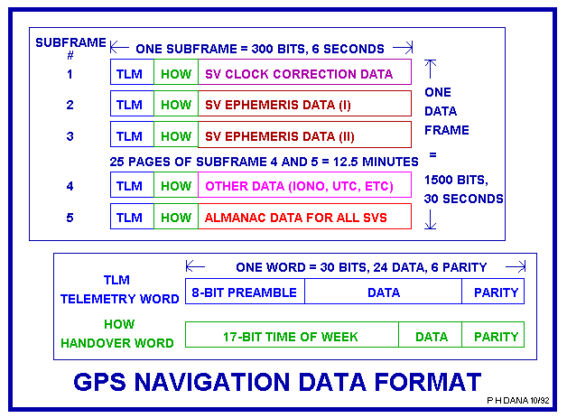

Figure 3-24 : Navigation data format

With a bit rate of 50 bps and a cycle time of 30 seconds, the total information content of a navigation data set is 1500 bits. The navigation message consists of 25 data frames and is subdivided into five subframes of six-second duration comprising 300 bits of information. Each subframe contains the data words of 30 bits each. In calculation, it will take 30 seconds to receive one data frame and 12.5 minutes to receive the complete signal. Six of these are control bits. The first two words of each subframe are the Telemetry Work (TLM) and the C/A-P-Code Hand over Work (HOW). TLM contains information about the age of the ephemeris data which facilitates the access to the navigation data. The next word is the HOW, which contains GPS system time of transmission. HOW allows the transition between tracking the C/A code to the P(Y) code.

### Precision (P(Y)) Code

[27] The P(Y) code is also a PRN, however each satellite's P (Y) code PRN code is 6.1871 × 1012 bits long (6,187,100,000,000 bits) and only repeats once a week (it is transmitted at 10.23 Mbit/s). The extreme length of the P-code increases its correlation gain and eliminates any range ambiguity within the Solar System. However, the code is so long and complex it was believed that a receiver could not directly acquire and synchronize with this signal alone. It was expected that the receiver would first lock onto the relatively simple C/A code and then, after obtaining the current time and approximate position, synchronize with the P-code.

Whereas the C/A PRNs are unique for each satellite, the P-code PRN is actually a small segment of a master P-code approximately 2.35 × 1014 bits in length (235,000,000,000,000 bits) and each satellite repeatedly transmits its assigned segment of the master code.

To prevent unauthorized users from using or potentially interfering with the military signal through a process called spoofing, it was decided to encrypt the P-code. To that end the P-code was modulated with the **W-code**, a special encryption sequence, to generate the **Y-code**. The Y-code is what the satellites have been transmitting since the anti-spoofing module was set to the "on" state. The encrypted signal is referred to as the **P(Y)-code**.

The details of the W-code are kept secret, but it is known that it is applied to the P-code at approximately 500 KHz, which is a slower rate than that of the P-code itself by a factor of approximately 20. This has allowed companies to develop semi-codeless approaches for tracking the P(Y) signal, without knowledge of the W-code itself.

### GPS Signal Generation

The GPS signal generation is showed in the Figure 3-25 below. The C/A code and P(Y) code are combined with the navigation data through a modulo-2 adders. The exclusive OR operation is usded on binary sequences represented by 0’s and 1’s, and its properties are showed in Table 3-7.

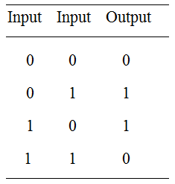

Table 3-7 :

Output of the exclusive OR Operation

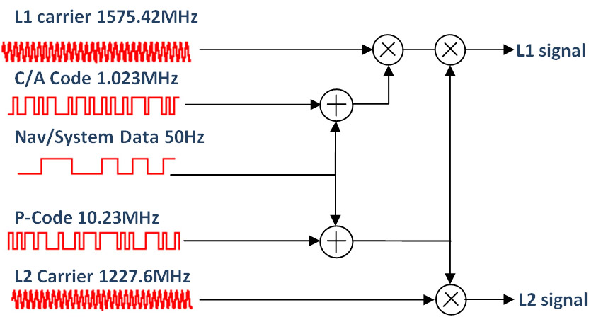

90º

Figure 3-25 : GPS Satellite signal generation

The C/A code **⊕** dataand the P(Y) code **⊕** datasignals are supplied to the two modulators for the L1 frequency. Here the signals are modulated onto the carrier signal using the binary phase shift keying (BPSK) method. The two codes are modulated in-phase and quadrature with each other on L1 which is 90º phase shift between the two codes. These two L1 signals are added to form the resulting L1 signal. The so-called standard positioning service (SPS) is based on C/A code signals alone.

It follows that the signal transmitted from satellite *k* can be described as



where

*PC*, *P*PL1, and *P*PL2 are the powers of signals with C/A or P code,

*Ck* is the C/A code sequence assigned to satellite number *k*,

*Pk* is the P(Y) code sequence assigned to satellite number *k*,

*Dk* is the navigation data sequence,

and *f*L1 and *f*L2 are the carrier frequencies of L1 and L2, respectively.

## Overview of Software-Defined GPS Receivers (SDR)

[28] GPS receiver is the third component of the GPS system. It can be implemented using software on a personal computer without investing in new hardware. The concept of SDR is not new and evolving capabilities of digital electronics are making practical many processes that were once only theoretically possible. Joseph Mitola published the first paper*a* on this topic in 1992. The SDR has its origins in the defense sector since the late 1970s in both U.S. and Europe. The first public software radio initiative was U.S. military project named SpeakEasy which used for communication.

First example of software based GPS receiver can be illustrated in the Figure 3-26 below.



Figure 3-26 : Architecture of Conventional GPS receiver



Figure 3-27 : Architecture of Software-based GPS Receiver

[29] The RF front-end and signal processor are all built upon IC chips. The outputs of the signal processor are displayed to a display unit. There is limited access to change the parameters or install new algorithms. Figure 3-27 shows architecture of a software-based GPS receiver (SGR). The hardware component is RF front-end device, however the rest of the signal processing is done using high level language like C/C++, MATLAB etc. It gives the highest level of flexibility.

*a* J Mitola, "The Software Radio," IEEE National Telesystems Conference, 1992 - Digital Object Identifier 10.1109/NTC.1992.267870

Second example of software GPS receiver designed and implemented on FPGA plus DSP partition.

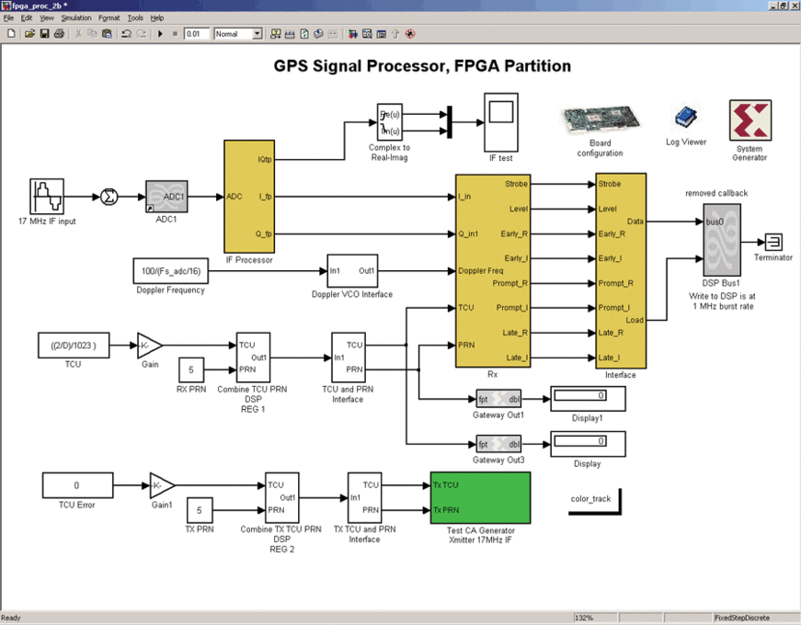

Figure 3-28 : FPGA portion of the GPS receiver design using Xilinx system generator library.

[30] Designs are increasing complex and often comprise hybrid technologies including RF, low to high speed signal processing and control. Instead of constructing a hardware module of GPS, which might be unclear about achieving the optimal output. Model based design can use the available toolbox options in MATLAB to implement a system model. This can verify the success of the performance goals before implement the model into field-programmable gate arrays (FPGAs) or application-specific integrated circuits (ASICs).

## Overview of CDMA systems

### Access Scheme

[31] For radio systems there are two resources, frequency and time. Division by frequency, so that each pair of communicators is allocated part of the spectrum for all of the time, results in Frequency Division Multiple Access (FDMA). Division by time, so that each pair of communicators is allocated all (or at least a large part) of the spectrum for part of the time results in Time Division Multiple Access (TDMA). In Code Division Multiple Access (CDMA), every communicator will be allocated the entire spectrum all of the time. CDMA uses codes to identify connections.

|  |
| --- |
| forest |
| Figure 3-29 : Multiple Access Schemes |

### Coding

CDMA uses unique spreading codes to spread the baseband data before transmission. The signal is transmitted in a channel, which is below noise level. The receiver then uses a correlator to despread the wanted signal, which is passed through a narrow bandpass filter. Unwanted signals will not be despread and will not pass through the filter. Codes take the form of a carefully designed one/zero sequence produced at a much higher rate than that of the baseband data.

### ****Direct Sequence Spreading Spectrum (DSSS)****

In a communication system, DSSS is a spread spectrum technique whereby the original data is multiplied with a Pseudo Random noise (PN).

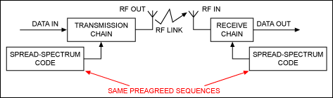

Figure 3-30 : Spread Spectrum communication system

The spread spectrum code is a pseudorandom sequence of 1 and -1 values at a frequency much higher than the original data signal, thereby spreading the energy of the original signal into a much wider band.

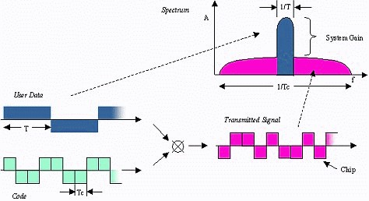

Figure 3-31 : Direct Sequence Spread Spectrum [32]

DSSS improves protection against interfering (or jamming) signals especially narrowband and makes the signal less noticeable. Multiple users are able to share a single channel by just using different PN codes.

In GNSS, U.S. NAVSTAR and European Galileo are using CMDA technology.

## GPS Application

### Military

[33] GPS tracking was developed in the 1970s by the United States Department of Defense to improve tracking capabilities of its targets. Since then, GPS tracking have also found other uses. The military applications of GPS span many purposes:

* Navigation: GPS allows soldiers to find objectives in the dark or in unfamiliar territory, and to coordinate the movement of troops and supplies.
* Target tracking: Various military weapons systems use GPS to track potential ground and air targets before they are flagged as hostile. These weapons systems pass GPS co-ordinates of targets to precision-guided munitions to allow them to engage the targets accurately.

### Personal navigation

A Personal Navigation Assistant (PNA) also known as Personal Navigation Device or Portable Navigation Device (PND) is a portable electronic product which combines a positioning capability (such as GPS) and navigation functions. The personal navigation market is growing rapidly, with unit sales in Europe and the US surpassing 8 million in 2005 and expected to reach almost 14 million by the end of 2006. Rising activity in mobile and smartphone solutions is likely to challenge manufacturers of dedicated navigation devices

### Vehicle tracking systems

[34] One of the biggest technological advancements in vehicle security has been the advent of the *vehicle* *tracking* *system*. Vehicle tracking systems use satellite or radio positioning in order to locate a vehicle after it has been stolen. Vehicle tracking systems are becoming increasingly popular for people who own expensive or executive cars. If the car is stolen, the vehicle tracking system will send out a signal that only the police can trace. Vehicles fitted with a satellite Global Positioning System (GPS) can pinpoint the exact location of the vehicle and send information to the police. Police departments also have equipment in place to track vehicles with GPS systems fitted. Software is used to plot the actual position of the vehicle on maps.

## 3.11 MATLAB/SIMULINK application

SIMULINK is an environment for multi-domain simulation and Model-Based Design for dynamic and embedded systems. It provides an interactive graphical environment and a customizable set of block libraries that let you design, simulate, implement, and test a variety of time-varying systems, including communications, controls, signal processing, video processing, and image processing.

Add-on products extend SIMULINK to mul­tiple modeling domains, as well as provide tools for design, implementation, and verifi­cation and validation tasks.

SIMULINK is integrated with MATLAB, providing immediate access to an extensive range of tools that let you develop algo­rithms, analyze and visualize simulations, create batch processing scripts, customize the modeling environment, and define signal, parameter, and test data.

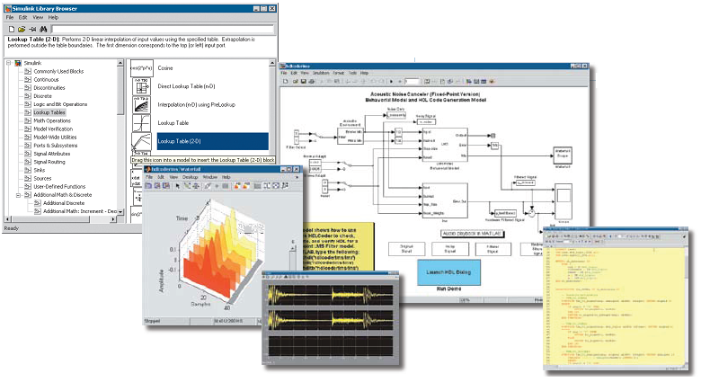

Figure 3-32 : SIMULINK interface

# CHAPTER FOUR

# SYSTEM DEVELOPMENT

## System Overview

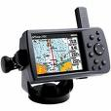

**GPS Satellite**

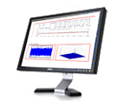

**Display**

* Acquisition
* Tracking
* Positioning
* C/A code Generation
* Precision code Generation
* Navigation data Generation

**GPS Receiver**

* Display results
* Plot graphs

Figure 4-1 : System level diagram for GPS model

The system level diagram of the GPS model is outlined in Figure 4-1. Looking at the GPS system level, practically the GPS is in hardware nature and the signal processing functions are in embedded processors. The system is not transparent and inflexible to the users. The functions of the GPS can be replicated in the MATLAB/SIMULINK which allows users to change the parameters and values.

Software modelling is as if strip-open of the hardware which let users to examine and understand the system portion by portion. The key components in the hardware shall be emulated into MATLAB/SIMULINK block functions.

Basically, GPS satellite (transmitter) and GPS receiver are the two main systems which will be modelled in SIMULINK. The transmitter model should perform the basic function of signal and codes generation. Demodulation and decoding will be the essential criterion that a single channel receiver should carry out. As a functional GPS receiver, the SIMULINK model should have the acquisition for visible signals, code and carrier tracking and navigation computing

## System Architecture

### Simple Transmitter Simulator Architecture

The GPS signal generation at the satellites are showed in the figure [] below.



Figure 4-2 . Generation of GPS signals at the satellites

Understanding the GPS signal generation from above figure, all GPS properties can be modelled in SIMULINK. In this project, only L1 band GPS signal is discussed. As C/A code is not modulated onto L2 carrier, L2 band signal is not necessary to implement onto the transmitter model. The structure of P(Y) code is rather complex and secret to civil user and furthermore it is not relevant to the acquisition and tracking algorithms, as the result of that, this component is simplified in the simulation.



Figure 4-3: Generation of L1 band GPS signal

The L1 GPS signal simulator should emulate GPS signal properties which similar to GPS environment. For each satellite, it should be possible to define the details listed below

|  |  |
| --- | --- |
| Satellite signal  properties | Additional details to define in GPS signal simulator |
| PRN | The pseudorandom noise number corresponding to the satellite. This number indicates which of the C/A codes should be used. |
| Doppler | The Doppler count is the frequency deviation from the IF. The Doppler count is directly associated with line-of-sight dynamics between the satellite and the receiver. |
| Code Phase | The code phase is the time alignment of the PRN code in the received data. |
| P(Y) Code | In addition to the C/A code, the L1 signal contains the P(Y) code. This code is modulated onto the carrier wave as a quadrature component while the C/A code is present in the in-phase component. |
| Data Bits | The navigation data bits are phase-modulated onto the carrier wave with a frequency of 50Hz. |
| Signal Strength | Due to the long signal path from the satellite to the receiver in combination with a low power transmitter at the satellite, the received signal is very weak. An additional property of the GPS signal is the signal-to-noise ratio (SNR), the ratio between the signal and the noise originating from the signal path. |

Table 3-8 : Some definitions inside a GPS signal simulator. [35]

### Simple Receiver Simulator Architecture

The basic concept of a receiver is showed in Fig 4-4.



Figure 4-4: Block diagram of the receiver

|  |  |
| --- | --- |
| Receiver blocks  properties | Additional details to define in GNSS receiver |
| Filter | The filters are used to extract the desired frequency band from the input while rejecting the reminder. |
| Low Noise Amplifier (LNA) | The LNA is placed to amplify the signal while adding a minimum of noise. |
| Mixers/ Local oscillator (LO) | The mixer is used for frequency conversion of information. The LO uses the voltage controlled to serve as a sampling clock for conversion. The combination of mixer & LO can convert the frequency to the desired Intermediate Frequency (IF) (usually lower frequency for signal processing). |
| Frequency Synthesizer | A frequency synthesize is basically a Phase Locked Loop (PLL) with a fixed reference frequency at the input and frequency division in the feedback so that it can use to generate channel frequencies with a certain spacing. |
| Demodulator | The demodulator correlates the input RF signal with the In-phase and Quadrature. |
| Analog to  Digital Converter (ADC) | After the I/Q demodulator and baseband filter/amplifier, signal is converted to digital domain. |

Table 3-9 : Some of the receiver blocks properties inside a GNSS receiver. [36]

The fully functional GNSS L1 front end is depicted in Figure 4-4. This figure establishes the concept of implementing the receiver in SIMULINK. The real GPS signal was taken from SE4110 ASIC-based front end which shows in Figure 4-5. The SE4110 is highly integrated GPS receiver offering high performance and low power operation. The parameters of the receiver components (e.g. sampling frequency, IF) can be emulated from GNSS L1 front end.



Figure 4-5 : GNSS L1 front end component



Figure 4-5 : The functional block diagram of the SE4100 ASIC-based front end. [35]

# CHAPTER FIVE

## SYSTEM DESIGN CONSIDERATIONS

## GPS Transmitter

Figure 5-1 shows the complete GPS signal simulator for one satellite implementation.

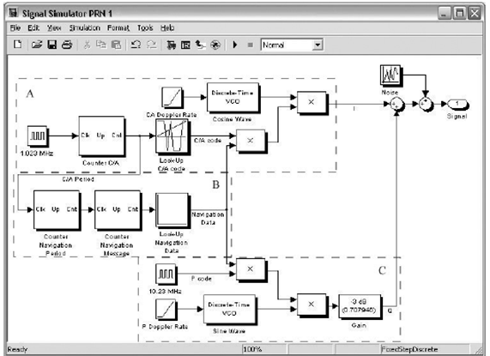

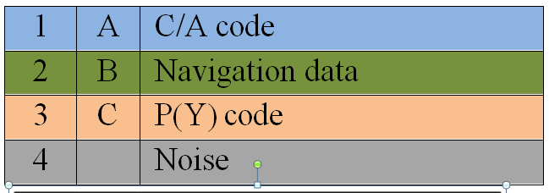

Figure 5-1 : GPS transmitter model in SIMULINK

There is two–level design for the Transmitter model. The lower level is the implementation of each satellite where the signal originating from each satellite is generated. The signals should include the following four components:

* **C/A code**
* **Navigation data**
* **P(Y) code**
* **Noise**

The upper level is where each satellite contributing to the resulting signal is initialized. The individual initialization data should be saved in a file:

* 32 possible PRN codes with all possible shifted versions. Refer to Table 5-11
* Navigation data. Refer to Table

## Coarse/Acquisition (C/A) code

### Overview

The C/A codes are often referred to as Gold codes named after Robert Gold and also referred to as Pseudo-Random noise sequence, or simply PRN sequences.

### Pseudo Random Noise (PRN) Sequence

The pseudorandom noise (PN) sequence are a series of 1’s and 0’s which lack of any definite pattern and consists of a deterministic sequence of pulse that will repeat after its period. The heart of PN sequence generator is usually made up of linear feedback shift registers (LFSR). Each C/A code is generated using a tapped LFSR and it generates a maximal-length sequence of length *N* = 2*n* – 1 elements.

The figure 5-2 below the maximal sequence consists of every possible state except the “0000” state. The XOR gate provides the feedback to the register that shifts bits from left to right.



Figure 5-2 : A 4 bit LFSR with its state diagram. [

### Gold Sequence

The generation of Gold codes using two preferred m-sequence generators of degree n, with a fixed non-zero seed in the first generator, $2^{n}$ Gold codes are obtained by changing the seed of the second generator from 0 to $2^{n}-1$. Another Gold sequence can obtained by setting all zero to the first generator, which is the second m-sequence itself. In total, $2^{n}+1$ Gold codes are available.

In SIMULINK, the Gold Sequence Generator can be created by using two PN Sequence Generator blocks to generate the preferred pair of sequences, and then XORs these sequences to produce the output sequence, as shown in the Figure 5-3.

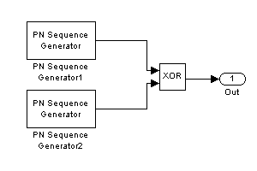

Figure 5-3: Gold Sequence Generator

On such instance of using PN Sequence Generator to create Gold code, it does not have the flexibility to generate different codes for GPS satellite when the output of G2 isn’t phase selected. Create various Gold code is made possible by using creating m-sequence example below which is taken from MATLAB help template.

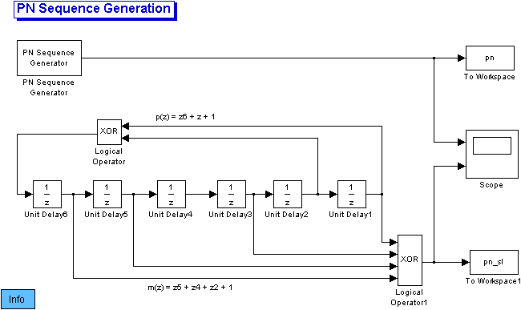

Figure 5-4 : Example of the operation of the PN Sequence generator

### C/A Code Generator

Taking the example of Gold code generation, the C/A code generator can be modelled as shown in the figure. It produces a different 1023 chip sequence for each phase tap (selector) setting.



$$G1 shift register= f\left(x\right)=1+x^{3}+x^{10}$$

$$G2 shift register=f\left(x\right)=1+x^{2}+x^{3}+x^{6}+x^{8}+x^{9}+x^{10}$$

**Tap 3 & 8 = PRN 31**

G1 and G2 Initial State = all ones

Figure 5-5 : GPS C/A code generator.

The gold code generator contains two shift registers known as G1 and G2. These shift registers have 10 cells generating sequence of length 1023. The two resulting 1023 chirping long sequences are modulo-2 added to generate a 1023 chip long C/A code. It works only if the polynomial is able to generate code of maximum length.

Every 1023rd period, the shift registers are reset with all ones, making the code start over.

The G1 register always has a feedback configuration with the polynomial $f\left(x\right)=1+x^{3}+x^{10}$, meaning that the state 3 and state 10 are fed back to the input. In the same way, G2 register has the polynomial $f\left(x\right)=1+x^{2}+x^{3}+x^{6}+x^{8}+x^{9}+x^{10}$.

To make different C/A codes for the satellites, the output of the 2 shift registers are combined in a very special manner. The G1 register always supplies it output, but the G2 register supplies two of its states to a modulo-2 adder to generate its output. The selection of states for the modulo2- adder is called the phase selection.

### C/A Code Generation

Pre Initialization stage

All 32 PRN C/A code sequence are generated and save into a file for initialization. The precomputed file can be used to load onto the Lookup table. The C/A code generator uses binary value 0 and 1, however in signal processing algorithms, it is more convenient to present the codes with a polar no-return-to-zero (NRZ) representation. C/A code repeats itself every 1 ms.

0

-1

1

1

Binary Bit

NRZ Bit

Binary Bit

NRZ Bit

Figure 5-7 : NRZ representation

After Initialization stage

All C/A codes are saved to a saved workspace where it can be retrieved when each satellite model points to its PRN number. For example, Satellite #1 will use PRN #1 C/A code. The flow chart is the process of generating one complete 1023 chips C/A code generation.

**Part A**

**Part B**

Frequency of

chipping rate

Table contains

Precomputed

C/A codes

1.023 MHz

Up counter

From 0 to 1022

**(no code delay)**

Lookup Table

For C/A code

Reach 1022 ?

Yes

No

One PRN sequence successfully generated

(1023 chips)

**Code Phase Delay**

Up counter

From x *a* to x *a* +1023

**(code delay)**

Lookup Table

For C/A code

Reach 1022 ?

No

One PRN sequence successfully generated at code delayed (1023 chips)

Yes

Figure 5-8 : Flow chart of obtaining one complete C/A code

x *a* = code phase delay





Figure 5-9 : C/A code generation

In the satellite model, the C/A code generation must have three component parameters which is stated in the Table

|  |  |
| --- | --- |
| C/A Code  Parameters | Remarks |
| Frequency  oscillator | * 1.023 MHz (digital pulse) |
| Counter | Part A – non code phase delay   * Count from 0 to 1022, referring to the 1023 chips in one C/A code * Counter increases its value on a pulse falling edge * Output is reset to its initial zero after 1022 counts (non code phase delay)   Part B – code phase delay   * Count from x *a* to x *a* +1023, referring to the 1023 chips in one C/A code * Counter increases its value on a pulse falling edge * Output is reset to its x *a* after 1022 counts (code phase delay) * Supply the output to lookup table |
| Lookup Table | * Two dimensional array * First dimension indicates 32 PRN codes * Second Dimension indicates the 1023 chips |

Table 5-10 : Parameter for generating C/A Code

### C/A Code Phase Assignment

The selection of different states for the code phase generates the different C/A codes for the GPS satellites. There are 37 PRN C/A codes and the first 32 codes are assigned to satellites while code 33 to code 37 are reserved for other uses, including ground transmitter.



Table 5-11 : C/A code phase assignment.

## Navigation Data

### Overview

In this project, real navigation data are not used in the simulation, the default navigation data signal is simulated as a digital signal alternating between −1 and 1. The navigation data are transmitted on the L1 frequency with bit rate of 50 bps and mixed together with the C/A code and P(Y) code.

### Navigation Data Generation

Pre Initialization stage

The navigation data are also precomputed and saved into a file for initialization. The precomputed file can be used to load onto the Lookup table. The binary values 0 and 1 are also represented in NRZ representation. The data is designed to be pseudorandom for its correlation properties.

0

−1

1

1

Binary Bit

NRZ Bit

Binary Bit

NRZ Bit

Figure 5-10: NRZ representation

The basic format of the navigation data is a 1500 bit long frame containing 5 subframes, each having length 300 bits. For this project, the simulation only requires simple data generation and navigation message does not compute positioning. Therefore navigation message can keep within a frame of consistent and manageable value to manipulate. The generation can build with PN sequence which allows 1,500 bits of deterministic pattern. PN Sequence Generator has a linear feedback shift register (LFSR) and base on the default parameters to create the pseudorandom sequence. The sample time determines the number of bits and it is set to 1499 in turn generates 1500 bits (0 to 1499).

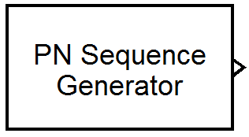 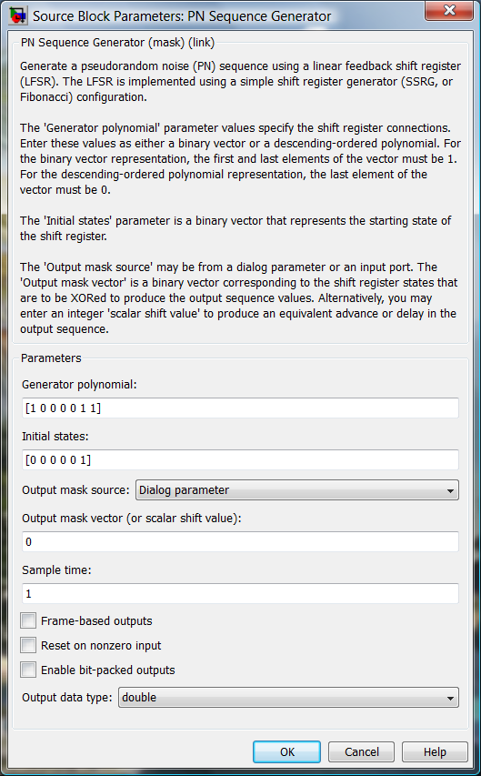

Figure 5-11 : PN Sequence Generator block

After Initialization stage

Navigation data saved to a saved workspace where it can be loaded on the Lookup table in each satellite model.

≈1 KHz

Up counter #1

From 0 to 20

Up counter #2

Fom 0 to 1500

Period = 1 ms

From C/A code period

Bit rate = 50 Hz (20 ms)

Navigation frame

size = 1500

Lookup Table

For Navigation data

Table contains

Precomputed Navigation data

Figure

**Part A**

Complete cycle of a PRN code

Table contains

Precomputed

Navigation bit

≈ 1 ms

Up counter

From 0 to 20

Lookup Table

For Navigation data

Reach 1499 ?

Yes

No

One period of successfully generated navigation data

Frame (1500 bits)

Reach 20 ?

Yes

Up counter

From 0 to 1499

**(no navigation delay)**

No

Up counter

From 0 to 20

Lookup Table

For Navigation data

Reach 1499 ?

Yes

No

One period of successfully generated navigation data

Frame (1500 bits)

Reach 20 ?

Yes

Up counter

From x *a* to x *a* +1499

**(navigation delay)**

No

**Navigation delay**

**Part B**

Figure 5-12 : Flow chart of obtaining one complete Navigation data

x *a* = navigation phase delay





Figure 5-13 : Navigation data generation

In another part of the satellite model, the navigation data generation must have three component parameters which is stated in the Table

|  |  |
| --- | --- |
| Navigation Data  Parameters | Remarks |
| Frequency | * 1.023 KHz (output from C/A counter) |
| Counter #1  **(Navigation**  **Period)** | * Count from 0 to 20, referring to the 50 Hz * Counter increases its value on a pulse falling edge * Output is reset to its initial zero when it reaches 20 |
| Counter #2  **(Navigation**  **Message)** | Part A – non navigation phase delay   * (non navigation delay)   Part B – navigation phase delay   * Count from x *a* to x *a* +1499, referring to the 1500 frame size * Counter increases its value on a pulse falling edge * Output is reset to its x *a* after 1499 counts (navigation phase delay) * Supply the output to lookup table |
| Lookup Table | * Load Navigation bits from precomputed file |

Table 5-12 : Parameter for generating Navigation data

## Precision (P/Y) code

### Overview

Similarly to navigation data, P(Y) code is simulated as a digital signal alternating between −1 and 1. The frequency of the chip rate is 10.23 MHz

### Precision code Generation

The P(Y) code generation has the same principles as the C/A code, except that 4 shift registers with 12 cells are used. However in system architecture, it was mentioned that the P(Y) code can be implemented as squared pulse. A simulated P(Y) code is sufficient to apply in the GPS satellites.

The simple P(Y) code is created by clock pulses. In order to have a NRZ representation, P(Y) code is required to simulate as alternating between −1 and 1. The period is 10.23 million chips per second.

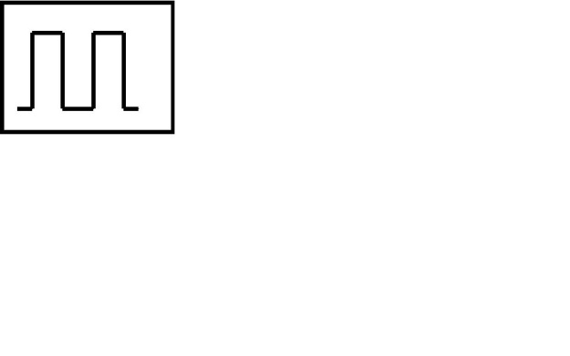

Period = 10.23 MHz

Figure 5-14: Clock to generate P(Y) code

The clock block should output 1 for the first half of the specified sample period and −1 for the other half of the sample period. The Unit Delay block delays the input by the P(Y) code period and initial condition should set as −1 to achieve NRZ.

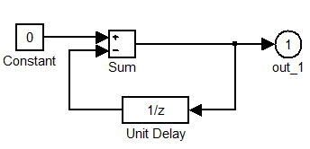

Figure 5-15 : Sub system of the clock

## Modulation

### Overview

L1 band GPS signal is transmitted at 1575 MHz and in a RF front end device, it is usually down converted from high frequency to a much lower frequency for processing. The reason for this is to bring the frequency to usable ranges in which to perform the analog to digital conversion (ADC). The lower frequency is called Intermediate Frequency (IF).

In circuitry level, active devices such as transistors cannot deliver much gain without becoming unstable. In order to minimise the poor signal processing at high frequency (usually GHz), using a lower frequency translation is becoming necessary. The key reason for using IF is to improve frequency selectivity. There is always a difficult task to filter the wanted signal/(s). Filter has better selectivity at lower frequency when bandwidth is narrower. The task to separate out of extract the wanted signal/(s) is easier at lower IF. The down conversion is achieved by using a local oscillator.

### Mixer/Local Oscillator Implementation

The local oscillator is implemented with Discrete Time Voltage Controlled Oscillator (VCO). VCO produces a periodic signal, the frequency of which changes based on an input. Base on the down conversion, we use IF = 9.548 MHz at the quiescent frequency.

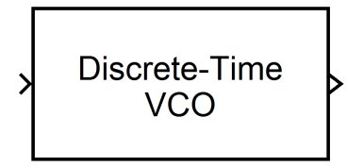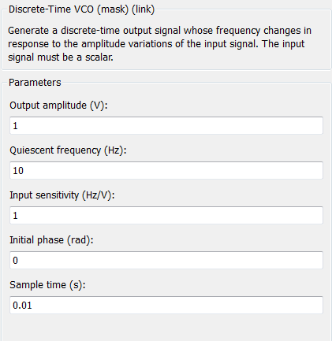

Figure 5-16 : SIMULINK block for mixer/local oscillator

### BPSK Modulation

The local oscillator is implemented with Discrete Time Voltage Controlled Oscillator (VCO). VCO produces a periodic signal, the frequency of which changes based on an input. Base on the down conversion, we use IF = 9.548 MHz at the quiescent frequency.



**Data bits**

**PRN code**

**Data bits * PNR code**

**Carrier**

**Carrier after BPSK**

Figure 5-17 : The effect of BPSK modulation of the L1 carrier wave with the C/A code and the navigation data

## Correlation Properties

C/A codes have two important properties which are described below.

* *Nearly no cross correlation*. All the C/A codes are nearly uncorrelated with each other. The codes Ci and Ck for satellite I and k, the cross correlation can be written as
$$r_{ik}\left(m\right)=\sum_{l=0}^{1022}{C^{i}}\left(l\right)C^{k}\left(l+m\right)≈0 f all m.$$

* *Nearly no correlation except for zero lag*. All the C/A codes are nearly uncorrelated with themselves, except for zero lag. This property makes it easy to find out when two similar codes are perfectly aligned. The autocorrelation property for satellite k can be written as

$r_{kk}\left(m\right)=\sum_{l=0}^{1022}{C^{k}}\left(l\right)C^{k}\left(l+m\right)≈0 f all \left\lfloor m\right\rfloor ≥1.$

## Combining the signal components in GPS Transmitter

The signal component combines:

* C/A code is combined with the Navigation data (Part I)
* P(Y) code is combined with the Navigation data (Part II)
* Part I is modulated onto a carrier using BPSK modulation
* Part II is modulated on a 90º phase shift carrier using BPSK modulation



**90º phase shift BPSK Modulation**

**BPSK Modulation**

Combining signal components

**Part II**

**Part I**

Figure 5-18 : Combining all the transmitter components.

**Part I**

The C/A code is multiplied with the navigation data. In the earlier section on both signals, they are generated in binary data sequence consisting of −1s and 1s. After multiplication, the signal is modulated onto a carrier generated by cosine wave in a voltage-controlled oscillator (VCO).

**Part II**

Similarly, navigation data is also multiplied with the P(Y) code. The multiplied signal is modulated onto another carrier generated by sine wave in the second voltage-controlled oscillator (VCO).

## GPS Receiver

The GPS receiver implementation is showed by the block diagram below.

*optional



Figure 5-19 : One receiver channel

There are two different parts for a receiver to achieve in the scope of the objective.

* Acquisition
* Demodulation (Tracking)

Basically, the receiver has to be able to acquire the signal from the transmitter. The identifying of visible satellite is done at the acquisition part. The tracking part is split to two parts which consist of code tracking and carrier tracking. These two tracking components are able to demodulate the transmitted signal.

## Data Acquisition

The rough estimation process of code phase and Doppler frequency is called acquisition. Basically, for acquisition, C/A code and carrier wave are generated for the satellite. The receiver generated signal is then correlated with incoming signal and the correlation value is evaluated to make decision whether a satellite visible.

There are three types of data acquisition:

1. Serial Search Acquisition
2. Parallel Frequency Space Search Acquisition
3. Parallel Code Phase Search Acquisition

The three methods are to discuss in term of the implementation and their performance. One of the methods will be chosen for the acquisition design.

### Serial Search Acquisition



Figure 5-20 : Block diagram of the serial search algorithm

[book]Serial search acquisition is an often used method for acquisition in CDMA systems. As seen in Figure 5-20 , the algorithm is based multiplication of locally generated PRN code sequences and locally generated carrier signals. The PRN generator generates a C/A codes corresponding to a specific satellite. After multiplication with the PRN sequence, the signal is multiplied by a locally generated carrier signal. Multiplication with the locally generated carrier signal generates the inphase signal *I*, and multiplication with a 90° phase-shifted of the locally generated carrier signal generates the quadrature signal *Q*.

The *I* and *Q* signals are integrated over the period of one C/A code, and finally squared and added. Ideally, the signal power should be located in the *I* part of the signal, as the C/A code is only modulated onto that. However, in this case the *I* signal generated at the satellite does not necessarily correspond to the demodulated *I* . This is because the phase of the received signal is unknown. So to be certain that the signal is detected, it is necessary to investigate both the *I* and the *Q* signal. The output is a value of correlation between the incoming signal and the locally generated signal. If a predefined threshold is exceeded, the frequency and code phase parameters are correct, and the parameters can be passed on to the tracking algorithms.

The output is visible with a peak when the parameters are correct and the output is not present when the parameters are not matched. The Figure 5-21 shows these output.



Figure 5-21 : Output from serial search acquisition

(a) PRN 19 is not visible so no peak is present. (b) PRN 21 is visible so a significant peak is present. The peak occurs at C/A code phase = 359 chips and frequency 9.5475 MH

The serial search algorithm performs two different sweeps: a frequency sweep over all possible carrier frequencies of IF ±10 kHz in steps of 500 Hz and a code phase sweep over all 1023 different code phases.

In total, this sum up to a total of



The combinations are considerably large number which the search routines tend to be the main weakness.

### Parallel Frequency Space Search Acquisition



Figure 5-22 : Block diagram of the parallel frequency space search algorithm

[35] As the name parallel frequency space search acquisitionimplies, this second method of acquisition parallelizes the search for the one parameter. This method utilizes the Fourier transform to perform a transformation from the time domain into the frequency domain.

The incoming signal is multiplied by a locally generated PRN sequence, with a code corresponding to a specific satellite and a code phase between 0 and 1022 chips. The resulting signal is transformed into the frequency domain by a Fourier transform.

The result of multiplying the incoming signal with a perfectly aligned locally generated PRN sequence. The result is a continuous wave signal. Of course, this only happens when the locally generated PRN code is perfectly aligned with the code in the incoming signal. If the incoming signal contains signal components from other satellites, these components will be minimized as a result of the cross-correlation properties of the PRN sequences.

With a perfectly aligned PRN code, the output of the Fourier transform will show a distinct peak in magnitude. The peak will be located at the frequency index corresponding to the frequency of the continuous-wave signal and thereby the frequency of the carrier wave signal.



Figure 5-23 : PSD plot of the incoming signal multiplied by a locally generated PRN code sequence.

(a) When multiplying with a perfectly aligned PRN code, the output will show a peak at the carrier frequency. (b) When multiplying with a nonaligned code, the output will not show any peaks. The IF is 9.548 MHz.

### Parallel Code Phase Search Acquisition



Figure 5-24 : Block diagram of the parallel code phase search algorithm.

The goal of the parallel code phase search acquisition is to perform a correlation with the incoming signal and a PRN code. Instead of multiplying the input signal with a PRN code with 1023 different code phases as done in the serial search acquisition method, it is more convenient to make a circular cross correlation between the input and the PRN code without shifted code phase.

Parallel code phase search acquisition utilizes the advantage of parallelizing the quicker code phase to do the search. The goal of the acquisition is to perform a correlation with the incoming signal and a PRN code. Instead of multiplying the input signal with a PRN code with 1023 different code phases as done in the serial search acquisition method, it is more convenient to make a circular cross correlation between the input and the PRN code without shifted code phase.

When the frequency domain representation of the cross correlation is found, the time-domain representation can be found through inverse Fourier transform. The incoming signal is multiplied by a locally generated carrier signal. Multiplication with the signal generates the *I* signal, and multiplication with a 90◦ phase-shifted version of the signal generates the *Q* signal. The *I* and *Q* signals are combined to form a complex input signal x(n) = I (n) + j Q(n) to the DFT function.

The generated PRN code is transformed into the frequency domain and the result is complex conjugated.

The Fourier transform of the input is multiplied with the Fourier transform of the PRN code. The result of the multiplication is transformed into the time domain by an inverse Fourier transform. The absolute value of the output of the inverse Fourier transform represents the correlation between the input and the PRN code. If a peak is present in the correlation, the index of this peak marks the PRN code phase of the incoming signal.



Figure 5-25 : Output from parallel code phase search acquisition.

(a) PRN 19 is not visible so no peak is present. (b) PNR 21 is visible so a significant peak is present. The peak code phase 13404 samples and frequency 9.5475 MHz.

### The Selection of Acquisition Search

The choice of implementing the data acquisition search will depend on their criteria. The considerations are:

* The effect of navigation data bit transitions
* The probability of making a successful acquisition
* The computation demands as a function of the length of data to be analyzed.

The three considerations will determine the speed and accuracy of the acquisition. With the requirement of fast processing speed, **Parallel Code Phase Search** is chosen



Table 5-13 : Execution time for three different acquisition search

## Demodulation

### Overview

Once, acquisition is successfully determined, the satellites are visible at that time. In the next step, the visible satellites are continuously for fine tuning of the code phase and Doppler frequency. The tracking process removes the C/A code and carrier wave from the GPS signal and hence the remaining signal represents navigation data and some noise.



Figure 5-26 : Demodulation scheme to demodulate the navigation message.

There are some equations to describe how the demodulation scheme is conducted.

The total signal is given as

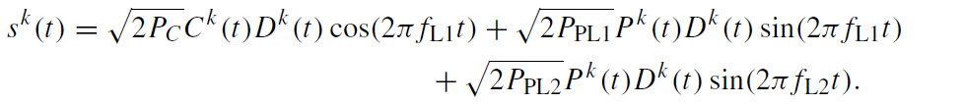

$f_{L1} and f_{L2}$-- carrier frequencies of L1 and L2.

$P_{c, }, P_{PL1, } and P_{PL2 }$-- power signals with C/A or P code

$C^{k}(t)$– C/A code sequence , $P^{k}(t)$– P(Y) code sequence, $D^{k}(t)$– Navigation data sequence

The output from the front end including filtering and down conversion can be described as



where $ω_{IF}$ is the intermediate frequency

This signal is then sampled by the A/D converter. Because of the narrow bandpass filter around the C/A code, the P code is distorted. In this way the last term in Equation (7.2) is filtered out and cannot be demodulated and is in the following described as noise *e(n)*. The signal from satellite *k* after the A/D conversion can be described as



with *n* in units of 1*/fs* ; *n* indicates that the signal is discrete in time.

To obtain the navigation data *Dk (n)* from the above signal, the signal has to be converted down to baseband. The carrier removal is done by multiplying the input signal with a replica of the carrier as shown in Figure 5-26. If the carrier replica is identical to the incoming carrier in both frequency and phase, the product of both is



where the first term is the navigation message multiplied with the PRN code and the second term is a carrier with the double intermediate frequency. The latter part of the signal can be removed by applying a lowpass filter. The signal after the lowpass filter is



The next step is to remove the code *Ck (n)* from the signal. This is done by correlating the signal with a local code replica. If the code replica is exactly the same as the code in the signal, the output of the correlation is



where *N Dk (n)* is the navigation message multiplied by the amount of points in the signal *N*.

The above description of the demodulation is only for a signal with one satellite. This gives a simpler idea of the demodulation scheme. In the demodulation scheme, two local signal replicas are required. To produce the exact replica some kind of feedback is required. The feedback loop to the carrier replica is referred to as the *carrier tracking loop* and the feeback loop to produce the exact code replica is referred to as the *code tracking loop*.

### Carrier Tracking

#### Overview

Costas loop is a phase-locked loop (PLL) used for carrier phase receiver from the suppressed-carrier modulation signals. The second order PLL system contains a first order filter and a voltage controlled oscillator (VCO). The damping ratio and noise bandwidth are crucial factors for the implementation.

#### Demodulation of carrier

To demodulate the navigation data successfully, an exact carrier wave replica has to be generated. To track a carrier wave signal, phase lock loops (PLL) or frequency lock loops (FLL) are often used.



Figure 5-27 : Basic GPS receiver carrier tracking loop block diagram

The two first multiplications wipe off the carrier and the PRN code of the input signal. The loop discriminator block is used to find the phase error on the local carrier wave replica. The output of the discriminator, which is the phase error, is then filtered and used as a feedback to the numerically controlled oscillator (NCO), which adjusts the frequency of the local carrier wave. In this way the local carrier wave could be an almost precise replica of the input signal carrier wave.

On the point to note, ordinary PLL is sensitive to 180° phase shift. Due to navigation bit transitions, a PLL used in a GPS receiver has to be insensitive to 180° phase shifts. Costas loop has the property of this insensitive to phase shift. Figure 5-28 shows the Costas loop.



Figure 5-28 : Costas loop used to track the carrier wave

The first multiplication is the product between the input signal and the local carrier wave and the second multiplication is between a 90° phase-shifted carrier wave and the input signal. The aim of the Costas loop is to try to keep all energy in the *I* (in-phase) arm. In order to do this, some kind of feedback to the oscillator is needed. If it is assumed that the code replica in Figure 5-28 is perfectly aligned, the multiplication in the *I* arm yields the following sum:



where $φ$ is the phase difference between the phase of the input signal and the phase of the local replica of the carrier phase.

The multiplication in the quadrature arm gives the following:



If the two signals are lowpass filtered after the multiplication, the two terms with the double intermediate frequency are eliminated and the following two signals remain:



To find a term to feed back to the carrier phase oscillator, it can be seen that the phase error of the local carrier phase replica can be found as



The phase error is minimized when the correlation in the quadrature-phase arm is zero and the correlation value in the in-phase arm is maximum.

### Code Tracking

#### Overview

Delay lock loop (DLL) is used for keeping track of the code phase of a specific code in the signal. The output of the loop is a perfectly aligned replica of the code. The DLL is correlated to the input signal with three replicas of the PRN code.

#### Demodulation of code



Figure 5-29 : Basic code tracking loop block diagram

The incoming signal is multiplied by the perfectly aligned local replica of the carrier wave. Afterwards the signal is multiplied with three code code replicas. The three replicas are nominally generated with a spacing of $±\frac{1}{2}$ chip. After this second multiplication, the three outputs are integrated and dumped. The output of these integrations is a numerical value indicating how much the specific code replica correlates with the code in the incoming signal.

The three correlation outputs *IE* , *IP*, and *IL* are then compared to see which one provides the highest correlation. The Figure 5-30 illustrates an example of code tracking. The DLL with three correlators is optimal when the local carrier wave is locked in phase and frequency.



Figure 5-30 : Code tracking Three local codes are generated and correlated with the incoming signal.

(a) The late replica has the highest correlation so the code phase must be decreased, i.e., the code sequence must be delayed. (b) The prompt code has the highest correlation and the early and late have similar correlation. The loop is perfectly tuned in.

However when there is a phase error on the local carrier wave, the signal will be noisier, making it more difficult for the DLL to keep lock on the code. Often, DLL in a GPS receiver is designed with six correlators as in Figure 5-31. The advantage of the design is that it is independent of the phase on the local carrier wave. If the local carrier wave is in phase with the input signal, all the energy will be in the in-phase arm. But if the local carrier phase drifts compared to the input signal, the energy will switch between the in-phase and the quadrature arm.



Figure 5-31 : DLL block diagram with six correlators

## Factors Affecting GPS Accuracy

There are multiple error sources associated with GNSS signal processing. Below is the list of them:

**Navigation error sources**

Error in the calculated navigation state can arise from four main sources:

**Instrumentation Errors:** The sensed variables may not equal the physical quantities because of imperfections in the sensor (e.g. bias, scale factor, nonlinearity, random noise).

**Computational Errors:** The navigation equations are typically implemented by a digital computer. Quantization, overflow, and numeric (e.g. integration) errors can occur.

**Alignment Errors:** The sensors and their platform cannot be aligned perfectly with their assumed directions. In addition, instrumentation and computational errors result in errors in the computed transformations between reference frames. If uncompensated, a portion of the computed motion along a given axis is manifested along a difference axis in the actual system.

**Environment Errors:** The environment cannot be modeled exactly and affects compensation of the measurements. An example is the inability to exactly predict the magnitude and the direction of the effective gravity vector.

* Receiver clock bias
* Satellite clock bias
* Atmospheric delay (nondispersive and dispersive)
* Tropospheric delay (for satellites at low elevations)
* Ionospheric delay
* Selective Availability (intentional dithering of the satellite clock as to degrade the accuracy of civilian receiver)
* Ephemeris errors (radial, tangential and cross track)
* Multipath
* Receiver noise
* Pseudorange error model

# CHAPTER SIX

## SIMULINK MODEL DEVELOPMENT FOR GPS TRANSMITTER

## GPS Transmitter in SIMULINK model implementation

### Pre Initialization

During the pre initialization, there are two parts to execute so that the parameters are setup for GPS transmitter simulation. The two parts are:

**Part 1 – C/A Code Generation**

We require to create the model of the m-sequence shift registers for generating the C/A code of a particular satellite. The shift register is represented by the *unit delay block*.

With reference to the Figure 5-5, the C/A generator can be created. According to the Table 5-11, the phase selector is chosen to generate the PRN signal number. The Figure 6-1 shows the model of PRN #01. The code phase selection is 2 $⊕$ 6. The output of unit delay 2 and unit delay 6 are modulo-2 added.

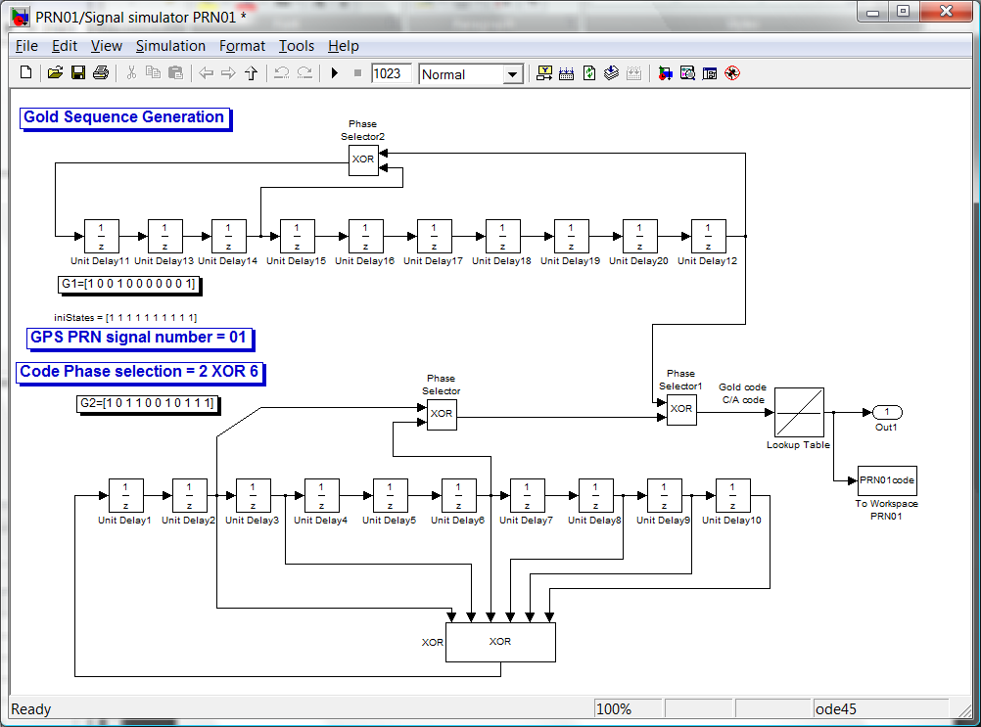

Figure 6-1: C/A code generator

In the C/A code generator, all unit delay blocks’ initial conditions have to be pre-defined once the model is opened. All the initial conditions are defined as ‘1’ at the Callbacks preload function.

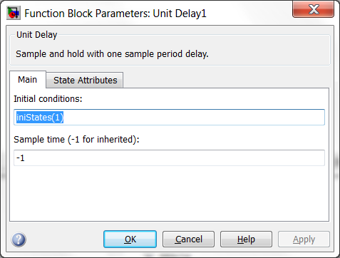

Figure 6-2 : Unit delay initial condition

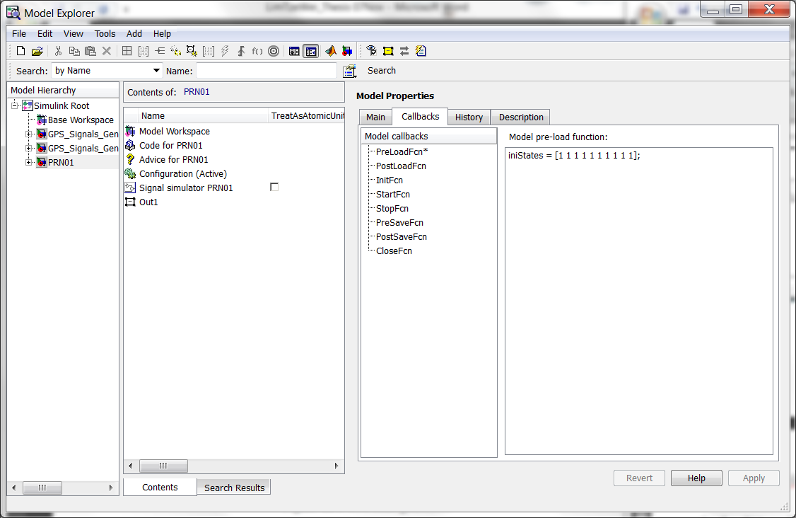

Figure 6-3 : Preload the initial states when the C/A code generator is executed

The C/A code generator for one PRN is being blocked under a sub system. By selecting the entire C/A code generator, a subsystem is created.

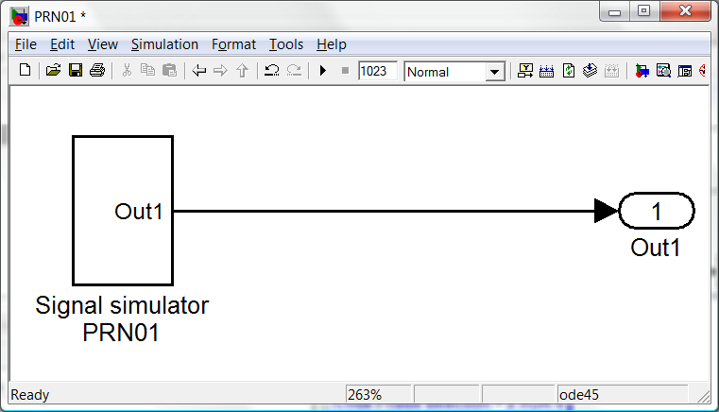

Figure 6-4 : PRN01 main system block of the C/A code generator

As the NRZ is more convenient in the simulation, the lookup table will convert the binary bit 0 to a NRZ bit -1.

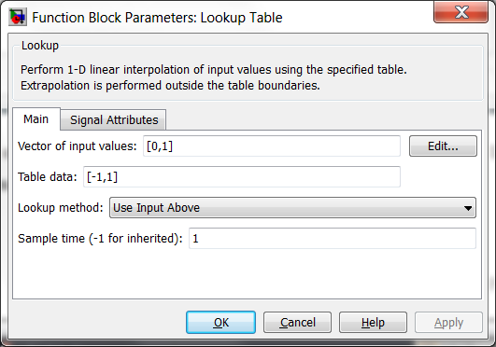

Figure 6-5 : Lookup Table input values

After converting the binary bits of the C/A code generator, the result is saved into a workspace. The data points are limited to 1023 to emulate one cycle. A variable name is assigned for each PRN signal number.

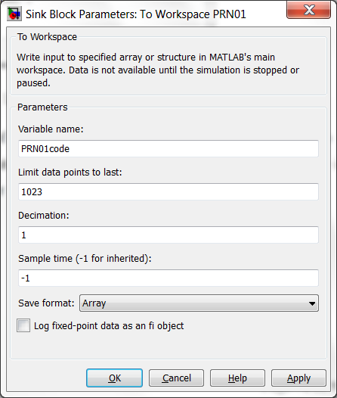

Figure 6-6 : To workspace is to store the C/A code PRN01 value

The C/A code consists of 1023 sequences which have binary value of 0 and 1. The figure below shows one period of the C/A code.

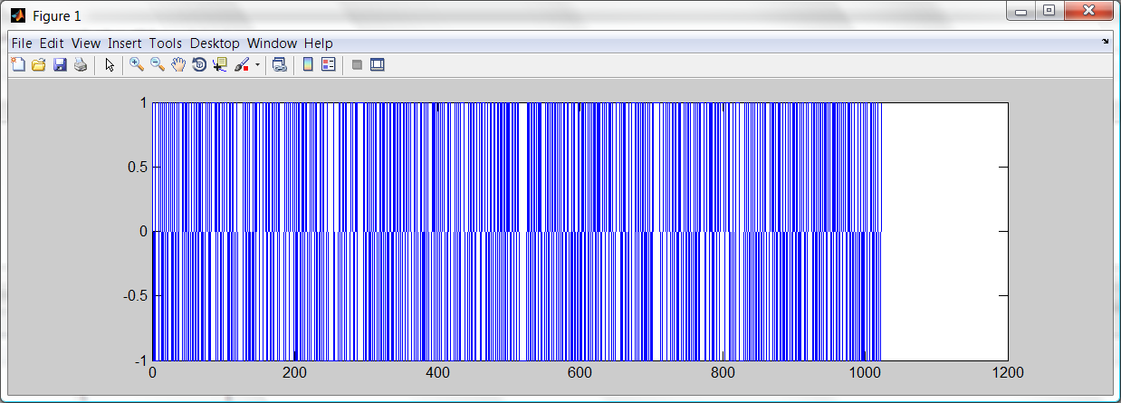

Figure 6-7 : 1023 sequence C/A code

There are 32 PRN signal numbers to be created in order to simulate the GPS satellites Gold codes. It applies the identical method of creating PRN#01 and duplicates the C/A code generator for the rest of the 31 PRN signal numbers. Refer to Appendix C for the model of all PRN signal simulator.

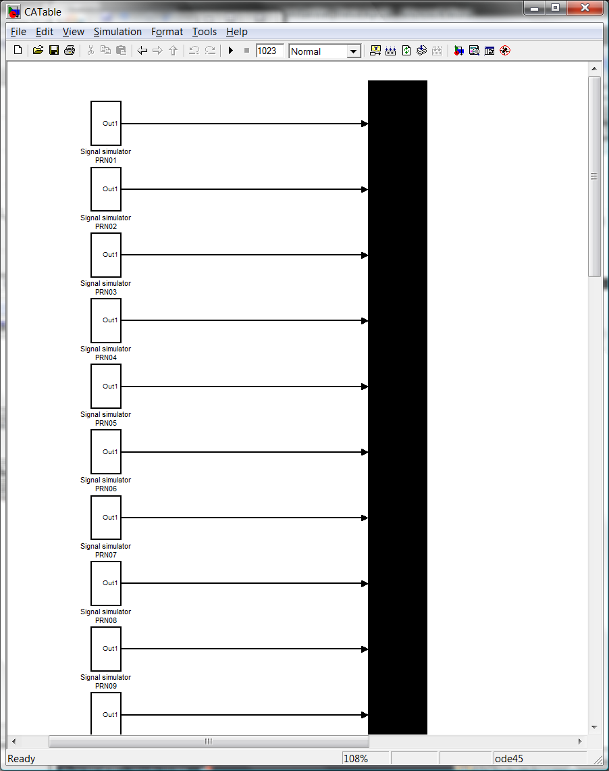

Figure 6-8 : Combining the PRN signal numbers with a bus creator

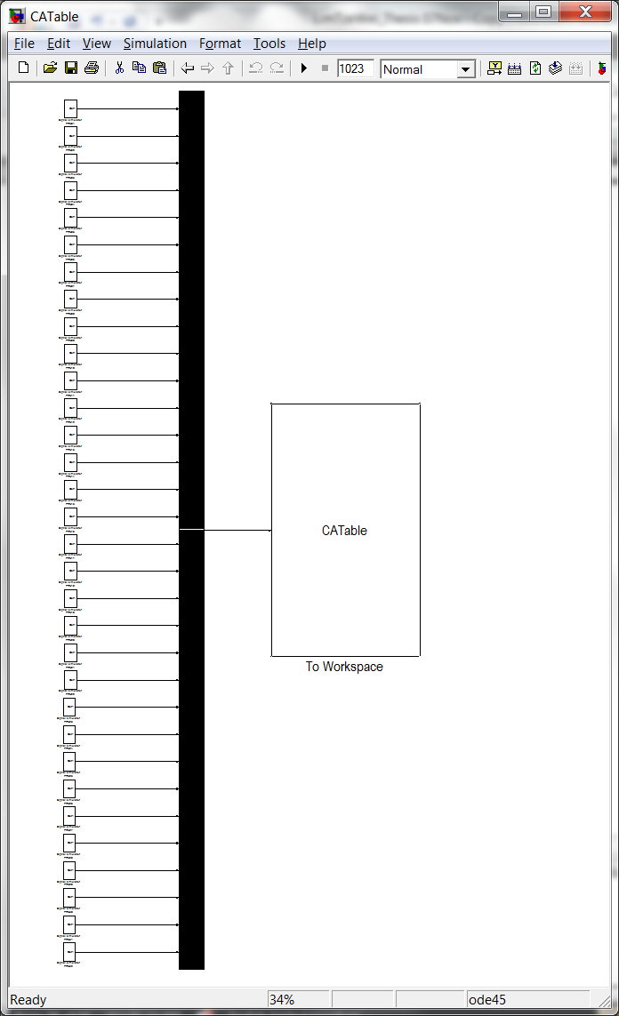

Figure 6-9 : 32 PRN signal numbers combined by a bus creator block to the Workspace for storage

The result of the 32 C/A codes is plotted below. All the values are stored into a lookup table which will be used for PRN selector during the transmitter signal generation. Refer to the Appendix C for the C/A codes values.

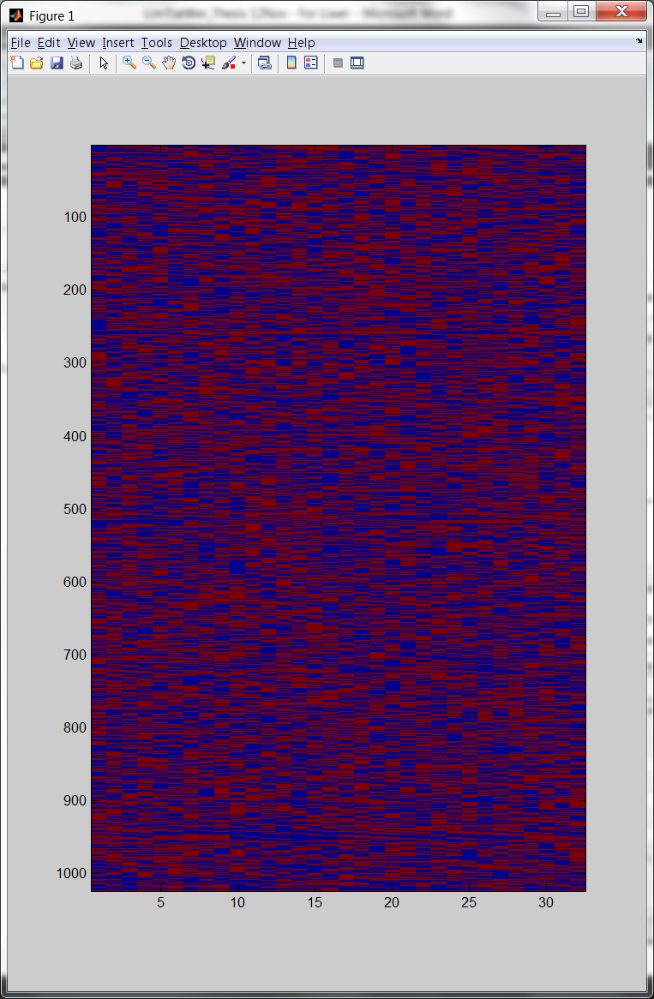

**PRN Signal number**

**Bits of C/A codes (1023)**

**Bit ‘1’**

**Bit ‘0’**

Figure 6-10 : The values of 32 PRN signal number C/A codes.

**Part 2 – Navigation Generation**

The navigation data is a set of pseudo random data generated by the PN sequence generator block. With the similar implementation of C/A code, it is also a NRZ representation and therefore a lookup table is used for bit conversion. The bit is converted and stored into the workspace.

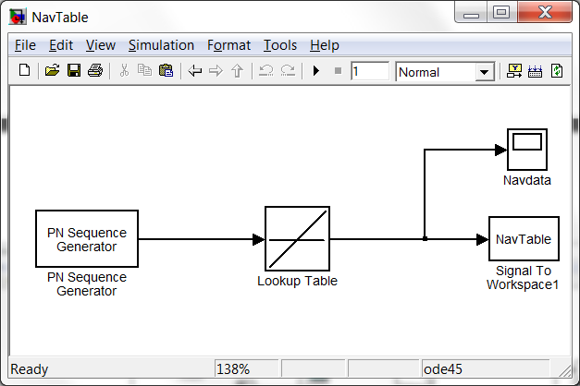

Figure 6-11 : Navigation data generator

The data points are limited to 1500 to emulate one cycle. A variable name “NavTable” is assigned for call up. The plot of navigation data is showed in Figure 6-12.

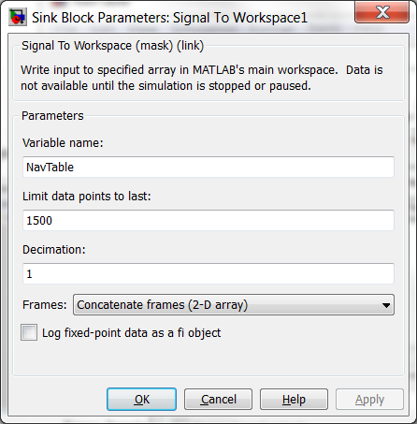

Figure 6-12 : To Workspace to store Navigation data

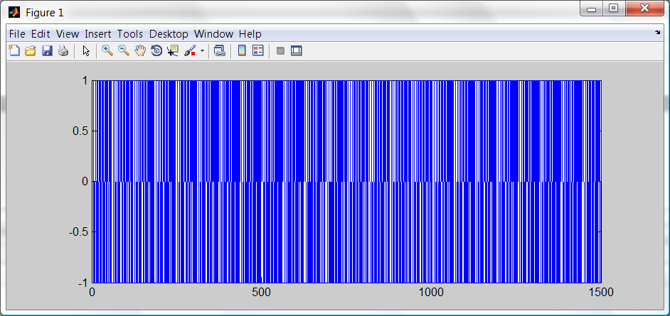

Figure 6-13 : Sample of Navigation data in one period, 1500 bits

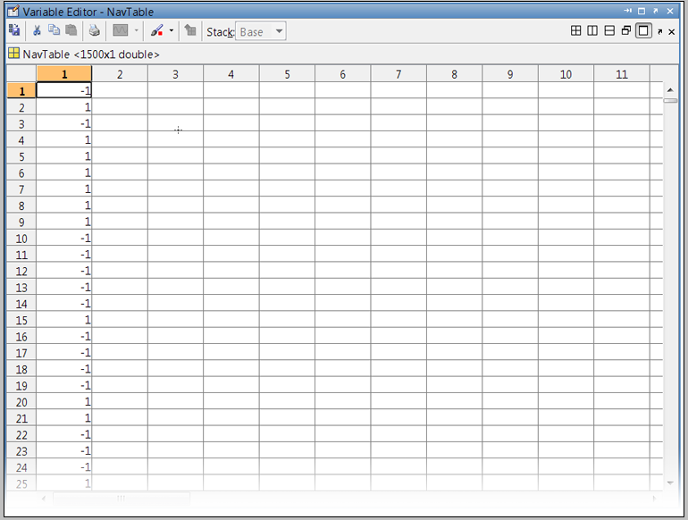The input of the PN sequence generator’s initial states is configured to [1 1 0 1 0 1] so that the navigation data can have some differentiation at the beginning few bits.

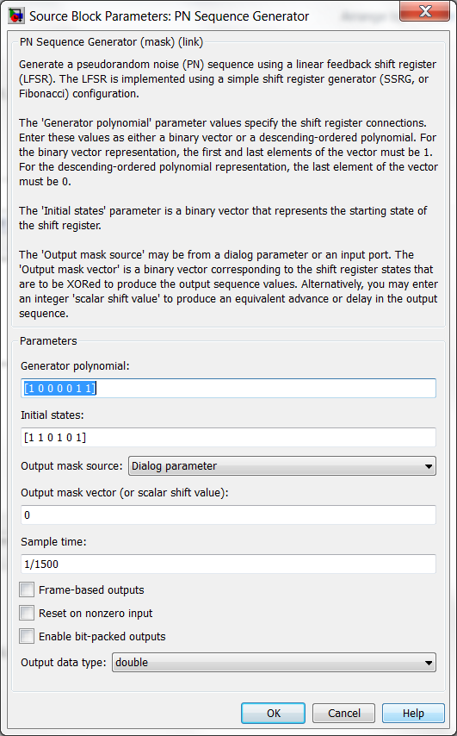

Figure 6-14 : PN Sequence generator for navigation data generation

Figure 6-15 : The first 25 bits of navigation data

## Result on C/A code generation for Transmitter

Once the pre initialization is done on the C/A code generation and navigation data generation, the two modules can be inserted into the transmitter model. The C/A code requires the clock of 1.023 MHz to trigger. One C/A period is a counter of 1023 before the counter resets the count again.

There is a user defined parameter if user likes to create a code phase shift change on the starting bit. The parameter name is “*code*” places at the C/A counter.

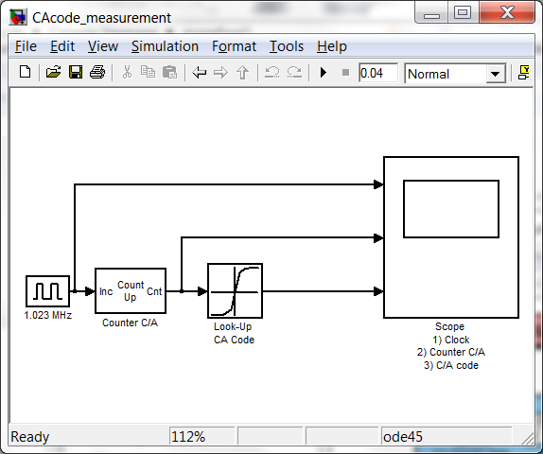

Figure 6-16 : Using scope to get the results of C/A codes

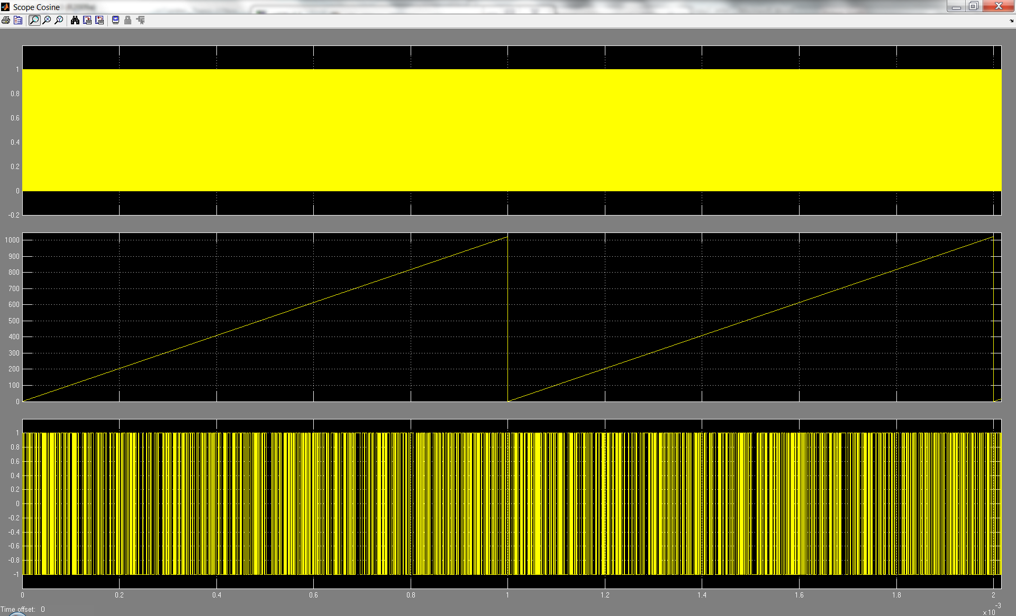

1 period

1 complete count

C/A code counter (1023)

C/A code period (1ms)

1.023 MHz clock

Figure 6-17 : C/A code counter

The look-up table points to one set of C/A code with each period.

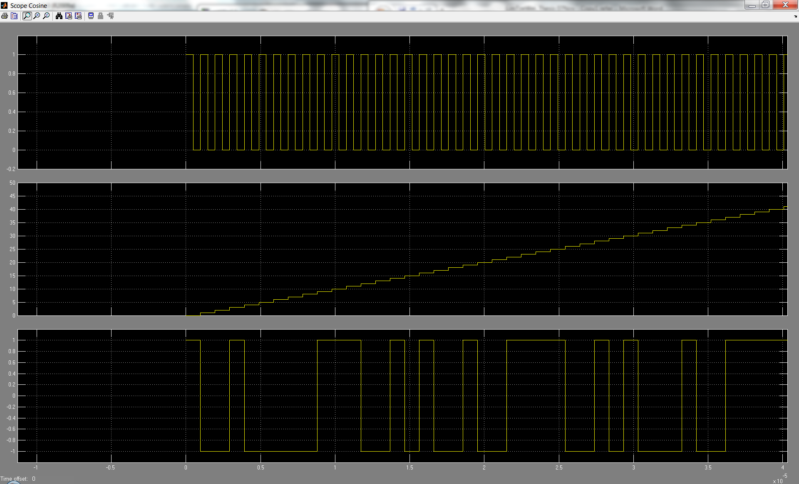

C/A code (1ms)

C/A code counter (1023)

1.023 MHz clock

Figure 6-18 : A zoom in on the C/A code counter

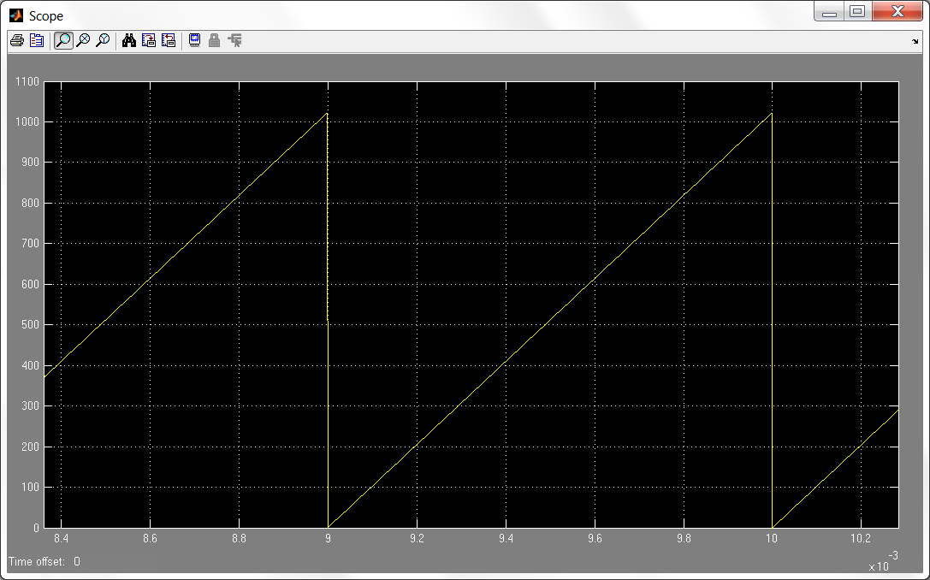

1 period

Figure 6-19 : C/A counter resets approximately every 1ms

The look-up table points to the last bit of the one cycle C/A code at 1022 counts. The look-up table will go back to first bit of C/A code after the counter resets. The cycle of the C/A code will continue to run until the simulation is stopped.

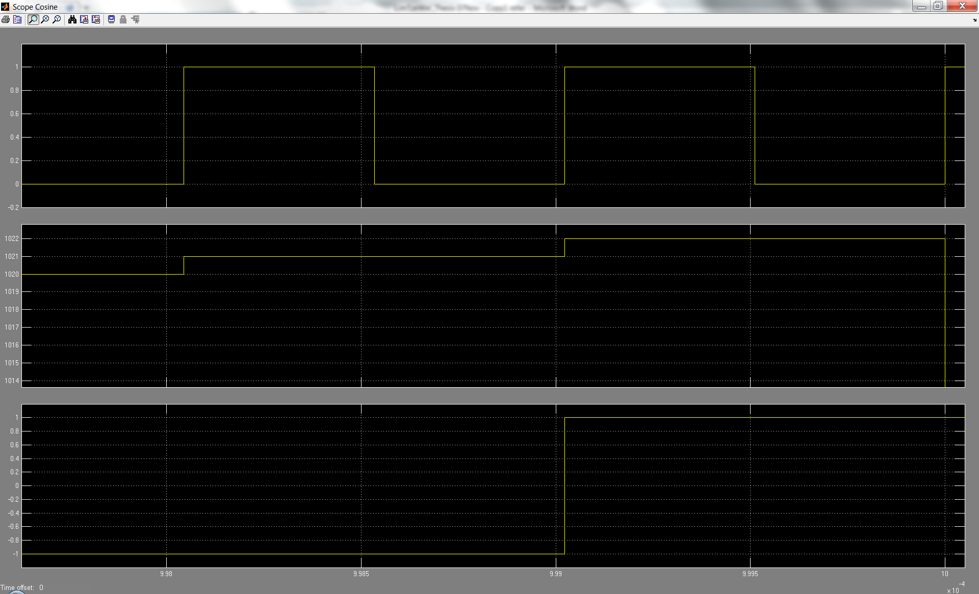

C/A code counter (1023)

C/A code (1ms)

1.023 MHz clock

Counter resets at 1022 counts

Last bit of PRN#01 C/A code

Figure 6-20 : Zoom in on the counter resets when it reaches 1022

The required C/A code for the transmitter is chosen at the upper level. When the transmitter selects the PRN signal number, the look-up table will point to the correct PRN C/A code. In order to perform this, a variable parameter (*prn*) is used at the Table data. The vector of input values has a range of 0 to 1022 which in total, there is 1023 vector to contain one set of C/A code.

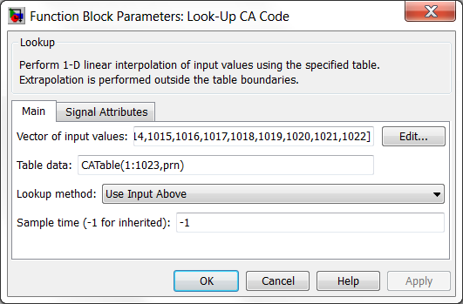

Figure 6-21 : Parameters in Look-Up for C/A code

The Figure 6-22 shows the Look-up Table block data when the transmitter points to the required PRN signal number.

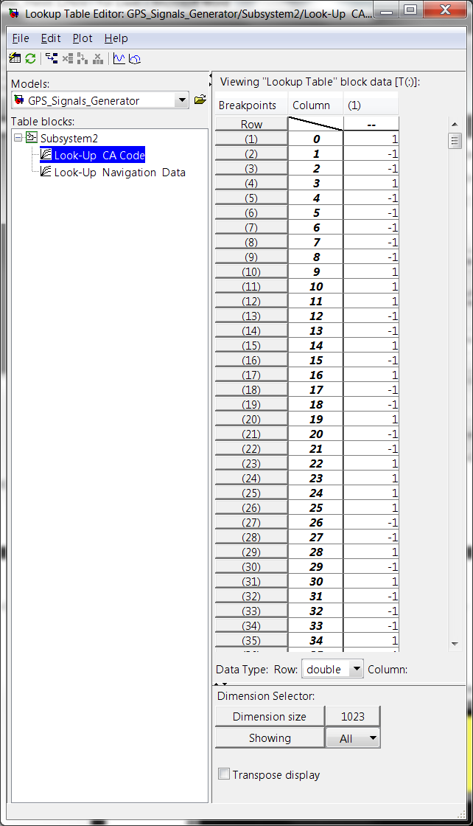

Figure 6-22 : Look-up Table for PRN#01

## Result on Navigation data generation for Transmitter

The navigation counter required the counter of C/A code to clock the navigation data. The first counter for navigation period is based on 20 before it resets, that is, every 20ms corresponding to 50 Hz. The second counter works in the same as the counter in C/A part. That is, it increases its output value with every falling edge of the input signal, and it resets at the end of a period. In this case, the period is set to be one navigation data frame corresponding to 1500 bits.

There is a user defined parameter if user likes to create a navigation phase change on the starting bit. The parameter name is “*seed*” places at the 2nd navigation message counter.

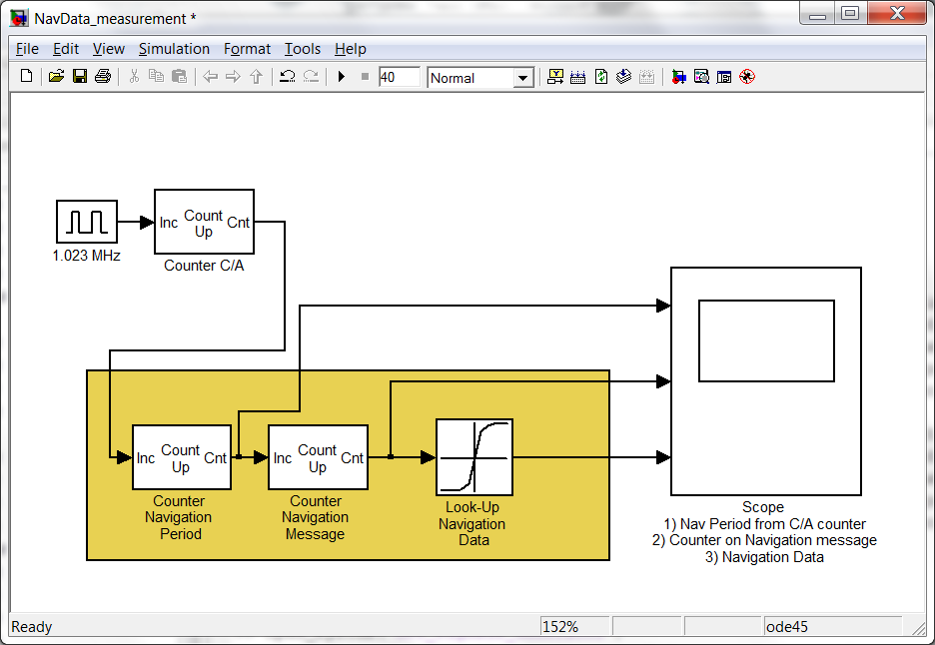

Figure 6-23 : Using scope to get the results of navigation data

The look-up table points to one set of navigation data with each period.

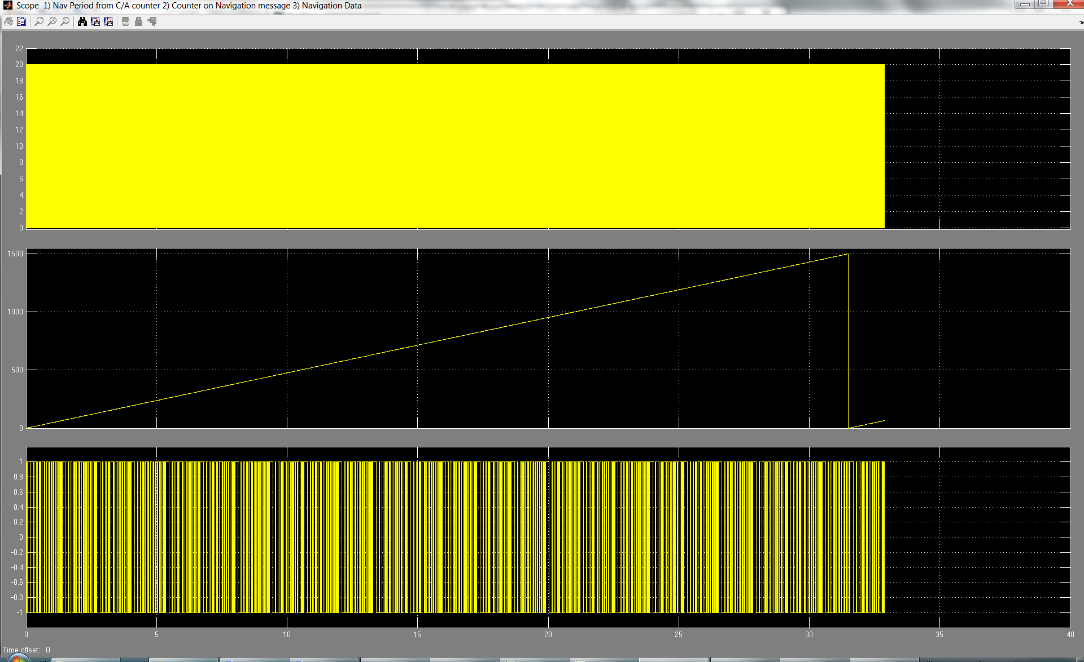

1 period

1 complete count

50 Hz clock

Navigation data (≈30sec)

Navigation message counter (1500 counts)

Navigation period counter (20 counts)

Figure 6-24 : Navigation counter

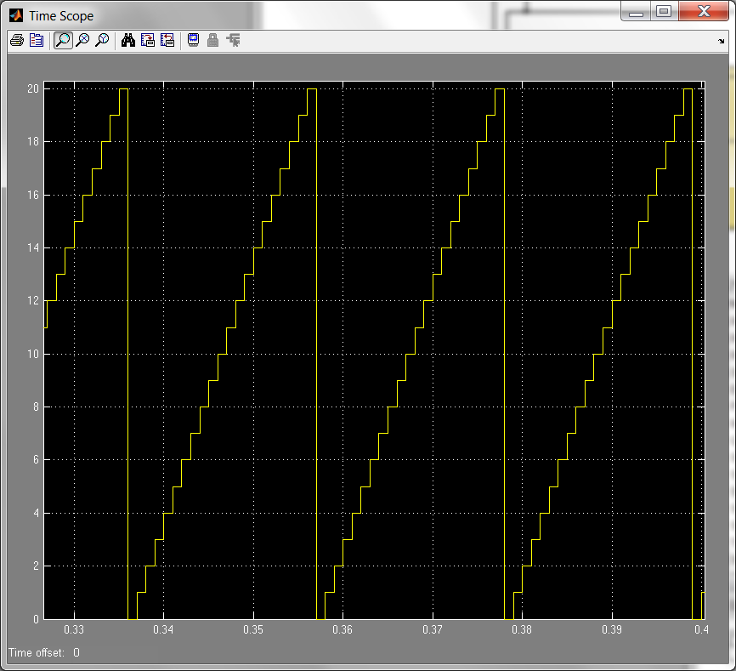

Figure 6-25 : A zoom in on the navigation period counter. It resets after 20 steps

The look-up table points to the last bit of the one cycle navigation data at 1499 counts. The look-up table will go back to first bit of navigation data after the counter resets. The cycle of the navigation data will continue to run until the simulation is stopped.

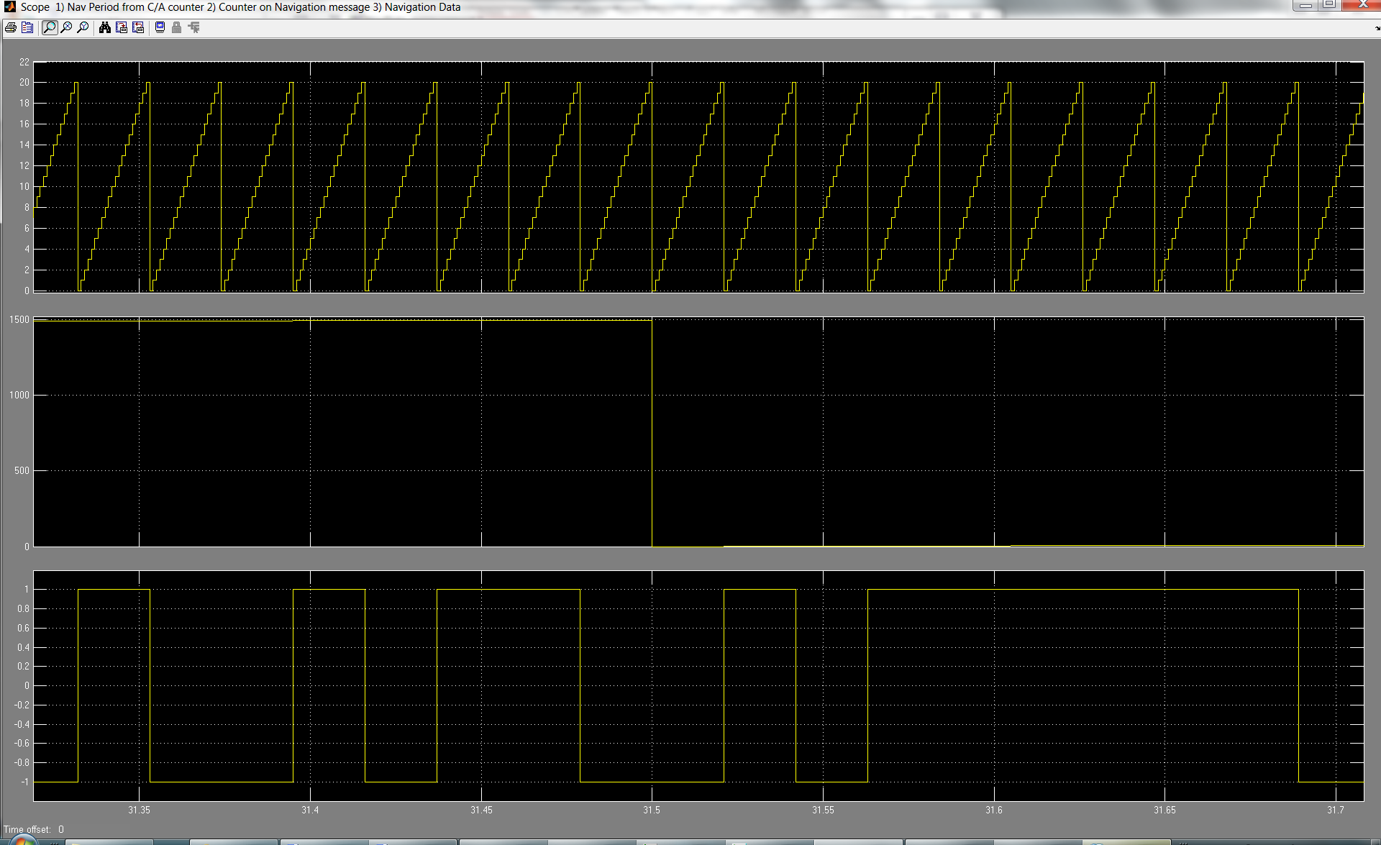

Last bit of Navigation data

Navigation data (≈30sec)

Navigation period counter (20 counts)

Navigation message counter (1500 counts)

Counter resets at 1500 counts

Counter resets at 20 counts

Figure 6-26 : A zoom in on the Navigation counter

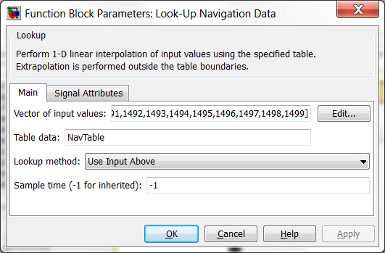

Figure 6-27 : Parameters in Look-Up for Navigation data

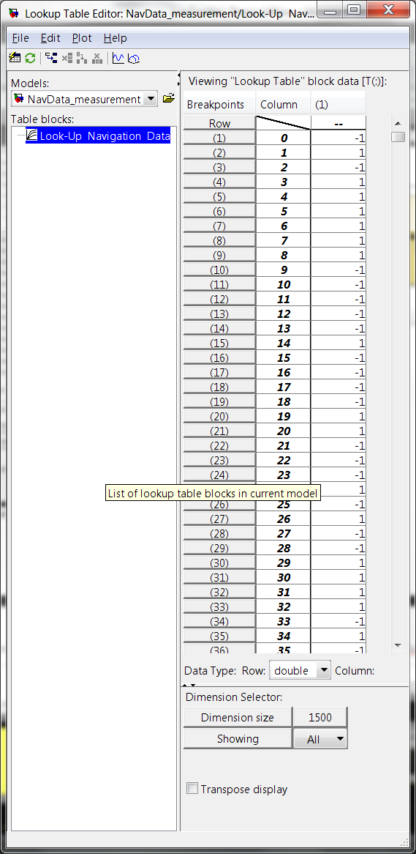

Figure 6-28 : Look-up Table for Navigation data

The Figure 6-29 and Table 6-14 is used to verify the correct look-up table output.

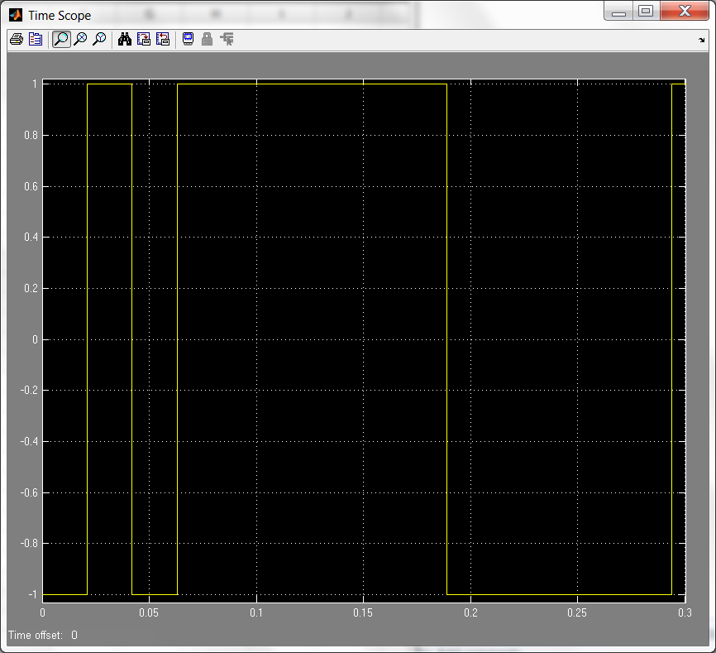

Figure 6-29 : The navigation data from 0 to 0.3 sec

|  |  |
| --- | --- |
| **No** | **Bit** |
| 1 | -1 |
| 2 | 1 |
| 3 | -1 |
| 4 | 1 |
| 5 | 1 |
| 6 | 1 |
| 7 | 1 |
| 8 | 1 |
| 9 | 1 |
| 10 | -1 |
| 11 | -1 |
| 12 | -1 |
| 13 | -1 |
| 14 | -1 |
| 15 | 1 |

Table 6-14 : Navigation data of first fifteen bits.

## Result on P(Y) code generation for Transmitter

The P(Y) code in the transmitter is not relevant to the acquisition and tracking algorithms and thus, it only requires to simulate as a square pulse alternating between 1 and -1.

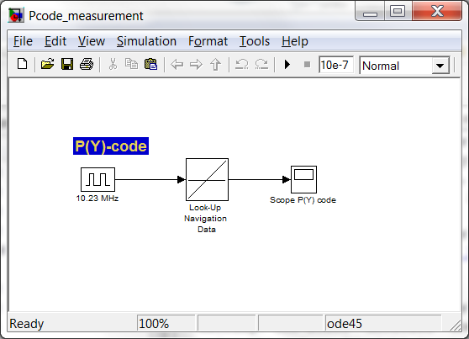

Figure 6-30 : Using scope to get the results of P(Y) code

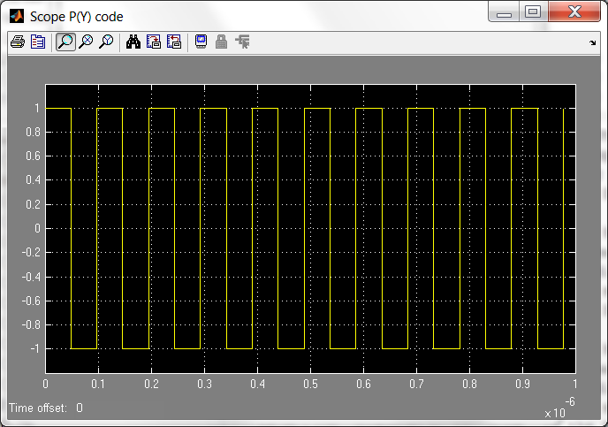

Figure 6-31 : P(Y) code at 10.23 MHz

## Result on carrier generation for Transmitter

The carrier generation is using a Discrete Time VCO with the ramp input. The ramp input requires being in discrete format and therefore a zero-order hold is placed before the VCO. The VCO quiescent frequency is using the IF 9.548 MHz.

On the C/A code generating portion, there is a phase shift of 90° compared to the other VCO for P code. The 90° phase shift VCO generates a cosine wave. The Doppler shift is set as a variable parameter which can be defined by user. It is defined by the parameter name ‘*doppler*’

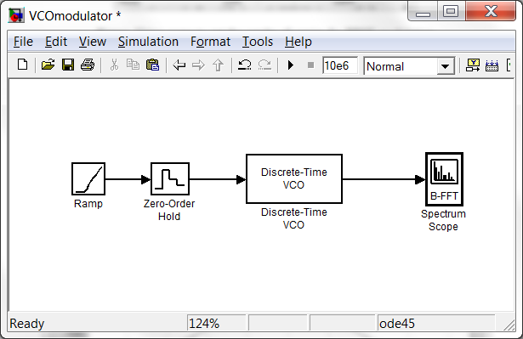

Figure 6-32 : Using scope to get the results of carrier for BPSK modulation

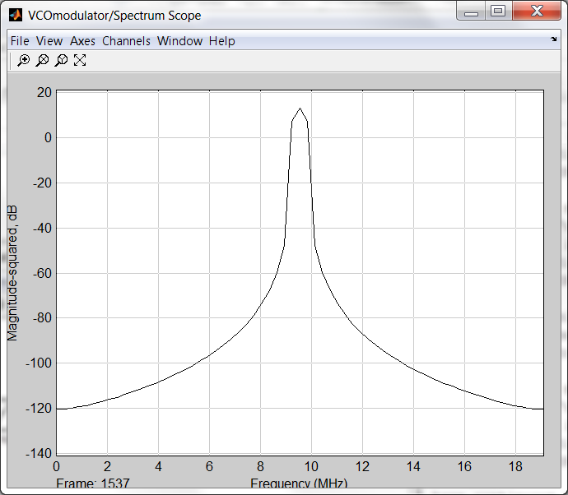

Figure 6-33 : Carrier wave at 9.548 MHz

## Integrating the components for Transmitter

All the components are integrated to create the model for transmitter. The components are showed in Figure 6-34.

* C/A code
* Navigation data
* P(Y) code
* Carrier
* Noise channel

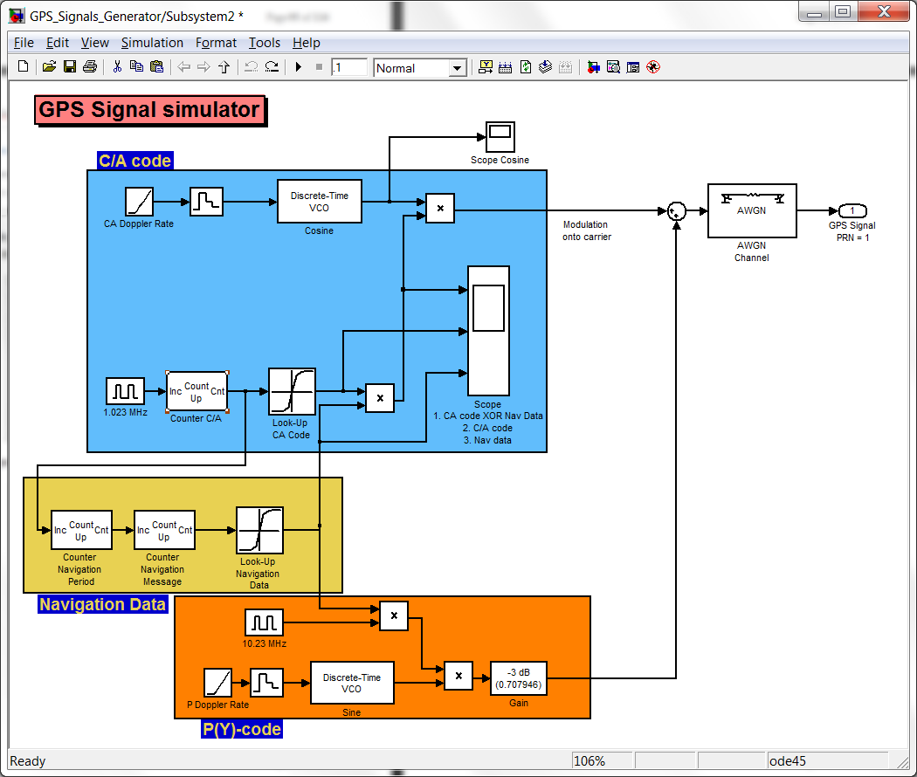

Figure 6-34 : Transmitter model after the integration

The components are then created into a sub system for easy managed which the Figure 6-35 shows the transmitter system.

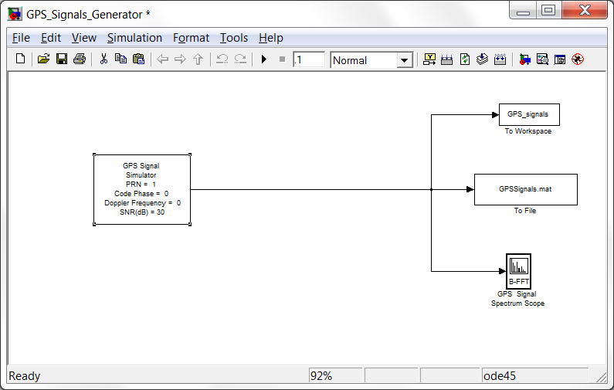

Figure 6-35 : GPS signal simulator for generating PNR #01

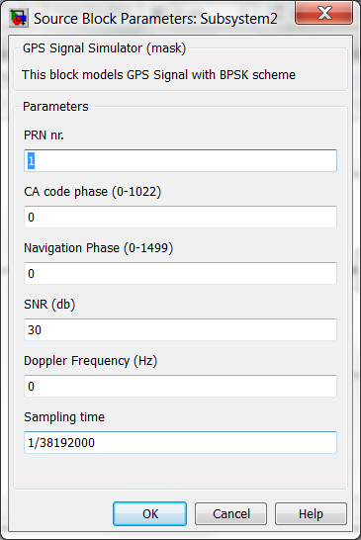In this GPS transmitter model, there are some parameters that can be defined by user. They are:

* PRN signal number (Range from 1 to 32)
* C/A code phase (Range from 0 to 1022)
* Navigation Phase (Range from 0 to 1499)
* SNR dB
* Doppler Frequency Hz
* Sampling time (1/38192000)

Figure 6-36 : Parameter setting for transmitter

## System Testings and Results

The combined of C/A code and navigation data is multiplied onto the carrier. The combined P(Y) code and navigation is added into the carrier.

The Figure shows the signal of the transmitter. At a higher SNR, the signal is more distinct from the noise.

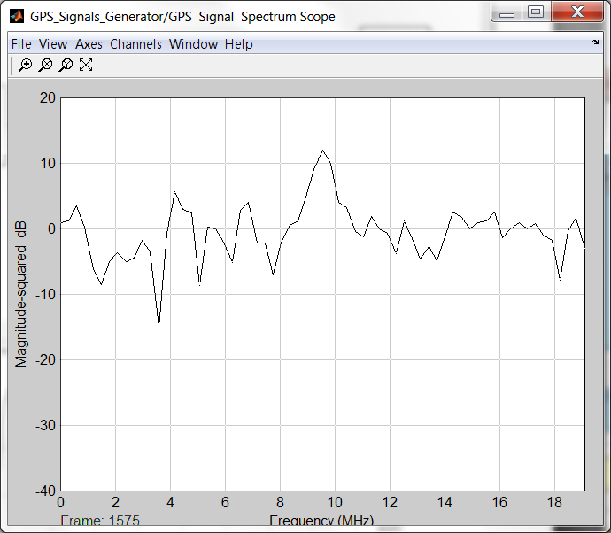

Figure 6-37 : Transmitter Signal modulated at IF = 9.548 MHz at SNR = 0dB 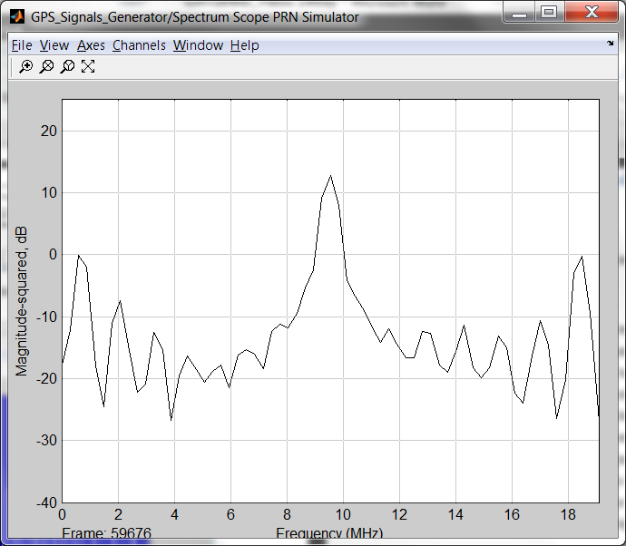

Figure 6-38 : Transmitter Signal modulated at IF = 9.548 MHz at SNR = 30dB

C/A code is multiplied to the navigation data to form the transmitter signal. The Figure 6-39 shows the transmitter’s signal has a change in amplitude when C/A code and navigation of different amplitudes are multiplied.

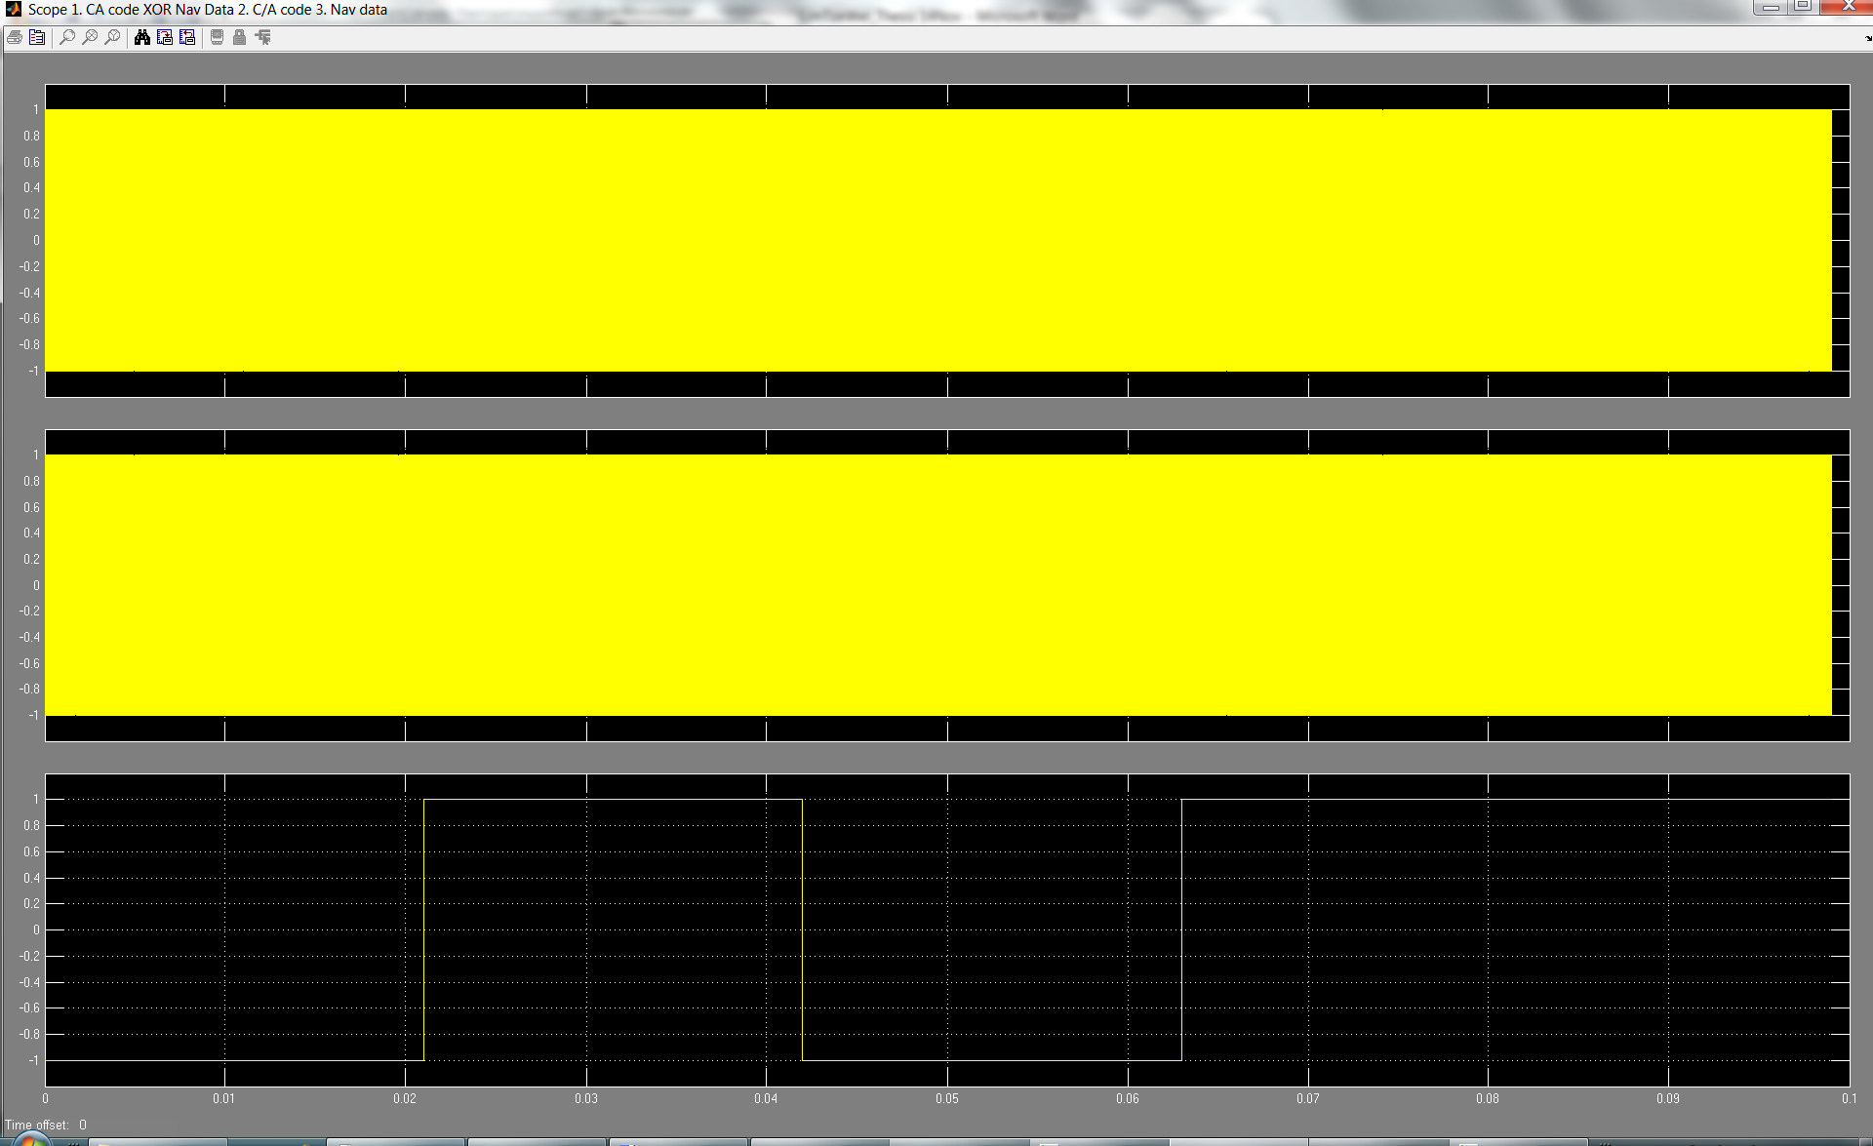

C/A code multiplied with Navigation data

C/A code for PRN#01

Navigation data

Figure 6-39 : Transmitter’s signal of first 5 bits of Navigation data.

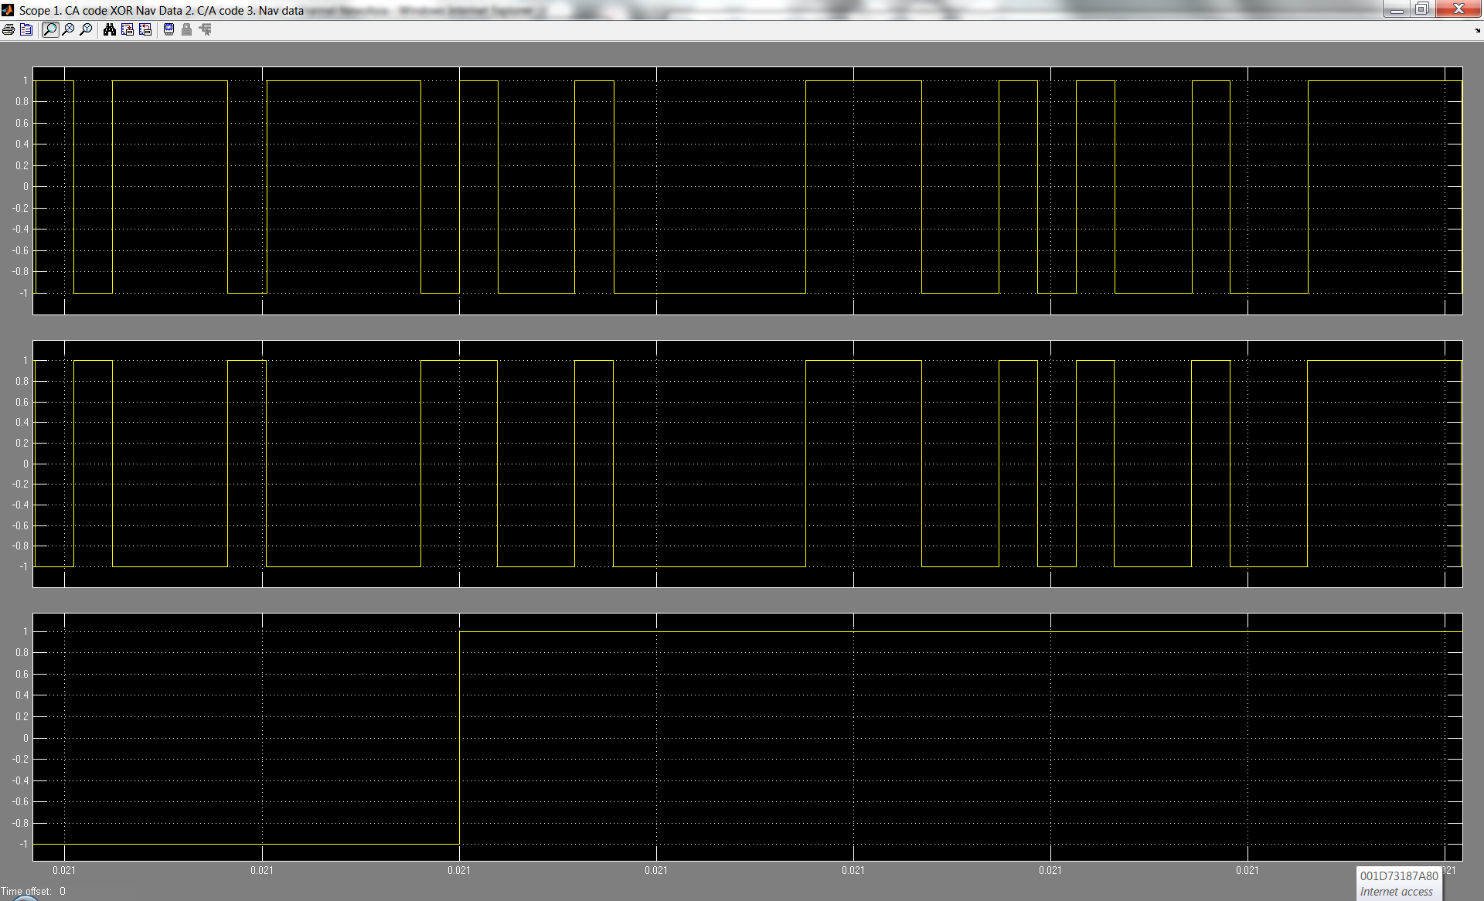

C/A code multiplied with Navigation data

C/A code for PRN#01

Navigation data

1

1

1 x 1 = 1

1

0

0

0 x 1 = 0

Figure 6-40 : A zoom in on the transmitter’s signal during the transition of 1st bit and 2nd bit of navigation data.

The figure below shows the transmitter’s signal changes in amplitude when the navigation data goes from 1 to 0.

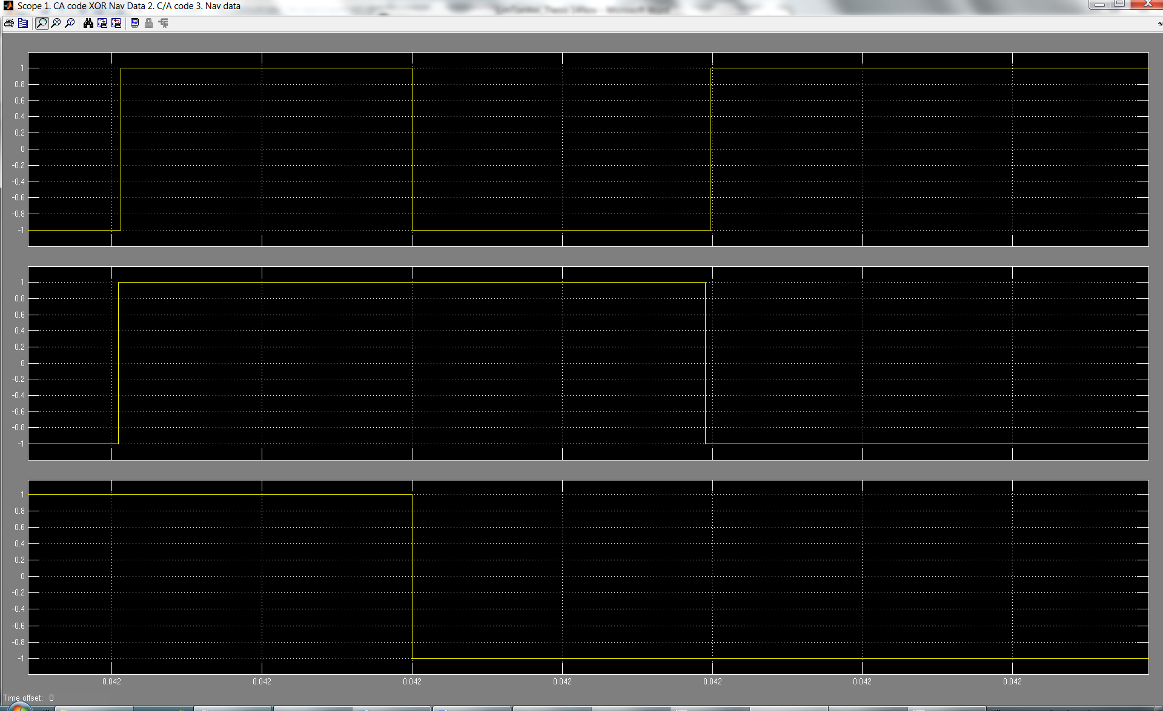

C/A code multiplied with Navigation data

C/A code for PRN#01

Navigation data

0

0

1

1

1

1 x 1 = 1

0 x 1 = 0

Figure 6-41 : GPS A zoom in on the transmitter’s signal during the transition of 2nd bit and 3rd bit of navigation data.

When the code phase is changed between 0 to 1022, the C/A code cycle will start at defined value. The Figure 6-42 shows the C/A code started at 51 when time is zero.

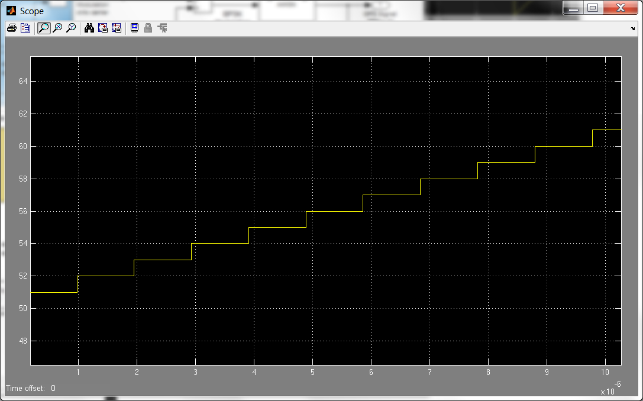

Code phase = 51

Figure 6-42 : C/A code started at code phase = 51

# CHAPTER SEVEN

## SIMULINK MODEL DEVELOPMENT FOR GPS RECEIVER

## GPS Receiver in SIMULINK model implementation

There are two parts in implementing the receiver models based on the system consideration in chapter 5. The two parts are

### Parallel code phase search acquisition

In this acquisition, it requires 2 local generated conditions for correlation with the incoming signal. The first condition is to create a local generated PRN code. This PRN generator is duplicated directly from the transmitter model.

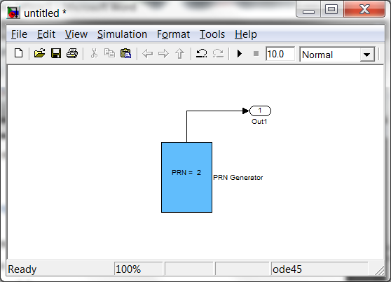

Figure 7-1 : Local PRN code generator

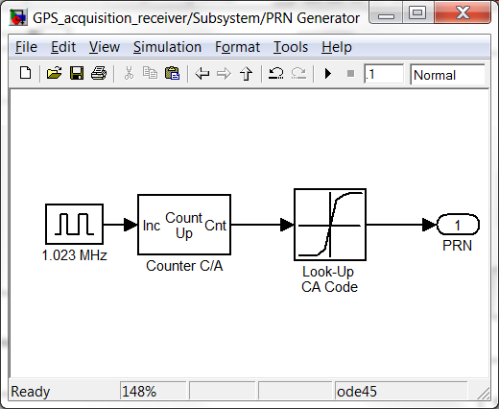

Figure 7-2 : Subsystem of PRN code generator

The second condition is to create local oscillator carrier signal which is a replica from the transmitter.

A user defined function called *S-Function* is used to perform the generating of local oscillation carrier. A level 2 S-Functions allow to create blocks with many of the features and capabilities of SIMULINK built-in blocks. The S-Function supports various signal attributes, the ability to accept vector or matrix signals.

The equation for generating carrier is



where $φ$ is 2πfc and *a(t)* is the amplitude.

A template of S-Function can be found in MATLAB M-file which can be used to setup the ports and parameters declaration. The function M-file for *oscillator_sfunc* can be referred to Appendix B3. The computation equation is taken out from this M-file.

function Outputs(block)

ts = block.RuntimePrm(1).Data;

load acq_data

block.OutputPort(1).Data = sin((0:38191)' * 2 * pi * ts*IFval);

block.OutputPort(2).Data = cos((0:38191)' * 2 * pi * ts*IFval);

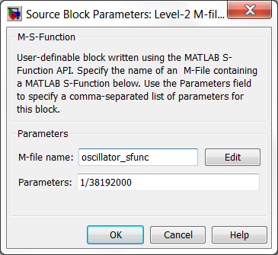

Figure 7-3 : Level-2 S-Function M-file for carrier generation.

The incoming signal from transmitter model is imported into the acquisition for identifying the right PRN signal number. Level-2 S-function is used to load the signal. The M-file of *insignal_sfunc* is at Appendix B2. The code below shows the loading of transmitter signal saved in ‘.mat’ file.

function Outputs(block)

load GPSSignals.mat;

idx = block.Dwork(1).Data;

idx = idx + 1;

X = signals(2,(idx-1)*38192+1:idx*38192)';

block.OutputPort(1).Data = X;

block.Dwork(1).Data = idx;

%endfunction

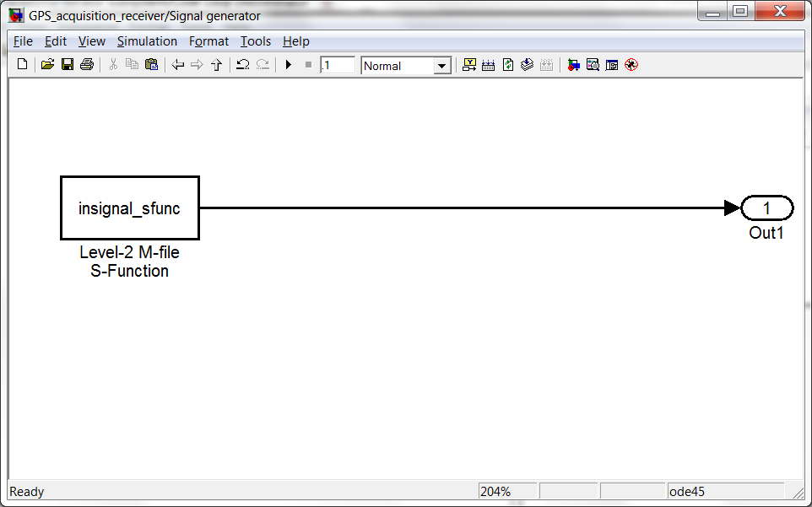

Figure 7-4 : insignal_sfunc for incoming signal

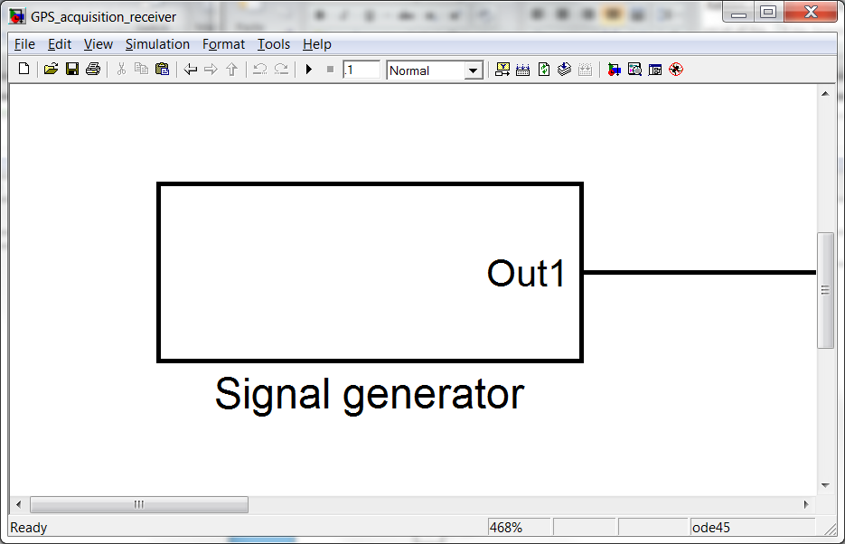

Figure 7-5 : System for insignal_sfunc

The *I* and *Q* signals are combined to form a complex input signal *x(n)* = *I (n)* + *j Q(n)* to the DFT function. The Fast Fourier transform (FFT) is used in the computation of the *I* and *Q* signals.



Figure 7-6 : Fast Fourier transform (FFT) at the *I* and *Q* signals

The FFT is performed by built in function of Level-2 S-function. The *fft_sfunc.m* for FFT function is found at Appendix B6.

function OutputFrame(block)

% Output method for the frame-based signals.

% Get the input data and allocate space for the output signal.

block.OutputPort(1).Data = fft(block.InputPort(1).Data + 1j* block.InputPort(2).Data);

At the PRN code generator, the C/A code without code phase is Fourier transmform and the result is complex conjugate. After the complex conjugate, the result is multiplied with the discrete *I* and *Q* signals. Then after, the output from the multiplication is used for inverse Fourier transform implemented as the built-in function IFFT in MATLAB. This function has the properties similar to the FFT function regarding execution time. The code for *ifft_sfunc.m* can be found at Appendix B7.

The output from the IFFT is squared to obtain absolute value. The function at the *acquire2_sfunc* signal is computing the peak of the value to be plotted onto the graph.

With the *acquire2_sfunc* S-function, there is a function to compare the value so that the highest peak can be recorded. There is a loop to execute the routine until the comparisons reach the end. A detail explanation of the comparison can be referred to Appendix B8

The *acquire2_sfunc* will provide the result of the carrier fequency and code phase chips at the display.

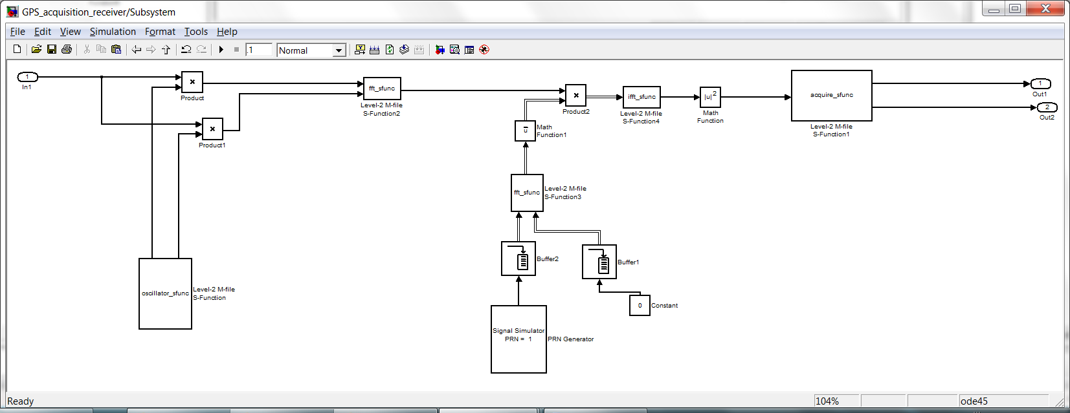

Figure 7-7 : The parallel code phase search acquisition model

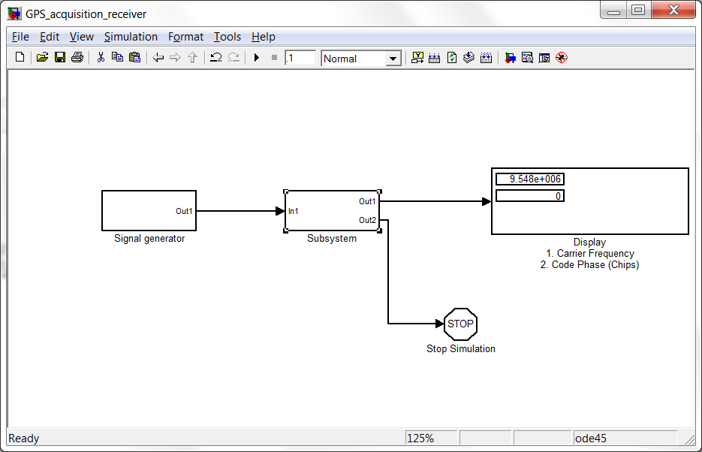

Figure 7-8 : The display of parallel code phase search result

## Modeling Testing and Results

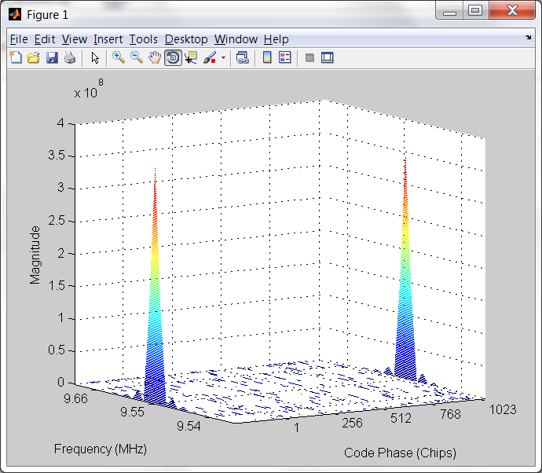

Figure 7-9 : The peak is visible for PRN 01 when the code phase = 0

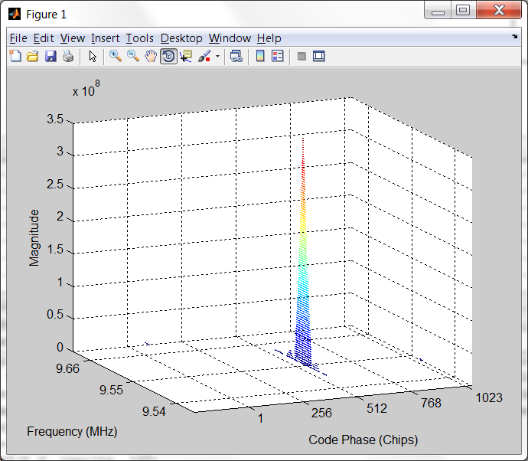

Figure 7-10 : The peak is visible for PRN 01 when the code phase = 511

## Carrier tracking implementation

## 

Figure 7-11 : Carrier tracking model

## 

Figure 7-12 : Result after carrier is removed

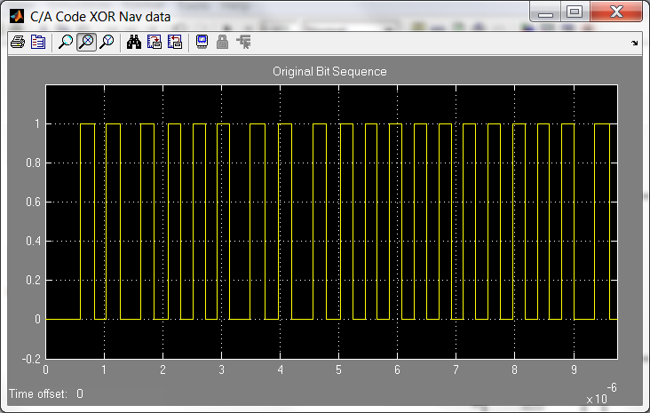

Figure 7-13 : Zoom in on the result after carrier is removed

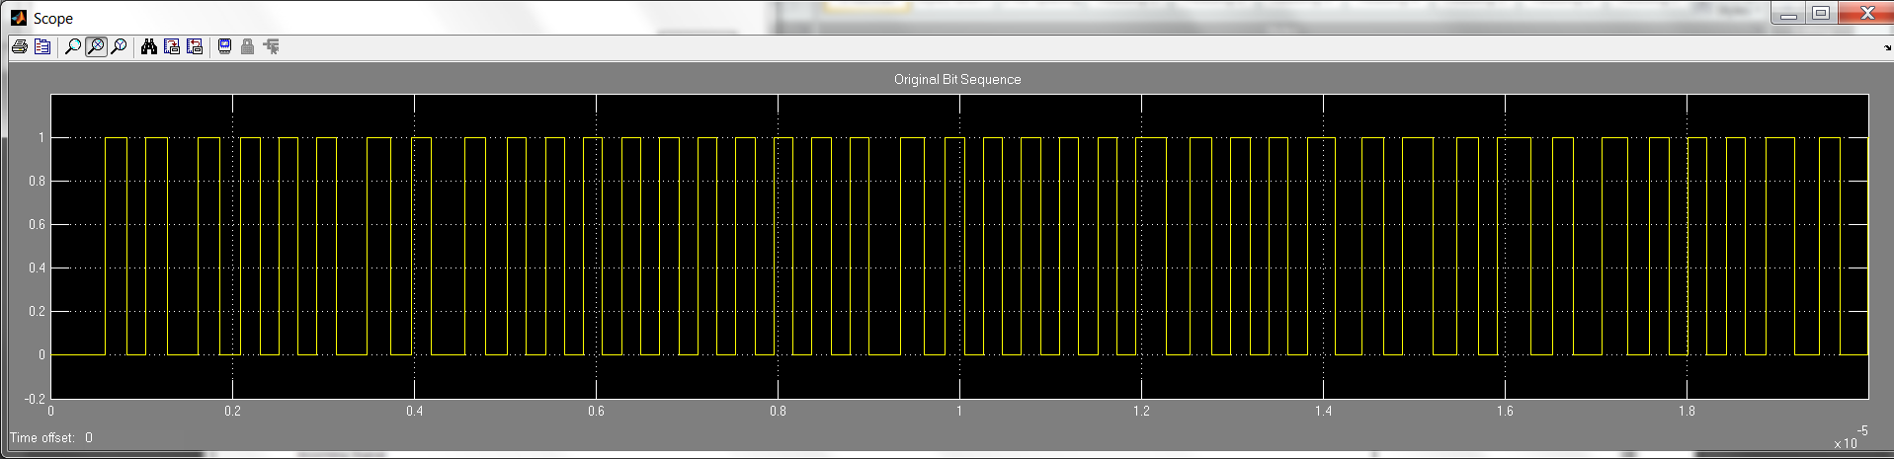

Figure 7-14 : Carrier removed at *I* signal

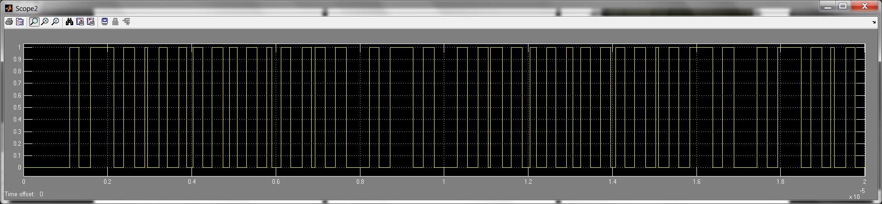

Figure 7-15 : Carrier removed at *Q* signal

# CHAPTER EIGHT

## PROBLEMS AND DISCUSSIONS

## Accuracy of GPS data

There are many types of error which could have happened during the wideband transmission. The important messages are transmitted together with the carrier. At certain times when the signal is not strong enough, the visibility of the result is not obvious. The issue can be elevated by amplifying the signal, however the signal to noise ratio could also be amplified.

## Compatibility Considerations

If you have implemented any S-functions in C, Ada, or Fortran or have models that reference other models, you should recreate any mexopts.bat files (other than the one in your MATLAB preferences directory) that you use to build S-functions and model reference simulation targets else it will have compilation error. There is also a chance of compatibility in the MATLAB software version. For instance, the I/O port interface might be lacking on the older version which resulted to have simulation error on the solver or compiler.

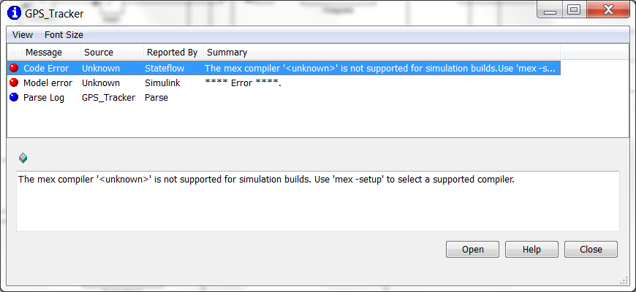

Figure 8-1 : The compiler does not support on certain block in SIMULINK

## Many types of data

There are some confusion when handling data type e.g. int16, int32, double, Boolean and etc. The type of data has to be given the right type in SIMULINK model building. There were many occasions whereas error occurred during the simulation.

## Correct usage of Sampling time

Usually majority of the SIMULINK block will require the input of sample time. When comes to calculate the sample time for the block, it is necessary to have the right answer for the sampling time. Otherwise the results might not be able to plot the correct graph.

This sampling time is also important in the synchronising of the

# CHAPTER NINE

## CONCLUSIONS AND RECOMMENDATIONS

## Conclusions

This capstone is indeed very interesting topic to touch on. The study of the GPS topology and the background has been an eye opening. The technology of wireless communication is such a wonder to discover and realize. The scope of this project is so vast that there is plenty of space to select the methods for implementation

In this report, the focus is on achieving a working GPS receiver model which allows the functions of acquire, demodulate GPS signals. The models are modular and independent by themselves. The models can also be copy onto the relevant module to achieve the results.

Because of the GPS topic has

There are many taste of failures during the whole period of the capstone. The problems encountered always look very challenging and unoptimistic to tackle. Nonetheless, putting in your best effort will definitely show results, seeking the right guidance and advice will enable us to move a little bit further.

The

## Recommendations and Future Work

There is certainly more rooms for further enhancement in this project.

* Improve on the speed of processing the SIMULINK model
* Create the code tracking model to decode the C/A code from the signal.
* Implement pseudo range calculation.
* Increase more channel receivers to process the search and tracking faster.

# CHAPTER TEN

## CRITICAL REVIEWS AND REFLECTIONS

Taking capstone for 3 semesters is quite a long time. Because of high commitment and some health issues, I tried very hard to pull through. This GPS topic is heavy and required a lot of effort to run simulation and debug.

Now I have learnt to better manage time between school work and other commitment. I know that I am a much organised person in coping with stress. This project really taught me a lot.

# REFERENCES

[1] Wikipedia (2010), ‘History of navigation’

<http://en.wikipedia.org/wiki/History_of_navigation>

[2] About.com:Inventors by Mary Bellis, ‘Hisotry of the Compass – The Compass and other Magnetic Innovations’

<http://inventors.about.com/od/cstartinventions/a/Compass.htm>

[3] Wikipedia (2010), ‘Sextant’

<http://en.wikipedia.org/wiki/Sextant>

[4] Wikipedia (2010), ‘GLONASS’

<http://en.wikipedia.org/wiki/GLONASS>

[5] Wikipedia (2010), ‘Beidou navigation system’

<http://en.wikipedia.org/wiki/Beidou_navigation_system>

[6] Wikipedia (2010), ‘Global Positioning System’

<http://en.wikipedia.org/wiki/Global_Positioning_System>

[7] Peter H. Dana, Department of Geography, University of Texas (1994), ‘Global Positioning System Overiew’

<http://www.colorado.edu/geography/gcraft/notes/gps/gps.html>

[8] GPS Primer (2007), ‘GPS Element’

<http://www.aero.org/education/primers/gps/elements.html>

[9] Peter H. Dana, Department of Geography, University of Texas (1994), ‘Global Positioning System Overiew’

<http://www.colorado.edu/geography/gcraft/notes/gps/gif/orbits.gif>

[10] The global positioning system and inertial navigation by Jay Farrell, Matthew Berth, (2005), ‘Chapter 5’

[11] Topic Briefs (2006), ‘How GPS Works’

http://www.how-gps-works.com/

[12] GPS Prime (2007), ‘How GPS Works’

<http://www.aero.org/education/primers/gps/howgpsworks.html>

[13] Trimble Navagation Limited (1999), ‘How GPS works, Triangulating’

<http://www.trimble.com/gps/howgps-triangulating.shtml>

[14] RoseIndia (2008), ‘What is Trilateration?’

http://www.roseindia.net/technology/gps/what-is-trilateration.shtml

[15] RMIT Research Repository (2006), Zhang J, Zhang K, Grenfell R, Deakin R, ‘On the Relativistic Doppler Effect for Precise Velocity Determination using GPS’

<http://researchbank.rmit.edu.au/eserv/rmit:138/n2006000316.pdf>

[16] Windows to the Universe (2010), Becca Hatheway, ‘The Doppler Effect’

<http://www.windows.ucar.edu/tour/link=/earth/Atmosphere/tornado/doppler_effect.html>

|  |
| --- |
| [17] SATCOM online (2002), Satellite School/Satellite Orbits  <http://www.satcom.co.uk/article.asp?article=11> |

[18] Andrews Space && Technology (2001), NAVSTAR GPS - summary

http://www.spaceandtech.com/spacedata/constellations/navstar-gps_consum.shtml

[19] The Global Navigation satellite system GLONASS : Development and usage in the 21st century (2002)

http:tycho.usno.navy.mil/ptti/ptti2002/paper13.pdf

[20] Andrews Space && Technology (2001), ‘GLONASS – summary’

http://www.spaceandtech.com/spacedata/constellations/glonass_consum.shtml

[21] European Space Agency (2005), ‘First Galileo satellite on orbit to demonstrate key technologies’

http://www.esa.int/esaCP/SEMSRO8A9HE_index_0.html

[22] European Space Agency ESA News (2005)

http://www.esa.int/images/Galileo_GSTB-V2A_08185_M,0.jpg

[23] Wikipedia (2010), ‘Global navigation satellite system

http://en.wikipedia.org/wiki/Galileo_(satellite_navigation)

[24] Encyclopaedia Britannica (1999),

<http://www.britannica.com/EBchecked/topic-art/585825/3697/Commercially-exploited-bands-of-the-radio-frequency-spectrum>

[25] FUNDAMENTALS OF GPS by P.L.N Raju

http://www.wamis.org/agm/pubs/agm8/Paper-7.pdf

[26] Kowoma.de (2009), ‘The GPS System, Composition of the Data Signal’

http://www.kowoma.de/en/gps/data_composition.htm

[27] Wikipedia (2010), ‘GPS signals’

http://en.wikipedia.org/wiki/GPS_signals

[28] Wikipedia (2010), ‘Software-defined radio

<http://en.wikipedia.org/wiki/Software-defined_radio>

[29] SOFTWARE-BASED GPS RECEIVER A RESEARCH AND SIMULATION TOOL FOR GLOBAL NAVIGATION SATELLITE SYSTEM Dinesh MANANDHAR, Ryosuke SHIBASAKI Center for Spatial Information Science, The University of Tokyo

[30] The Design and Implementation of a GPS Receiver Channel by Dick Benson, The MATHWORKS INC

<http://www.dsp-fpga.com/articles/id/?79>

[31] UMTSWorld (2003), ‘CDMA Overview’

http://www.umtsworld.com/technology/cdmabasics.htm

[32] Telecom ABC (2005), ‘DSSS – Direct Sequence Spread Spectrum’

http://www.telecomabc.com/d/dsss.html

[33] LandAirSea System, Inc (2009), ‘GPS Tracking in Action’

<http://www.landairsea.com/gps-tracking-blog/category/gps-tracking-aritcles/gps-tracking-in-action/>

[34] WiseGEEK (2010), ‘What is Vehicle Tracking?’

http://www.wisegeek.com/what-is-vehicle-tracking.htm

[35] A software-defined GPS and Galileo receiver, A single-frequency approach by Kai Borre, Dennis M Akos, Nicolaj Bertelsen, Perer Rinder, Soren Holdt Jensen (2007)

[36] Danish GPS Center (2006), GPS Receiver Technology – Receiver II: Receiver components

[37] Wikipedia (2010), ‘Linear Feedback Shift Register’

http://en.wikipedia.org/wiki/Linear_feedback_shift_register

# APPENDIX A

## User Manual for running SIMULINK models

**Steps**

1. Copy the folder to your MATLAB software folder in your hard disk. Always keep the working files folder at current directory

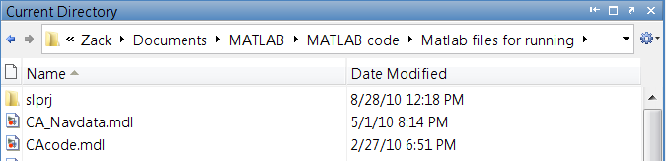

1. Open file <Run_Receiver.m>
2. To clear the previous variables and start fresh, it need to highlight the line 3 & line 4 and evaluate the both line by pressing **‘F9’** or right click on the highlighted line and choose ‘Evaluate Selection’

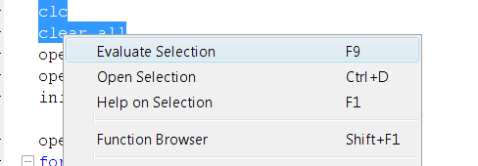

1. Evaluate line 5 “open_system (‘NavTable’) and the NavTable.mdl will open in the window.

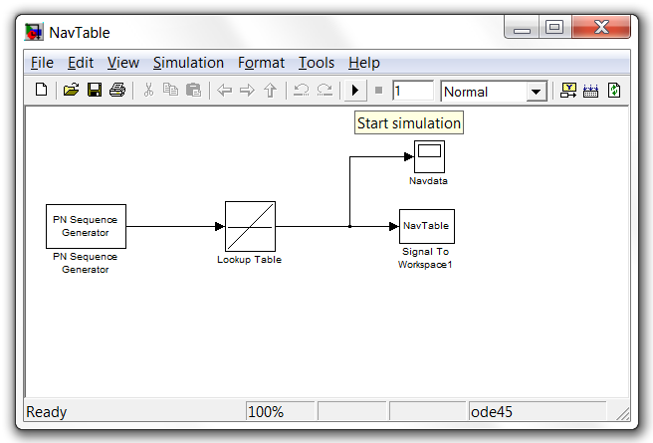

1. Press the  button to start the simulation to generate the Navigation data. The NavTable will be save onto the workspace in MATLAB

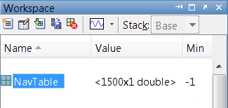

1. Evaluate line 6 “open_system (‘CATable’) and the CATable.mdl will open in the window.

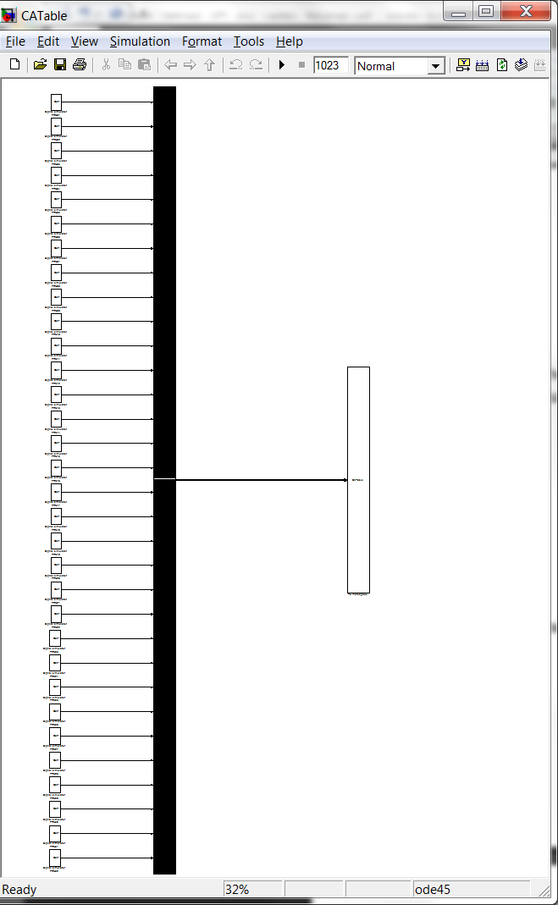

1. Ensure that the Workspace has the <iniStates> value before you generate the C/A codes. The iniStates is required in the shift register input.

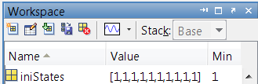

1. Press the  button to start the simulation to generate the C/A codes. The CATable will be save onto the workspace in MATLAB

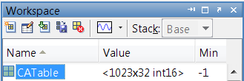

1. Evaluate line 7 “initSettings” to initialize the parameters required to run the files.

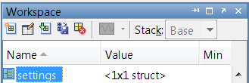

1. Evaluate line 9 “open_system (‘GPS_Signals_Generator’)” and GPS_Signals_Generator.mdl will open in the windows.

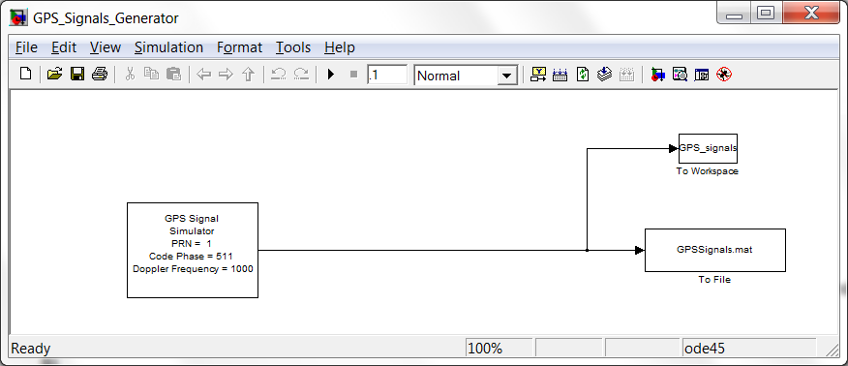

1. Press the  button to start the simulation to generate the GPS Signals. The GPSSignals.mat and GPS_signals will be saved onto the workspace in MATLAB. It will take 2 to 5 minutes depending on the computer processing speed.
2. Evaluate line 10 to 14 by highlighting them together in order to set up the parameter for data acquisition.

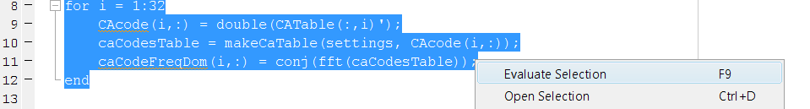

1. Evaluate line 16 to 22 by highlighting them together to load the GPSSignal.mat to the workspace for data acquisition.

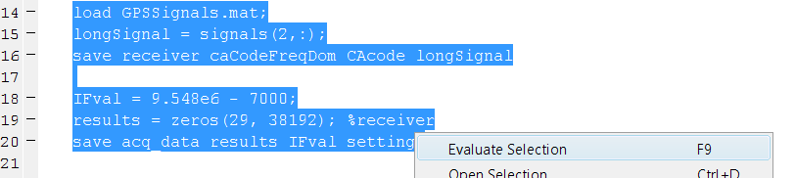

1. Evaluate line 24 “open_system (‘GPS_acquisition_receiver’)” and GPS_acquisition_receiver.mdl will open in the windows.

There will have three windows open up. Two of them are the subsystem of the GPS_acquisition_receiver.mdl.

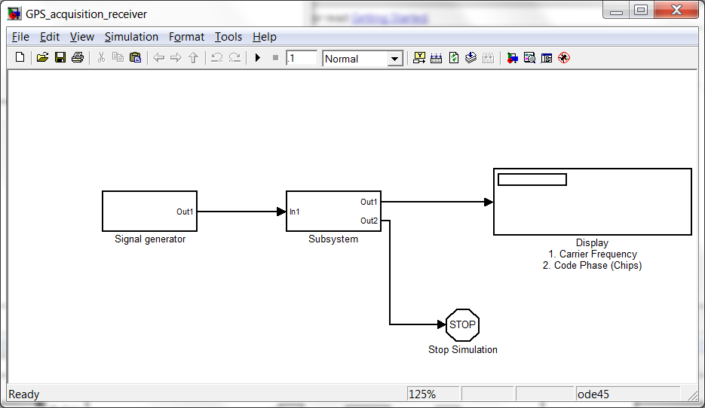

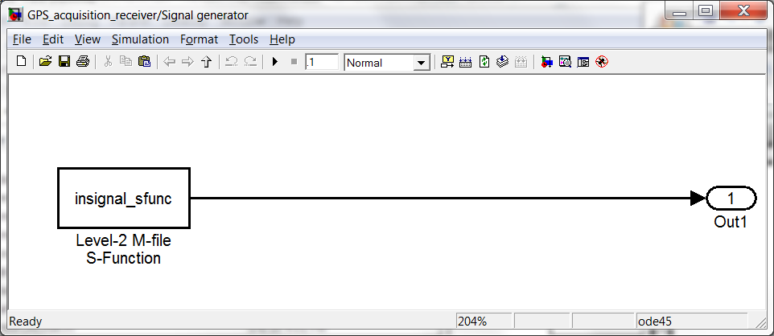

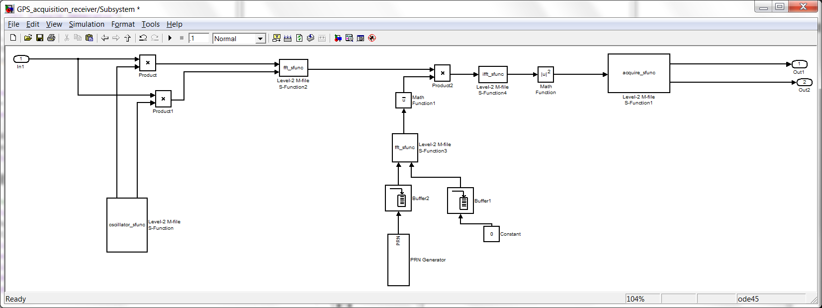

1. Press the  button to start the simulation to run the data acquisition. The CATable will be saved onto the workspace in MATLAB. It will take 2 to 3 minutes depending on the computer processing speed.

The display block will show information after the acquisition. The display show carrier frequency and the code phase based on the transmitter simulator

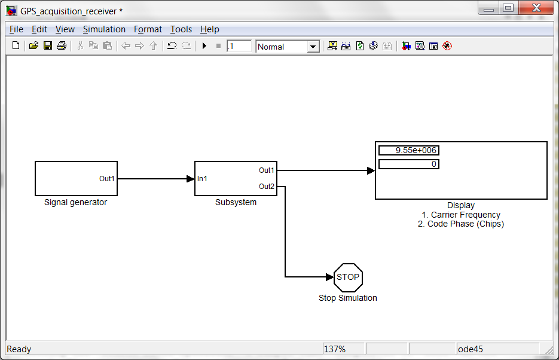

1. Evaluate line 28 to 35 by highlighting them together to plot the contour graph to demonstrate the acquired data.



1. Evaluate line 35 to 36 by highlighting them together to open the Carrier_tracking.mdl

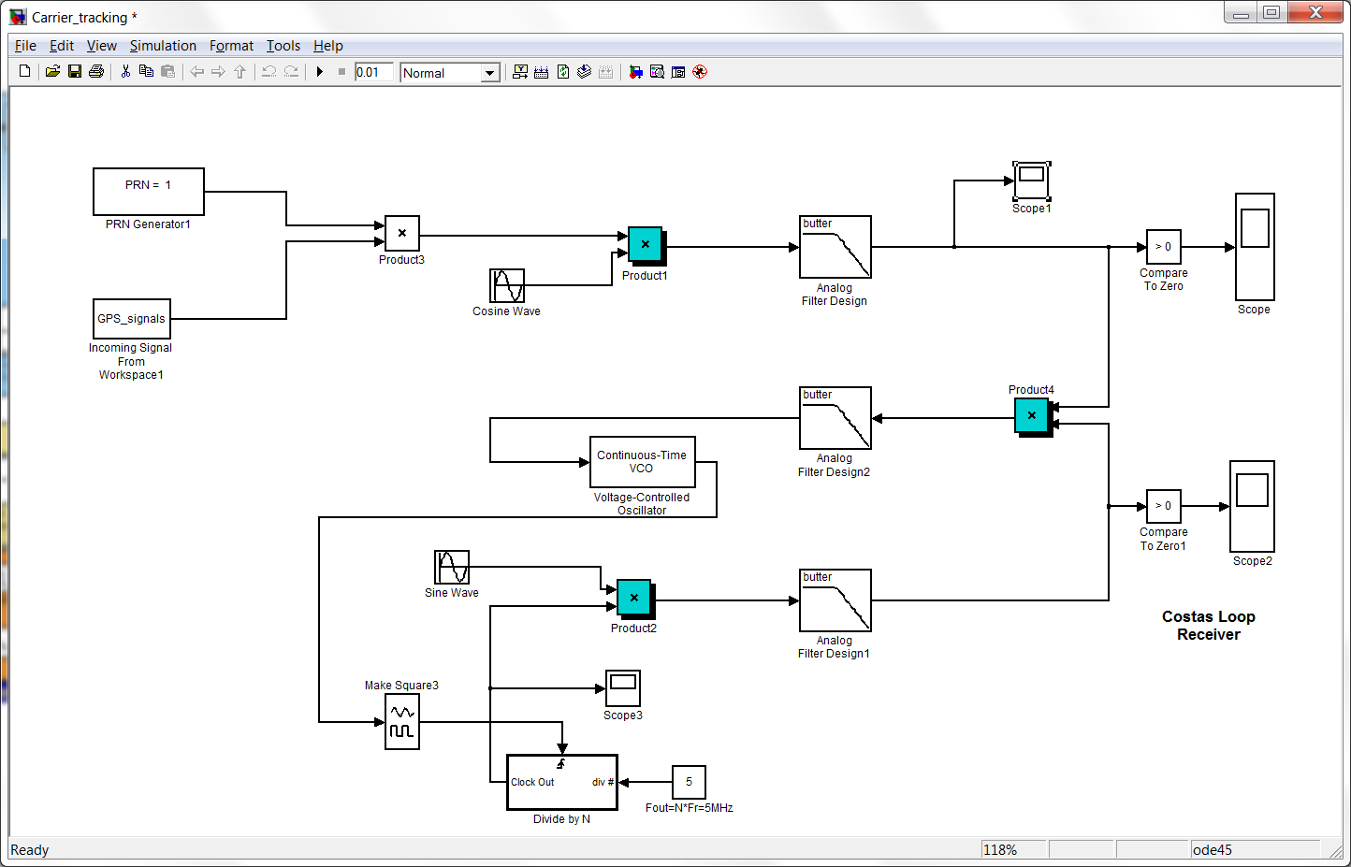

1. Press the  button to start the simulation to run the carrier tracking. The scope display the carrier has been removed.

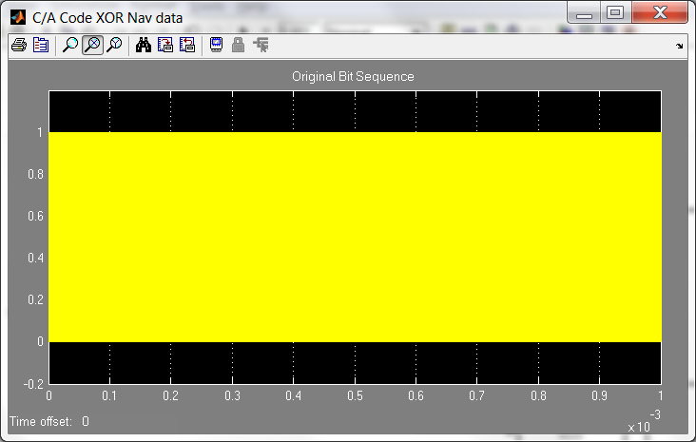

# APPENDIX B

# M-Files : initSettings.m

Initializing the paramenters and variables

%% Processing settings ====================================================

% Number of milliseconds to be processed used 36000 + any transients (see

% below - in Nav parameters) to ensure nav subframes are provided

settings.msToProcess = 37000; %[ms]

% Number of channels to be used for signal processing

settings.numberOfChannels = 8;

% Move the starting point of processing. Can be used to start the signal

% processing at any point in the data record (e.g. for long records). fseek

% function is used to move the file read point, therefore advance is byte

% based only.

settings.skipNumberOfBytes = 0;

%% Raw signal file name and other parameter ===============================

% This is a "default" name of the data file (signal record) to be used in

% the post-processing mode

settings.fileName = 'GPSSignals.mat';

% Data type used to store one sample

settings.dataType = 'int8';

% Intermediate, sampling and code frequencies

settings.IF = 9.548e6; %[Hz]

settings.samplingFreq = 38.192e6; %[Hz]

settings.codeFreqBasis = 1.023e6; %[Hz]

% Define number of chips in a code period

settings.codeLength = 1023;

%% Acquisition settings ===================================================

% List of satellites to look for. Some satellites can be excluded to speed

% up acquisition

settings.acqSatelliteList = 1:32; %[PRN numbers]

% Band around IF to search for satellite signal. Depends on max Doppler

settings.acqSearchBand = 14; %[kHz]

% Threshold for the signal presence decision rule

settings.acqThreshold = 2.5;

%% Tracking loops settings ================================================

% Code tracking loop parameters

settings.dllDampingRatio = 0.7;

settings.dllNoiseBandwidth = 2; %[Hz]

settings.dllCorrelatorSpacing = 0.5; %[chips]

% Carrier tracking loop parameters

settings.pllDampingRatio = 0.7;

settings.pllNoiseBandwidth = 25; %[Hz]

%% Navigation solution settings ===========================================

% Period for calculating pseudoranges and position

settings.navSolPeriod = 500; %[ms]

% Elevation mask to exclude signals from satellites at low elevation

settings.elevationMask = 10; %[degrees 0 - 90]

% Enable/dissable use of tropospheric correction

settings.useTropCorr = 1; % 0 - Off

% 1 - On

% True position of the antenna in UTM system (if known). Otherwise enter

% all NaN's and mean position will be used as a reference .

settings.truePosition.E = nan;

settings.truePosition.N = nan;

settings.truePosition.U = nan;

%% Plot settings ==========================================================

% Enable/disable plotting of the tracking results for each channel

settings.plotTracking = 1; % 0 - Off

% 1 - On

%% Constants ==============================================================

settings.c = 299792458; % The speed of light, [m/s]

settings.startOffset = 68.802; %[ms] Initial sign. travel time

# B2 M-Files : insignal_sfunc.m

function insignal_sfunc(block)

%MSFUNTMPL A template for an M-file S-function

% The M-file S-function is written as a MATLAB function with the

% same name as the S-function. Replace 'msfuntmpl' with the name

% of your S-function.

%

% It should be noted that the M-file S-function is very similar

% to Level-2 C-Mex S-functions. You should be able to get more

% information for each of the block methods by referring to the

% documentation for C-Mex S-functions.

%

% Copyright 2003-2009 The MathWorks, Inc.

% $Revision: 1.1.6.17 $

%

% The setup method is used to setup the basic attributes of the

% S-function such as ports, parameters, etc. Do not add any other

% calls to the main body of the function.

%

setup(block);

%endfunction

% Function: setup ===================================================

% Abstract:

% Set up the S-function block's basic characteristics such as:

% - Input ports

% - Output ports

% - Dialog parameters

% - Options

%

% Required : Yes

% C-Mex counterpart: mdlInitializeSizes

%

function setup(block)

% Register the number of ports.

block.NumInputPorts = 0;

block.NumOutputPorts = 1;

% Set up the port properties to be inherited or dynamic.

block.SetPreCompOutPortInfoToDynamic;

% Override the output port properties.

% trigger

block.OutputPort(1).DatatypeID = 0; % boolean

block.OutputPort(1).Complexity = 'Real';

block.OutputPort(1).SamplingMode = 'Sample';

block.OutputPort(1).Dimensions = 38192;

% Register the parameters.

block.NumDialogPrms = 0;

% Set up the continuous states.

block.NumContStates = 1;

block.SampleTimes = [-1 0];

% -----------------------------------------------------------------

% Options

% -----------------------------------------------------------------

% Specify if Accelerator should use TLC or call back to the

% M-file

block.SetAccelRunOnTLC(false);

% Specify the block simStateCompliance. The allowed values are:

% 'UnknownSimState', < The default setting; warn and assume DefaultSimState

% 'DefaultSimState', < Same SimState as a built-in block

% 'HasNoSimState', < No SimState

% 'CustomSimState', < Has GetSimState and SetSimState methods

% 'DisallowSimState' < Errors out when saving or restoring the SimState

block.SimStateCompliance = 'DefaultSimState';

% -----------------------------------------------------------------

% The M-file S-function uses an internal registry for all

% block methods. You should register all relevant methods

% (optional and required) as illustrated below. You may choose

% any suitable name for the methods and implement these methods

% as local functions within the same file.

% -----------------------------------------------------------------

% -----------------------------------------------------------------

% Register the methods called during update diagram/compilation.

% -----------------------------------------------------------------

%% Register methods

block.RegBlockMethod('PostPropagationSetup', @DoPostPropSetup);

block.RegBlockMethod('Start', @Start);

block.RegBlockMethod('WriteRTW', @WriteRTW);

block.RegBlockMethod('Outputs', @Outputs);

function DoPostPropSetup(block)

block.NumDworks = 1;

block.Dwork(1).Name = 'idx';

block.Dwork(1).Dimensions = 1;

block.Dwork(1).DatatypeID = 0; % double

block.Dwork(1).Complexity = 'Real'; % real

block.Dwork(1).UsedAsDiscState = true;

function Start(block)

%% Initialize Dwork

block.Dwork(1).Data = 0;

%endfunction

function WriteRTW(block)

block.WriteRTWParam('string', 'Mode', 'Auto');

%endfunction

function Outputs(block)

load GPSSignals.mat;

idx = block.Dwork(1).Data;

idx = idx + 1;

X = signals(2,(idx-1)*38192+1:idx*38192)';

block.OutputPort(1).Data = X;

block.Dwork(1).Data = idx;

%endfunction

# M-Files : oscillator_sfunc.m

function oscillator_sfunc(block)

%MSFUNTMPL A template for an M-file S-function

% The M-file S-function is written as a MATLAB function with the

% same name as the S-function. Replace 'msfuntmpl' with the name

% of your S-function.

%

% It should be noted that the M-file S-function is very similar

% to Level-2 C-Mex S-functions. You should be able to get more

% information for each of the block methods by referring to the

% documentation for C-Mex S-functions.

%

% Copyright 2003-2009 The MathWorks, Inc.

% $Revision: 1.1.6.17 $

%

% The setup method is used to setup the basic attributes of the

% S-function such as ports, parameters, etc. Do not add any other

% calls to the main body of the function.

%

setup(block);

%endfunction

% Function: setup ===================================================

% Abstract:

% Set up the S-function block's basic characteristics such as:

% - Input ports

% - Output ports

% - Dialog parameters

% - Options

%

% Required : Yes

% C-Mex counterpart: mdlInitializeSizes

%

function setup(block)

% Register the number of ports.

block.NumInputPorts = 0;

block.NumOutputPorts = 2;

% Set up the port properties to be inherited or dynamic.

block.SetPreCompOutPortInfoToDynamic;

% Override the output port properties.

% trigger

block.OutputPort(1).DatatypeID = 0; % boolean

block.OutputPort(1).Complexity = 'Real';

block.OutputPort(1).SamplingMode = 'Sample';

block.OutputPort(1).Dimensions = [38192 1];

% Override the output port properties.

% trigger

block.OutputPort(2).DatatypeID = 0; % boolean

block.OutputPort(2).Complexity = 'Real';

block.OutputPort(2).SamplingMode = 'Sample';

block.OutputPort(2).Dimensions = [38192 1];

% Register the parameters.

block.NumDialogPrms = 1;

block.DialogPrmsTunable = {'Tunable'};

block.DialogPrm(1).DataTypeId = 0;

% Set up the continuous states.

block.NumContStates = 1;

% Register the sample times.

block.SampleTimes = [-1 0];

% -----------------------------------------------------------------

% Options

% -----------------------------------------------------------------

% Specify if Accelerator should use TLC or call back to the

% M-file

block.SetAccelRunOnTLC(false);

% Specify the block simStateCompliance. The allowed values are:

% 'UnknownSimState', < The default setting; warn and assume DefaultSimState

% 'DefaultSimState', < Same SimState as a built-in block

% 'HasNoSimState', < No SimState

% 'CustomSimState', < Has GetSimState and SetSimState methods

% 'DisallowSimState' < Errors out when saving or restoring the SimState

block.SimStateCompliance = 'DefaultSimState';

% -----------------------------------------------------------------

% The M-file S-function uses an internal registry for all

% block methods. You should register all relevant methods

% (optional and required) as illustrated below. You may choose

% any suitable name for the methods and implement these methods

% as local functions within the same file.

% -----------------------------------------------------------------

% -----------------------------------------------------------------

% Register the methods called during update diagram/compilation.

% -----------------------------------------------------------------

%% Register methods

block.RegBlockMethod('CheckParameters', @CheckPrms);

block.RegBlockMethod('ProcessParameters', @ProcessPrms);

block.RegBlockMethod('PostPropagationSetup', @DoPostPropSetup);

block.RegBlockMethod('Start', @Start);

block.RegBlockMethod('WriteRTW', @WriteRTW);

block.RegBlockMethod('Outputs', @Outputs);

% -------------------------------------------------------------------

% The local functions below are provided to illustrate how you may implement

% the various block methods listed above.

% -------------------------------------------------------------------

function CheckPrms(block)

a = block.DialogPrm(1).Data;

if ~strcmp(class(a), 'double')

DAStudio.error('Simulink:block:invalidParameter');

end

%endfunction

function ProcessPrms(block)

block.AutoUpdateRuntimePrms;

%endfunction

function DoPostPropSetup(block)

block.NumDworks = 0;

block.AutoRegRuntimePrms;

%endfunction

function Start(block)

function WriteRTW(block)

block.WriteRTWParam('string', 'Mode', 'Auto');

%endfunction

function Outputs(block)

ts = block.RuntimePrm(1).Data;

load acq_data

block.OutputPort(1).Data = sin((0:38191)' * 2 * pi * ts*IFval);

block.OutputPort(2).Data = cos((0:38191)' * 2 * pi * ts*IFval);

%endfunction

# M-Files : caCodesTable.m

function caCodesTable = makeCaTable(settings, caCode)

%Function generates CA codes for all 32 satellites based on the settings

%provided in the structure "settings". The codes are digitized at the

%sampling frequency specified in the settings structure.

%One row in the "caCodesTable" is one C/A code. The row number is the PRN

%number of the C/A code.

%

%caCodesTable = makeCaTable(settings)

%

% Inputs:

% settings - receiver settings

% Outputs:

% caCodesTable - an array of arrays (matrix) containing C/A codes

% for all satellite PRN-s

%--------------------------------------------------------------------------

% SoftGNSS v3.0

%

% Copyright (C) Darius Plausinaitis

% Written by Darius Plausinaitis

% Based on Peter Rinder and Nicolaj Bertelsen

%--------------------------------------------------------------------------

%This program is free software; you can redistribute it and/or

%modify it under the terms of the GNU General Public License

%as published by the Free Software Foundation; either version 2

%of the License, or (at your option) any later version.

%

%This program is distributed in the hope that it will be useful,

%but WITHOUT ANY WARRANTY; without even the implied warranty of

%MERCHANTABILITY or FITNESS FOR A PARTICULAR PURPOSE. See the

%GNU General Public License for more details.

%

%You should have received a copy of the GNU General Public License

%along with this program; if not, write to the Free Software

%Foundation, Inc., 51 Franklin Street, Fifth Floor, Boston, MA 02110-1301,

%USA.

%--------------------------------------------------------------------------

%CVS record:

%$Id: makeCaTable.m,v 1.1.2.6 2006/08/14 11:38:22 dpl Exp $

%--- Find number of samples per spreading code ----------------------------

samplesPerCode = round(settings.samplingFreq / ...

(settings.codeFreqBasis / settings.codeLength));

%--- Prepare the output matrix to speed up function -----------------------

caCodesTable = zeros(32, samplesPerCode);

%--- Find time constants --------------------------------------------------

ts = 1/settings.samplingFreq; % Sampling period in sec

tc = 1/settings.codeFreqBasis; % C/A chip period in sec

%=== For all satellite PRN-s ...

%--- Generate CA code for given PRN -----------------------------------

%=== Digitizing =======================================================

%--- Make index array to read C/A code values -------------------------

% The length of the index array depends on the sampling frequency -

% number of samples per millisecond (because one C/A code period is one

% millisecond).

codeValueIndex = ceil((ts * (1:samplesPerCode)) / tc);

%--- Correct the last index (due to number rounding issues) -----------

codeValueIndex(end) = 1023;

%--- Make the digitized version of the C/A code -----------------------

% The "upsampled" code is made by selecting values form the CA code

% chip array (caCode) for the time instances of each sample.

caCodesTable = caCode(codeValueIndex);

# M-Files : generateCaCodes.m

function CAcode = generateCAcode(PRN)

% generateCAcode.m generates one of the 32 GPS satellite C/A codes.

%

% CAcode = generateCAcode(PRN)

%

% Inputs:

% PRN - PRN number of the sequence.

%

% Outputs:

% CAcode - a vector containing the desired C/A code sequence

% (chips).

%--------------------------------------------------------------------------

% SoftGNSS v3.0

%

% Copyright (C) Darius Plausinaitis

% Written by Darius Plausinaitis

% Based on Dennis M. Akos, Peter Rinder and Nicolaj Bertelsen

%--------------------------------------------------------------------------

%This program is free software; you can redistribute it and/or

%modify it under the terms of the GNU General Public License

%as published by the Free Software Foundation; either version 2

%of the License, or (at your option) any later version.

%

%This program is distributed in the hope that it will be useful,

%but WITHOUT ANY WARRANTY; without even the implied warranty of

%MERCHANTABILITY or FITNESS FOR A PARTICULAR PURPOSE. See the

%GNU General Public License for more details.

%

%You should have received a copy of the GNU General Public License

%along with this program; if not, write to the Free Software

%Foundation, Inc., 51 Franklin Street, Fifth Floor, Boston, MA 02110-1301,

%USA.

%--------------------------------------------------------------------------

%CVS record:

%$Id: generateCAcode.m,v 1.1.2.5 2006/08/14 11:38:22 dpl Exp $

%--- Make the code shift array. The shift depends on the PRN number -------

% The g2s vector holds the appropriate shift of the g2 code to generate

% the C/A code (ex. for SV#19 - use a G2 shift of g2s(19) = 471)

g2s = [ 5, 6, 7, 8, 17, 18, 139, 140, 141, 251, ...

252, 254, 255, 256, 257, 258, 469, 470, 471, 472, ...

473, 474, 509, 512, 513, 514, 515, 516, 859, 860, ...

861, 862 ... end of shifts for GPS satellites

... Shifts for the ground GPS transmitter are not included

... Shifts for EGNOS and WAAS satellites (true_PRN = PRN + 87)

145, 175, 52, 21, 237, 235, 886, 657, ...

634, 762, 355, 1012, 176, 603, 130, 359, 595, 68, ...

386];

%--- Pick right shift for the given PRN number ----------------------------

g2shift = g2s(PRN);

%--- Generate G1 code -----------------------------------------------------

%--- Initialize g1 output to speed up the function ---

g1 = zeros(1, 1023);

%--- Load shift register ---

reg = -1*ones(1, 10);

%--- Generate all G1 signal chips based on the G1 feedback polynomial -----

for i=1:1023

g1(i) = reg(10);

saveBit = reg(3)*reg(10);

reg(2:10) = reg(1:9);

reg(1) = saveBit;

end

%--- Generate G2 code -----------------------------------------------------

%--- Initialize g2 output to speed up the function ---

g2 = zeros(1, 1023);

%--- Load shift register ---

reg = -1*ones(1, 10);

%--- Generate all G2 signal chips based on the G2 feedback polynomial -----

for i=1:1023

g2(i) = reg(10);

saveBit = reg(2)*reg(3)*reg(6)*reg(8)*reg(9)*reg(10);

reg(2:10) = reg(1:9);

reg(1) = saveBit;

end

%--- Shift G2 code --------------------------------------------------------

%The idea: g2 = concatenate[ g2_right_part, g2_left_part ];

g2 = [g2(1023-g2shift+1 : 1023), g2(1 : 1023-g2shift)];

%--- Form single sample C/A code by multiplying G1 and G2 -----------------

CAcode = -(g1 .* g2);

# M-Files : fft_sfunc.m

function fft_sfunc(block)

% Level-2 M file S-Function.

% Two-tap FIR filter implementation for frame-based and sample-based signals.

% Filter coefficients are passed as block parameters.

%

% Copyright 2009 The MathWorks, Inc.

% $Revision: 1.1.6.1 $ $Date: 2009/11/13 05:06:08 $

setup(block);

function setup(block)

% Register number of ports.

block.NumInputPorts = 2;

block.NumOutputPorts = 1;

% In Accelerator mode, the block runs on TLC.

block.SetAccelRunOnTLC(true);

% Set up the functional port properties.

block.SetPreCompInpPortInfoToDynamic;

block.SetPreCompOutPortInfoToDynamic;

% Set up the inport data-type properties.

block.InputPort(1).DatatypeID = -1;

block.InputPort(1).Complexity = 'Real';

block.InputPort(2).DatatypeID = -1;

block.InputPort(2).Complexity = 'Real';

% Set up the outport data-type properties.

block.OutputPort(1).DatatypeID = -1;

block.OutputPort(1).Complexity = 'Complex';

% Register the parameters.

block.NumDialogPrms = 0;

% Register the methods.

% Note that the Output method is registered in DoPostProp as it

% requires knowledge about the signal sampling mode.

block.RegBlockMethod('SetInputPortDimensions', @SetInpPortDims);

block.RegBlockMethod('SetOutputPortDimensions', @SetOutPortDims);

block.RegBlockMethod('SetInputPortSamplingMode',@SetInpPortFrameData);

block.RegBlockMethod('PostPropagationSetup', @DoPostPropSetup);

block.RegBlockMethod('Start', @Start);

block.RegBlockMethod('WriteRTW', @WriteRTW);

function SetInpPortDims(block, idx, di)

% Set the port dimensions for forward propagation of the dimensions.

block.InputPort(idx).Dimensions = di;

block.OutputPort(1).Dimensions = di;

function SetOutPortDims(block, idx, di)

% Set the port dimensions for backward propagation of the dimensions.

block.InputPort(1).Dimensions = di;

block.InputPort(2).Dimensions = di;

block.OutputPort(idx).Dimensions = di;

function SetInpPortFrameData(block, idx, fd)

% Set the block sampling mode to Frame or Sample depending on the

% sampling mode of the input signal.

block.InputPort(idx).SamplingMode = fd;

block.OutputPort(1).SamplingMode = fd;

function DoPostPropSetup(block)

% Set the proper Output method based on the sampling mode.

block.RegBlockMethod('Outputs', @OutputFrame);

% Set up the dwork vector or scalar.

block.NumDworks = 0;

function Start(block)

% Initialize the data.

function OutputFrame(block)

% Output method for the frame-based signals.

% Get the input data and allocate space for the output signal.

block.OutputPort(1).Data = fft(block.InputPort(1).Data + 1j* block.InputPort(2).Data);

# M-Files : ifft_sfunc.m

function ifft_sfunc(block)

% Level-2 M file S-Function.

% Two-tap FIR filter implementation for frame-based and sample-based signals.

% Filter coefficients are passed as block parameters.

%

% Copyright 2009 The MathWorks, Inc.

% $Revision: 1.1.6.1 $ $Date: 2009/11/13 05:06:08 $

setup(block);

function setup(block)

% Register number of ports.

block.NumInputPorts = 1;

block.NumOutputPorts = 1;

% In Accelerator mode, the block runs on TLC.

block.SetAccelRunOnTLC(true);

% Set up the functional port properties.

block.SetPreCompInpPortInfoToDynamic;

block.SetPreCompOutPortInfoToDynamic;

% Set up the inport data-type properties.

block.InputPort(1).DatatypeID = -1;

block.InputPort(1).Complexity = 'Complex';

% Set up the outport data-type properties.

block.OutputPort(1).DatatypeID = 0;

block.OutputPort(1).Complexity = 'Complex';

block.OutputPort(1).SamplingMode = 'Sample';

block.OutputPort(1).Dimensions = [38192 1];

% Register the parameters.

block.NumDialogPrms = 0;

% Register the methods.

% Note that the Output method is registered in DoPostProp as it

% requires knowledge about the signal sampling mode.

block.RegBlockMethod('SetInputPortDimensions', @SetInpPortDims);

block.RegBlockMethod('SetInputPortSamplingMode',@SetInpPortFrameData);

block.RegBlockMethod('PostPropagationSetup', @DoPostPropSetup);

block.RegBlockMethod('Start', @Start);

block.RegBlockMethod('WriteRTW', @WriteRTW);

function SetInpPortDims(block, idx, di)

% Set the port dimensions for forward propagation of the dimensions.

block.InputPort(idx).Dimensions = di;

block.OutputPort(1).Dimensions = di;

function SetInpPortFrameData(block, idx, fd)

% Set the block sampling mode to Frame or Sample depending on the

% sampling mode of the input signal.

block.InputPort(idx).SamplingMode = fd;

function DoPostPropSetup(block)

% Set the proper Output method based on the sampling mode.

block.RegBlockMethod('Outputs', @OutputFrame);

% Set up the dwork vector or scalar.

block.NumDworks = 0;

function Start(block)

% Initialize the data.

function OutputFrame(block)

% Output method for the frame-based signals.

% Get the input data and allocate space for the output signal.

block.OutputPort(1).Data = ifft(block.InputPort(1).Data);

function WriteRTW(block) % Save the parameters to an RTW file for code generation.

# M-Files : acquire2_sfunc.m

function acquire2_sfunc(block)

%MSFUNTMPL A template for an M-file S-function

% The M-file S-function is written as a MATLAB function with the

% same name as the S-function. Replace 'msfuntmpl' with the name

% of your S-function.

%

% It should be noted that the M-file S-function is very similar

% to Level-2 C-Mex S-functions. You should be able to get more

% information for each of the block methods by referring to the

% documentation for C-Mex S-functions.

%

% Copyright 2003-2009 The MathWorks, Inc.

% $Revision: 1.1.6.17 $

%

% The setup method is used to setup the basic attributes of the

% S-function such as ports, parameters, etc. Do not add any other

% calls to the main body of the function.

%

setup(block);

%endfunction

% Function: setup ===================================================

% Abstract:

% Set up the S-function block's basic characteristics such as:

% - Input ports

% - Output ports

% - Dialog parameters

% - Options

%

% Required : Yes

% C-Mex counterpart: mdlInitializeSizes

%

function setup(block)

% Register the number of ports.

block.NumInputPorts = 1;

block.NumOutputPorts = 2;

% Set up the port properties to be inherited or dynamic.

block.SetPreCompOutPortInfoToDynamic;

block.InputPort(1).Complexity = 'Real';

block.InputPort(1).DataTypeId = 0;

block.InputPort(1).SamplingMode = 'Sample';

block.InputPort(1).Dimensions = [38192 1];

% Override the output port properties.

% trigger

block.OutputPort(1).DatatypeID = 0; % boolean

block.OutputPort(1).Complexity = 'Real';

block.OutputPort(1).SamplingMode = 'Sample';

block.OutputPort(1).Dimensions = 2;

% Override the output port properties.

% trigger

block.OutputPort(2).DatatypeID = 8; % boolean

block.OutputPort(2).Complexity = 'Real';

block.OutputPort(2).SamplingMode = 'Sample';

block.OutputPort(2).Dimensions = 1;

% Register the parameters.

block.NumDialogPrms = 1;

block.DialogPrmsTunable = {'Tunable'};

block.DialogPrm(1).DataTypeId = 0;

% Set up the continuous states.

block.NumContStates = 1;

block.SampleTimes = [-1 0];

% -----------------------------------------------------------------

% Options

% -----------------------------------------------------------------

% Specify if Accelerator should use TLC or call back to the

% M-file

block.SetAccelRunOnTLC(false);

% Specify the block simStateCompliance. The allowed values are:

% 'UnknownSimState', < The default setting; warn and assume DefaultSimState

% 'DefaultSimState', < Same SimState as a built-in block

% 'HasNoSimState', < No SimState

% 'CustomSimState', < Has GetSimState and SetSimState methods

% 'DisallowSimState' < Errors out when saving or restoring the SimState

block.SimStateCompliance = 'DefaultSimState';

% -----------------------------------------------------------------

% The M-file S-function uses an internal registry for all

% block methods. You should register all relevant methods

% (optional and required) as illustrated below. You may choose

% any suitable name for the methods and implement these methods

% as local functions within the same file.

% -----------------------------------------------------------------

% -----------------------------------------------------------------

% Register the methods called during update diagram/compilation.

% -----------------------------------------------------------------

%% Register methods

block.RegBlockMethod('CheckParameters', @CheckPrms);

block.RegBlockMethod('ProcessParameters', @ProcessPrms);

block.RegBlockMethod('PostPropagationSetup', @DoPostPropSetup);

block.RegBlockMethod('Start', @Start);

block.RegBlockMethod('WriteRTW', @WriteRTW);

block.RegBlockMethod('Outputs', @Outputs);

% -------------------------------------------------------------------

% The local functions below are provided to illustrate how you may implement

% the various block methods listed above.

% -------------------------------------------------------------------

function CheckPrms(block)

a = block.DialogPrm(1).Data;

if ~strcmp(class(a), 'double')

DAStudio.error('Simulink:block:invalidParameter');

end

%endfunction

function ProcessPrms(block)

block.AutoUpdateRuntimePrms;

%endfunction

function DoPostPropSetup(block)

block.NumDworks = 3;

block.Dwork(1).Name = 'X2';

block.Dwork(1).Dimensions = 38192;

block.Dwork(1).DatatypeID = 0; % double

block.Dwork(1).Complexity = 'Real'; % real

block.Dwork(1).UsedAsDiscState = true;

block.Dwork(2).Name = 'flags';

block.Dwork(2).Dimensions = 3;

block.Dwork(2).DatatypeID = 0; % double

block.Dwork(2).Complexity = 'Real'; % real

block.Dwork(2).UsedAsDiscState = true;

block.Dwork(3).Name = 'IF';

block.Dwork(3).Dimensions = 1;

block.Dwork(3).DatatypeID = 0; % double

block.Dwork(3).Complexity = 'Real'; % real

block.Dwork(3).UsedAsDiscState = true;

%endfunction

function Start(block)

%% Initialize Dwork

block.Dwork(1).Data = zeros(38192,1);

block.Dwork(2).Data = [0;0;0];

block.Dwork(3).Data = 9.548e6 - 7000;

%endfunction

function WriteRTW(block)

block.WriteRTWParam('string', 'Mode', 'Auto');

%endfunction

function Outputs(block)

X1 = block.InputPort(1).Data;

PRN = block.DialogPrm(1).Data;

load acq_data

flg = block.Dwork(2).Data;

if sum(X1) ~= 0

X2 = block.Dwork(1).Data;

flg(1) = flg(1) + 1;

if flg(1) == 2 && flg(3) < 30

flg(3) = flg(3) + 1;

if (max(X2) > max(X1))

results(flg(3), :) = X2';

else

results(flg(3), :) = X1';

end

flg(1) = 0;

IFval = IFval + 500;

end %if flg(1) == 2 && flg(3) < 30

if flg(3) == 29

initSettings

acqResults.carrFreq = 0;

acqResults.codePhase = 0;

%% Look for correlation peaks in the results ==============================

% Find the highest peak and compare it to the second highest peak

% The second peak is chosen not closer than 1 chip to the highest peak

%--- Find the correlation peak and the carrier frequency --------------

[peakSize frequencyBinIndex] = max(max(results, [], 2));

%--- Find code phase of the same correlation peak ---------------------

[peakSize codePhase] = max(max(results));

%--- Find 1 chip wide C/A code phase exclude range around the peak ----

samplesPerCodeChip = round(settings.samplingFreq / settings.codeFreqBasis);

excludeRangeIndex1 = codePhase - samplesPerCodeChip;

excludeRangeIndex2 = codePhase + samplesPerCodeChip;

%--- Correct C/A code phase exclude range if the range includes array

%boundaries

if excludeRangeIndex1 < 2

codePhaseRange = excludeRangeIndex2 : (38192 + excludeRangeIndex1);

elseif excludeRangeIndex2 >= 38192

codePhaseRange = (excludeRangeIndex2 - 38192) : excludeRangeIndex1;

else

codePhaseRange = [1:excludeRangeIndex1, excludeRangeIndex2 : 38192];

end

%--- Find the second highest correlation peak in the same freq. bin ---

secondPeakSize = max(results(frequencyBinIndex, codePhaseRange));

flg(2) = 1;

%--- Store result -----------------------------------------------------

acqResults.peakMetric = peakSize/secondPeakSize;

if (peakSize/secondPeakSize) > settings.acqThreshold

acqResults.codePhase = codePhase;

IFval = 9.548e6 - 7000 + (frequencyBinIndex-1)*500;

acqResults.carrFreq = IFval;

acqResults.PRN = PRN;

end % if (peakSize/secondPeakSize) > settings.acqTh

save acq_results acqResults

end

block.Dwork(2).Data = flg;

block.Dwork(1).Data = X1;

save acq_data results IFval

end

if flg(2) == 0

block.OutputPort(1).Data = [IFval 0];

block.OutputPort(2).Data = boolean(0);

else

block.OutputPort(1).Data = [IFval floor(acqResults.codePhase*1022/38192)];

block.OutputPort(2).Data = boolean(1);

end

%endfunction

# M-Files : Run_Reciver.m

%Use F9 to evaluate each line.

%Refer to Appendix A for user guide on running the GPS receiver models

clc

clear all

open_system('NavTable')

open_system('CATable')

initSettings

open_system('GPS_Signals_Generator') %start simulation and proceed next only when simulation ends

for i = 1:32

CAcode(i,:) = double(CATable(:,i)');

caCodesTable = makeCaTable(settings, CAcode(i,:));

caCodeFreqDom(i,:) = conj(fft(caCodesTable));

end

load GPSSignals.mat; %load incoming signal for receiver

longSignal = signals(2,:);

save receiver caCodeFreqDom CAcode longSignal

IFval = 9.548e6 - 7000;

results = zeros(29, 38192); %receiver

save acq_data results IFval settings

open_system('GPS_acquisition_receiver') %start simulation and proceed next only when simulation ends

% To plot the aquisition, highlight and evaluate line 27"load acq_data" to

% line 35"zlabel ('Magnitude') in same time

load acq_data

[X,Y] = meshgrid(linspace(1,1023,38192), (IFval:500:IFval+14000)/1e6);

contour3(X,Y, results, 100)

set(gca,'YTickLabel',{'9.54','9.55','9.66'})

ylabel ('Frequency (MHz)')

set(gca,'XTickLabel',{'1','256','512','768','1023'})

xlabel ('Code Phase (Chips)')

zlabel ('Magnitude')

%to run Carrier Tracker

load acq_results

open_system('Carrier_tracking')

# APPENDIX C

## SIMULINK model File for PRN 01 to PRN 32

PRN01.mdl

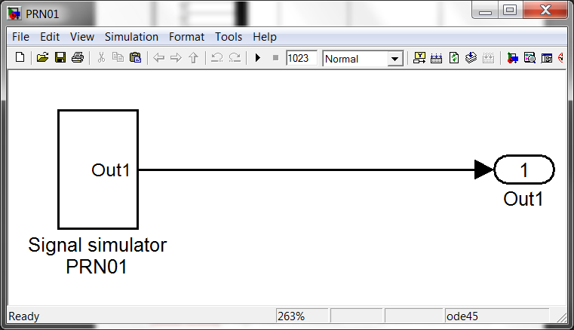

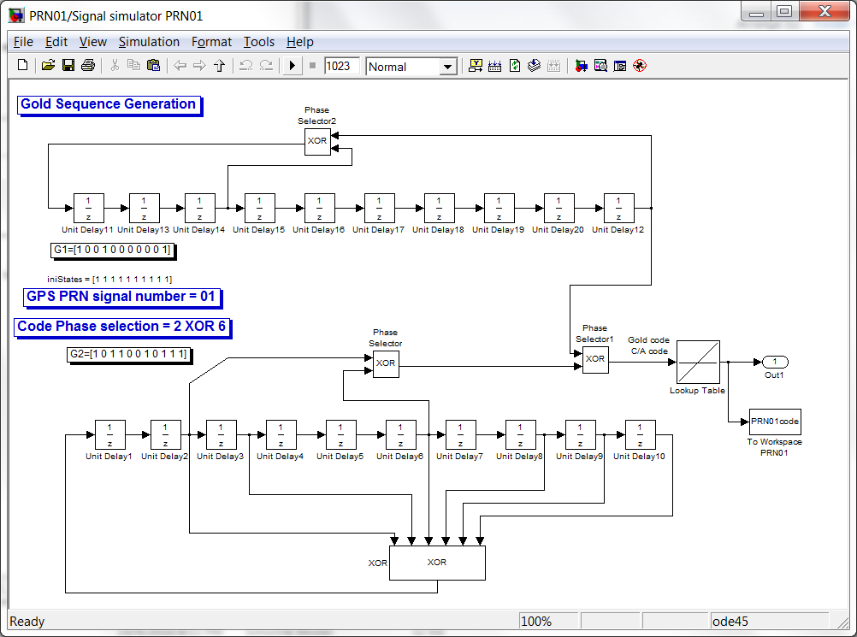

PRN02.mdl

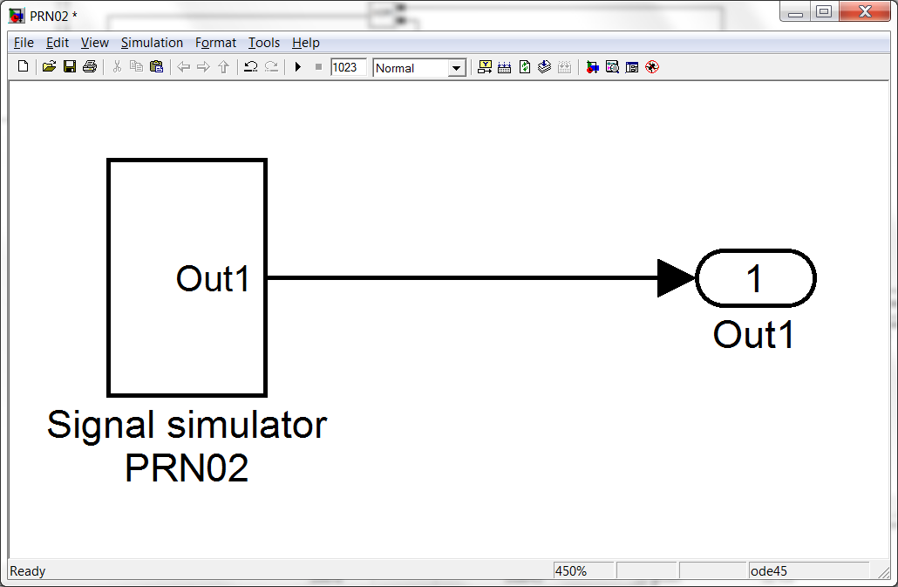

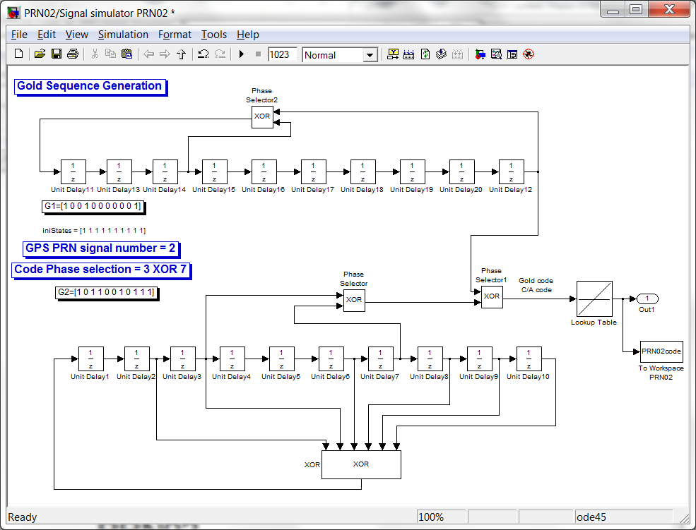

PRN03.mdl

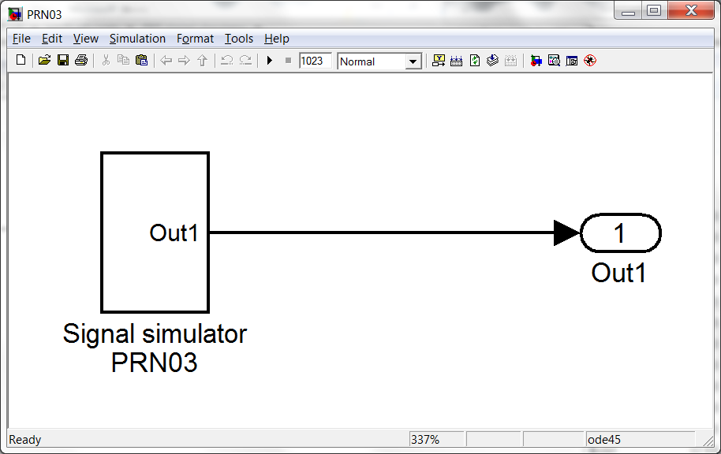

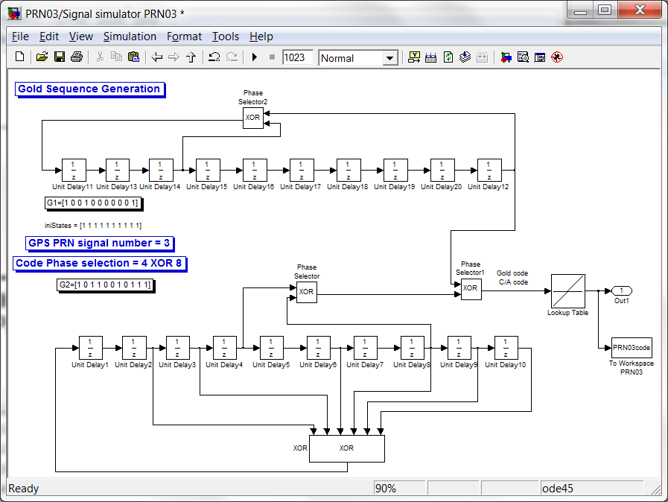

PRN04.mdl

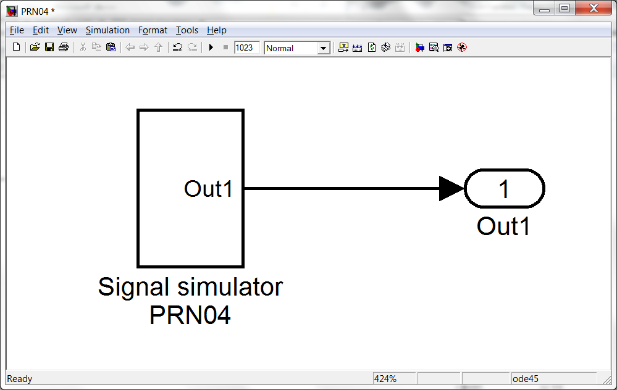

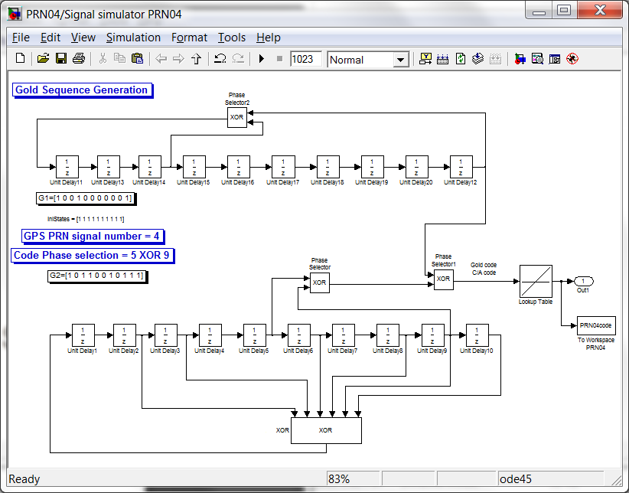

PRN05.mdl

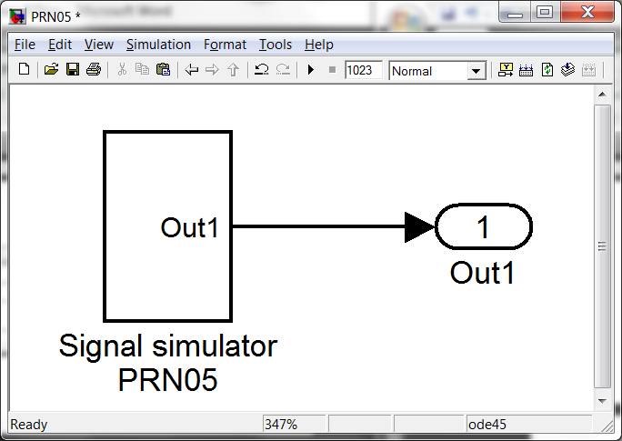

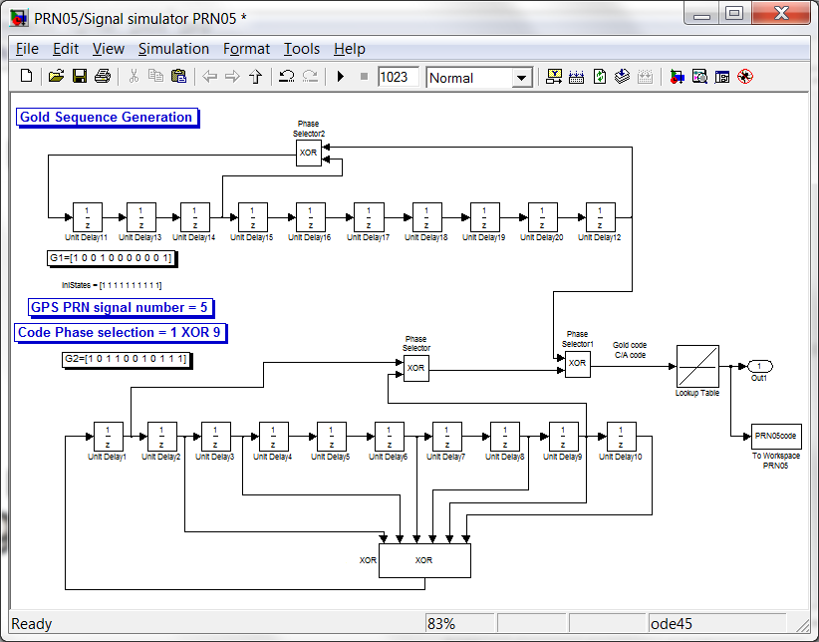

PRN06.mdl

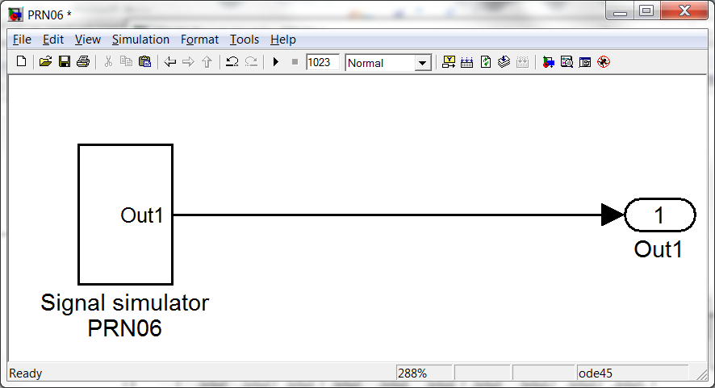

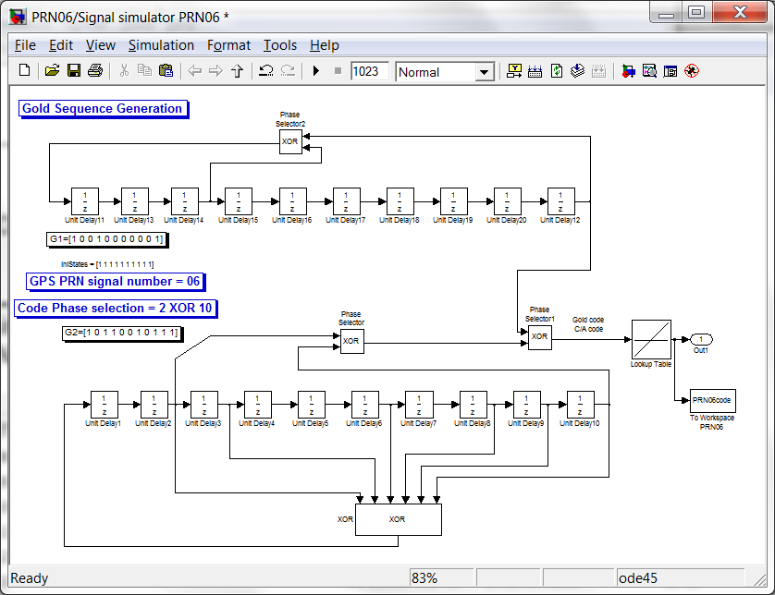

PRN07.mdl

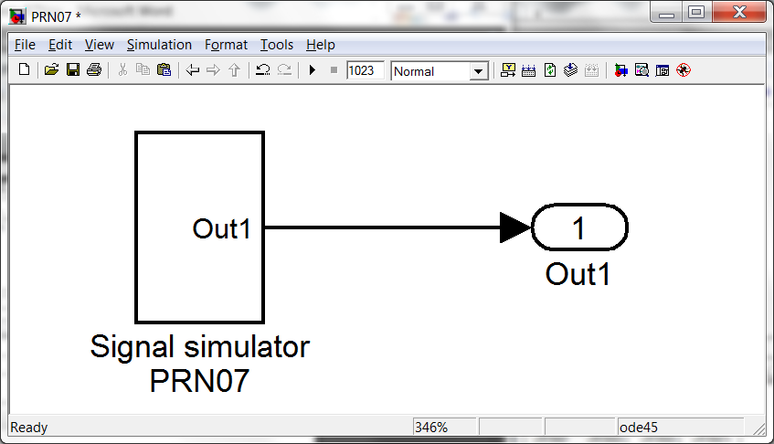

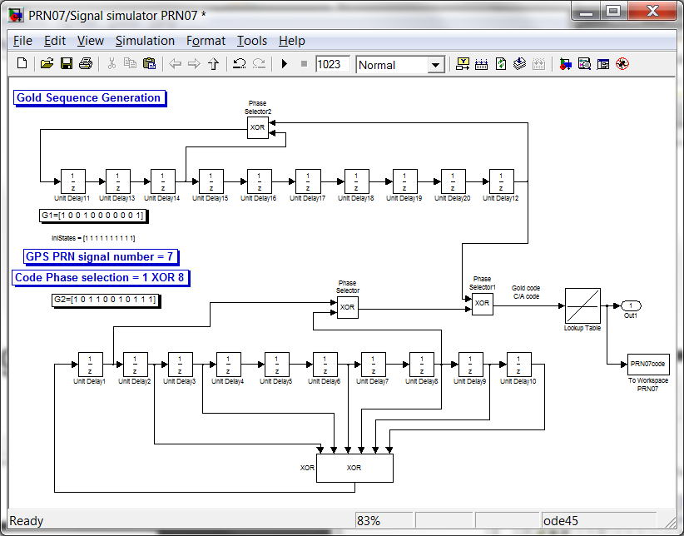

PRN08.mdl

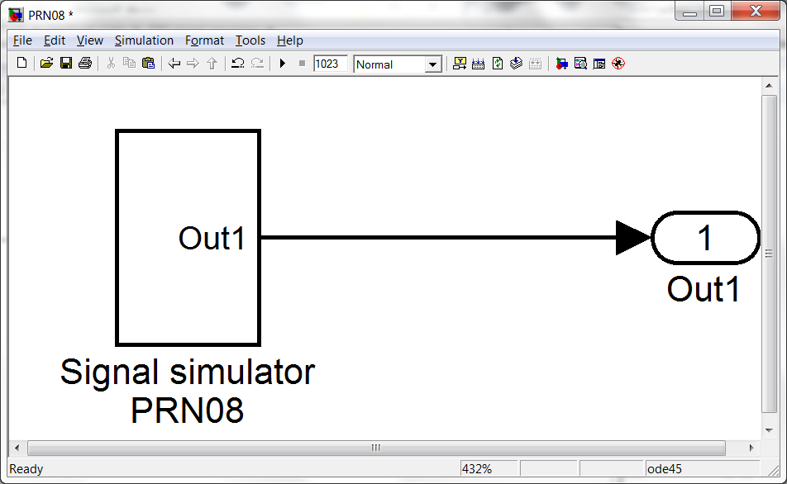

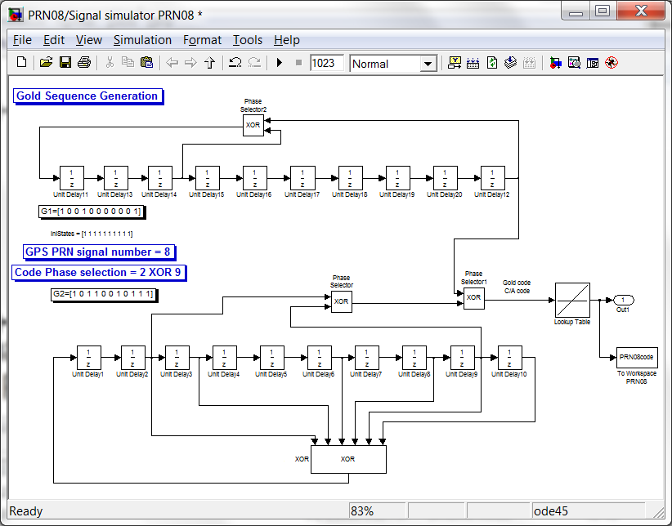

PRN09.mdl

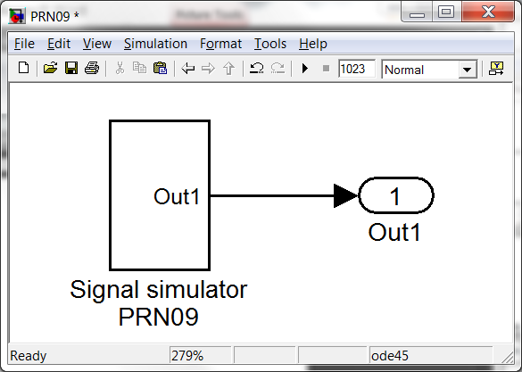

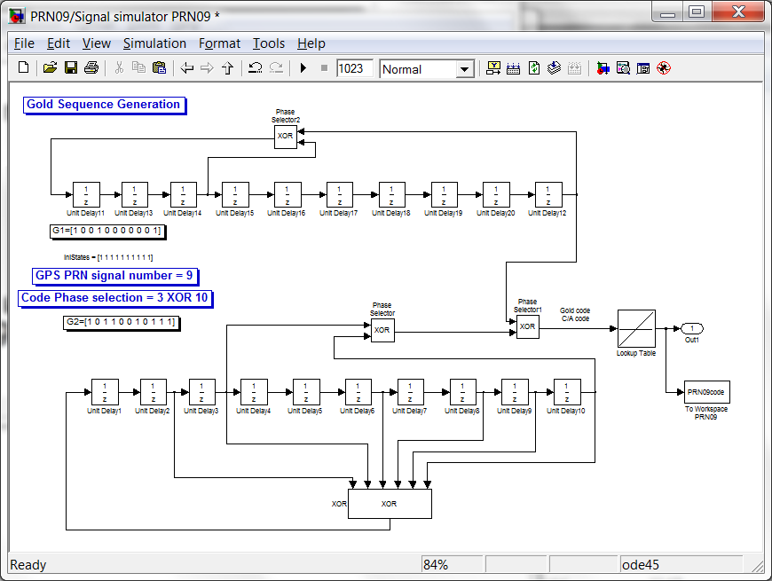

PRN10.mdl

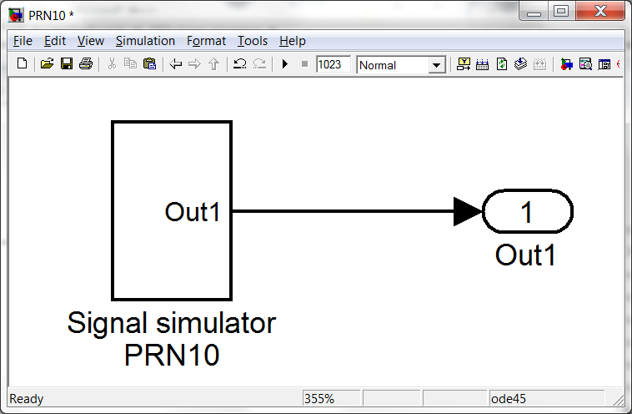 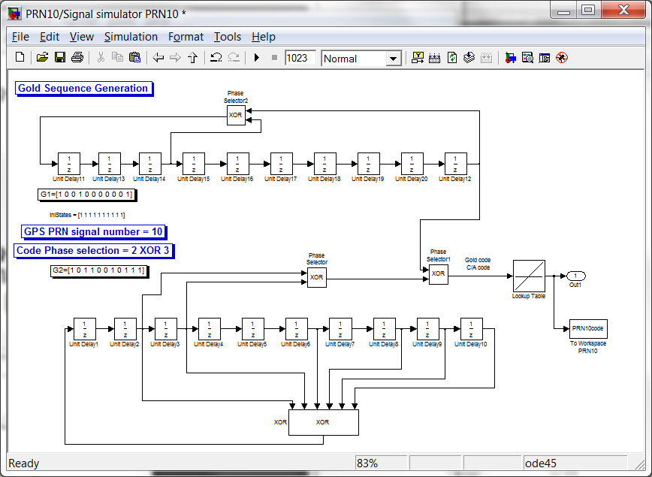

PRN11.mdl

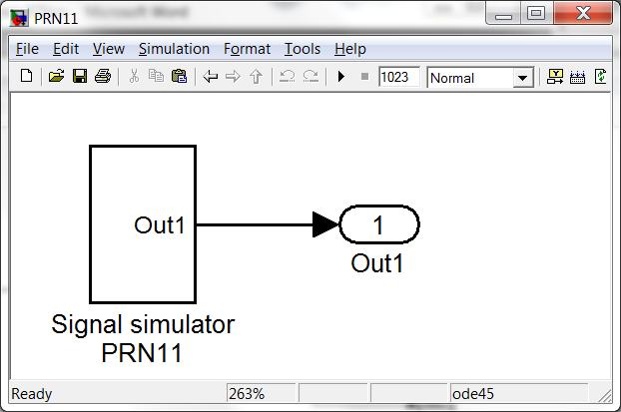 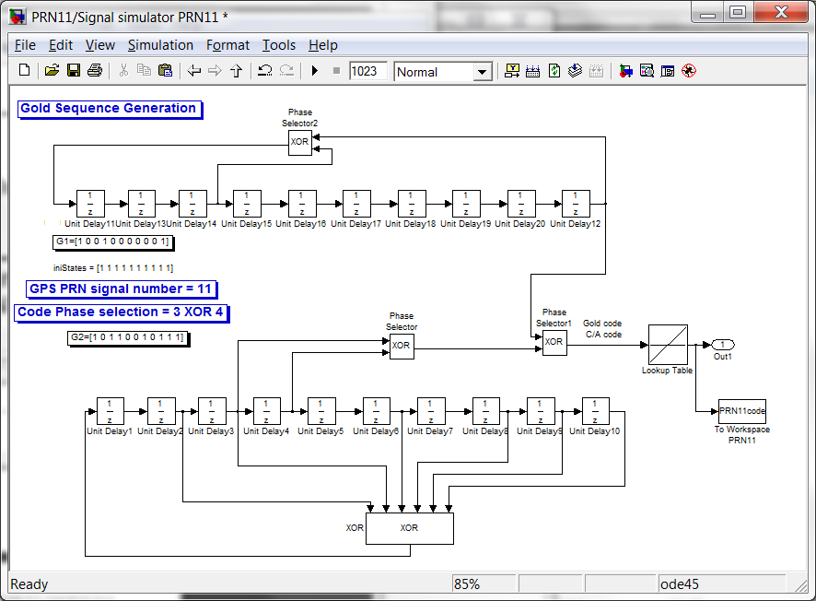

PRN12.mdl 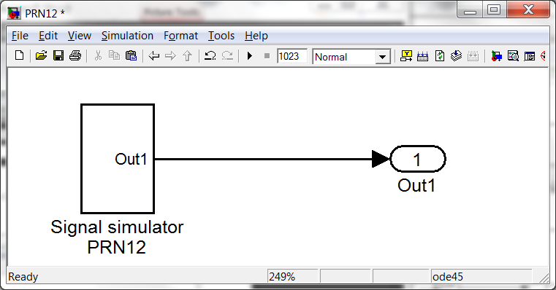 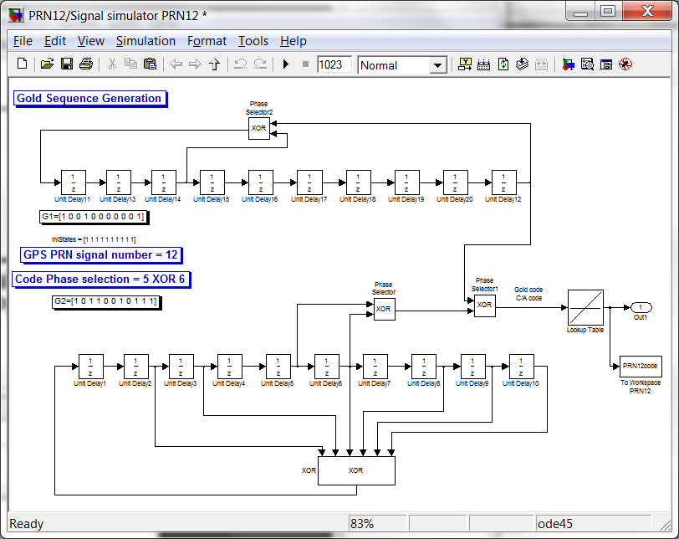

PRN13.mdl

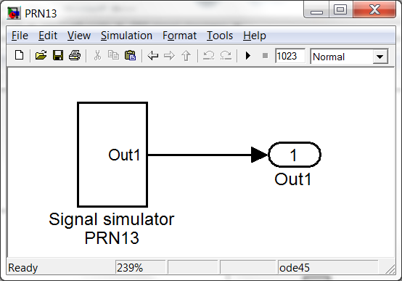

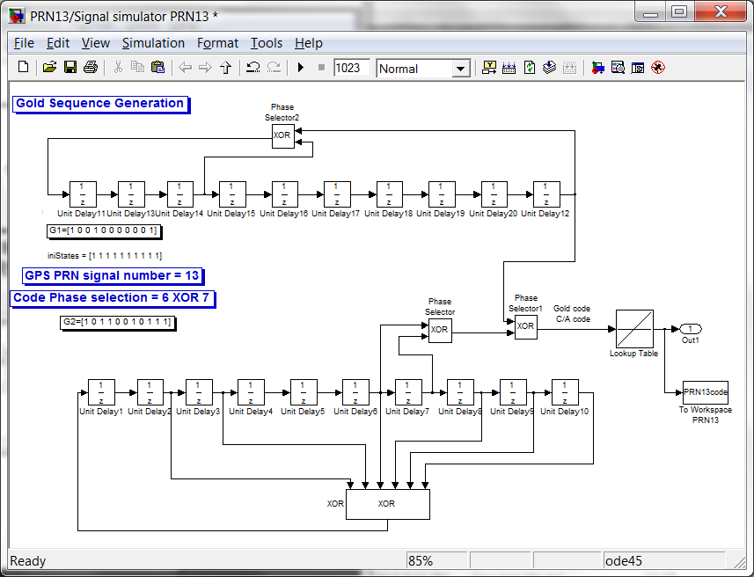

PRN14.mdl

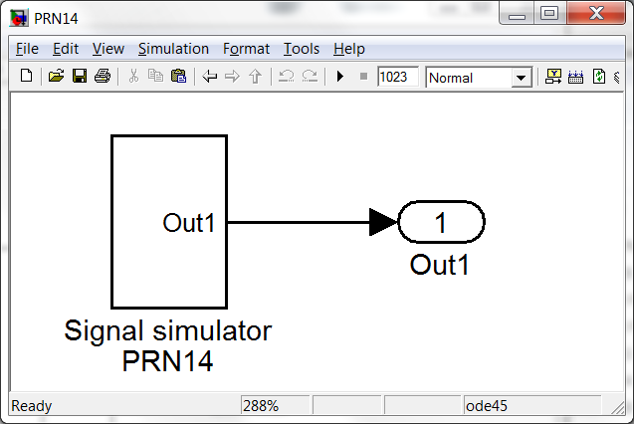

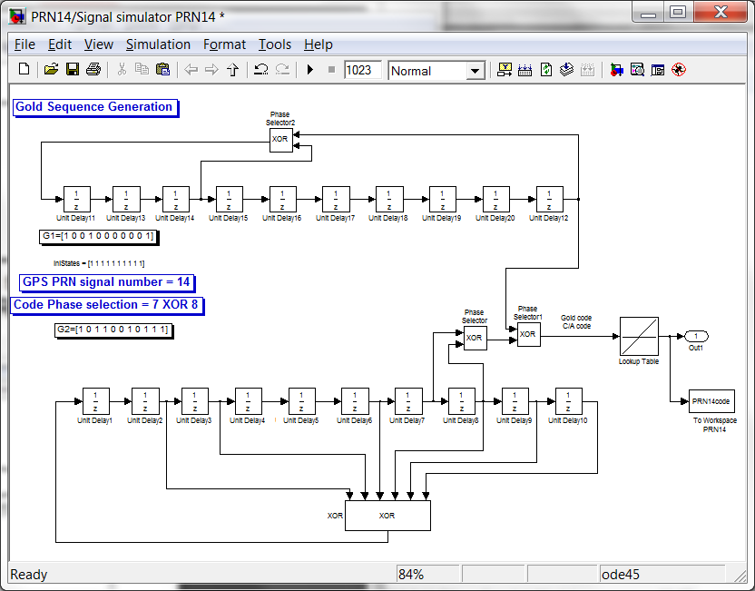

PRN15.mdl

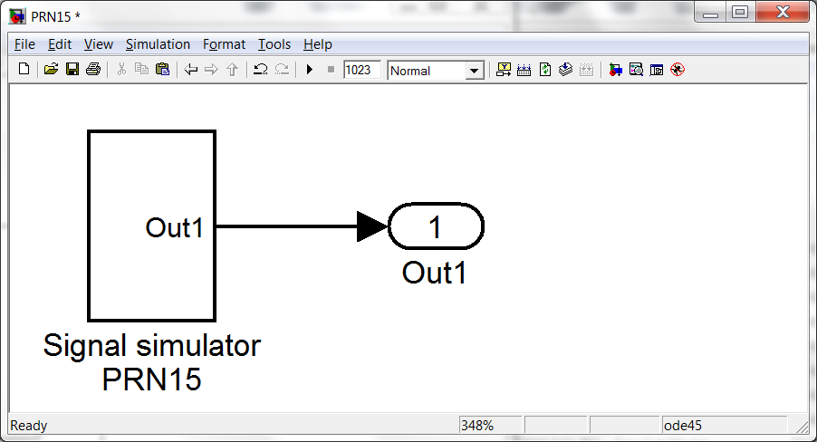

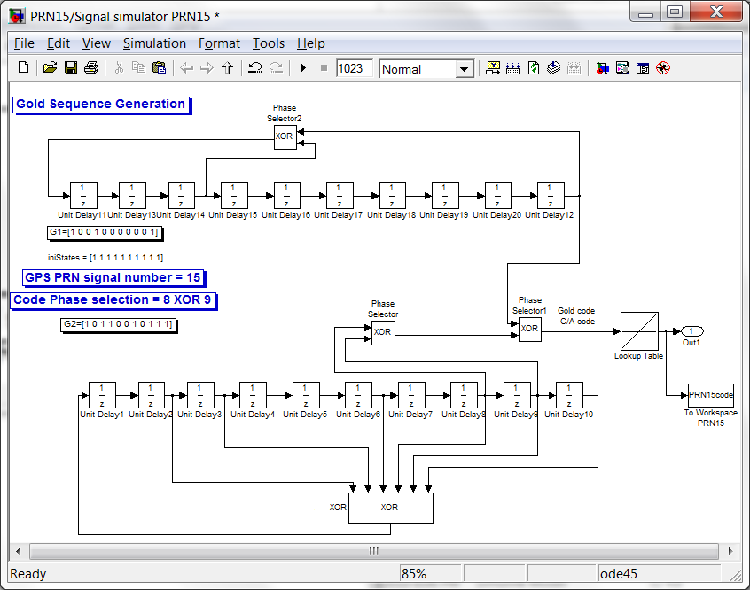

PRN16.mdl

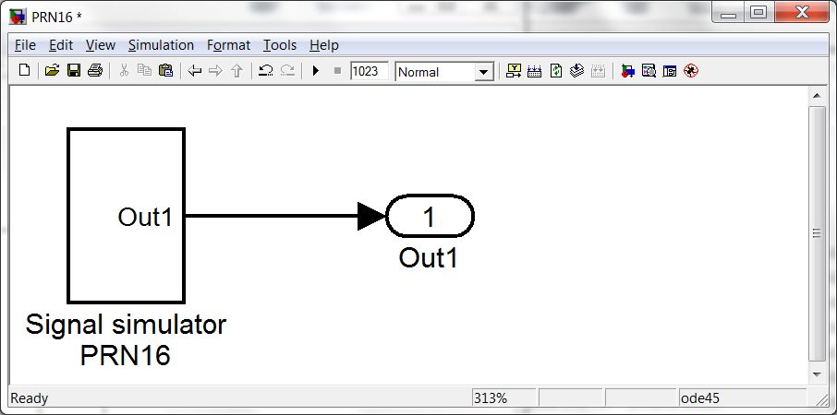 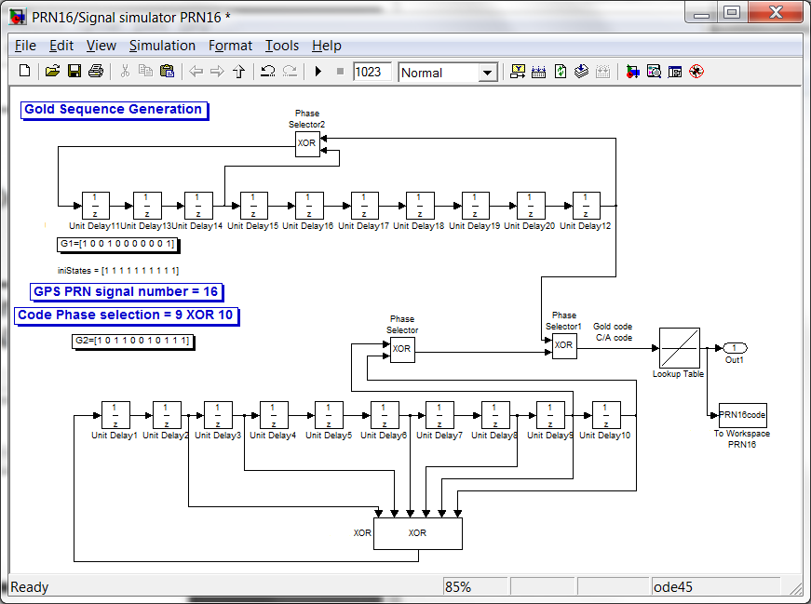

PRN17.mdl

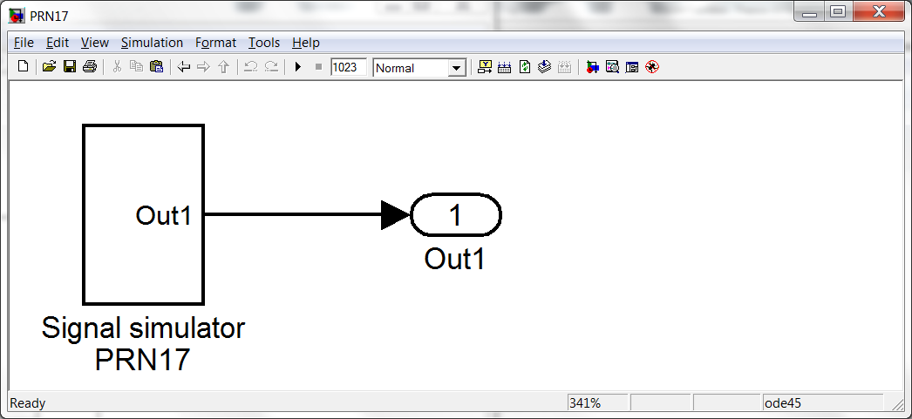 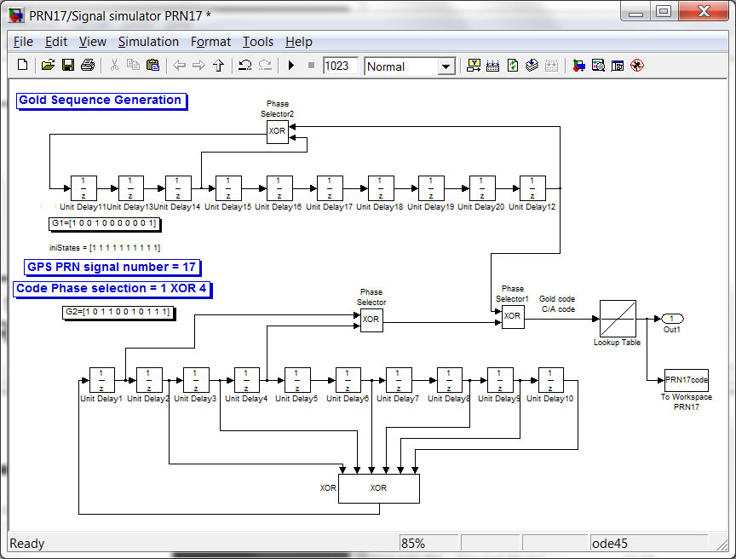

PRN18.mdl

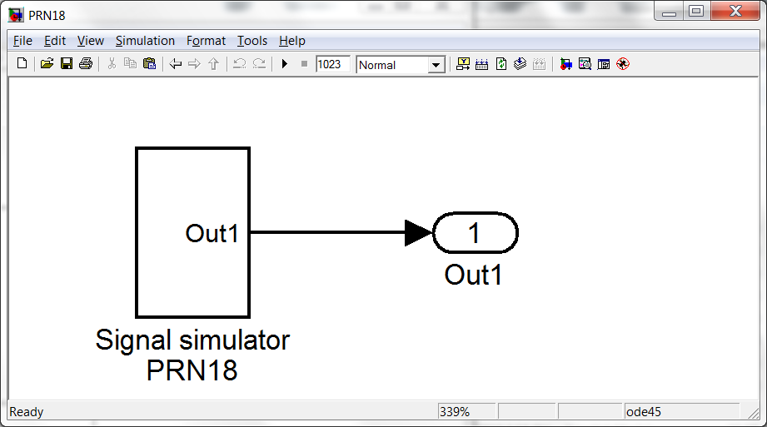

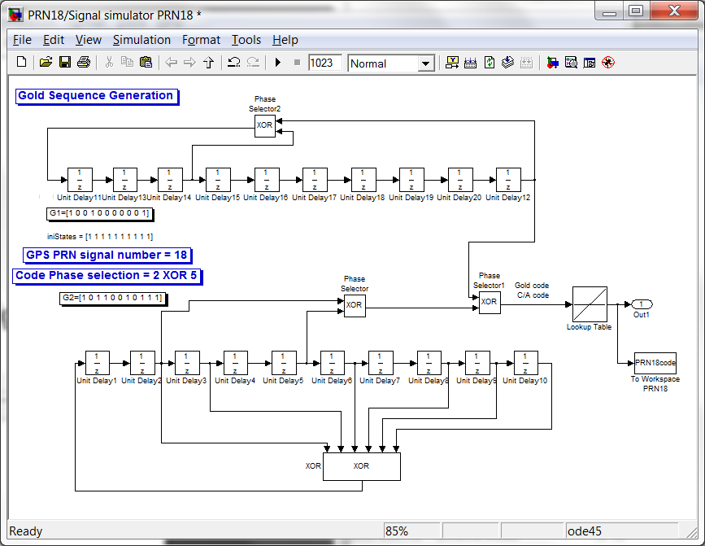

PRN19.mdl

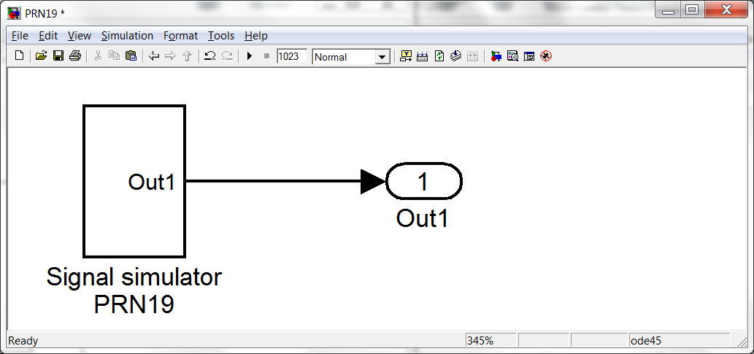

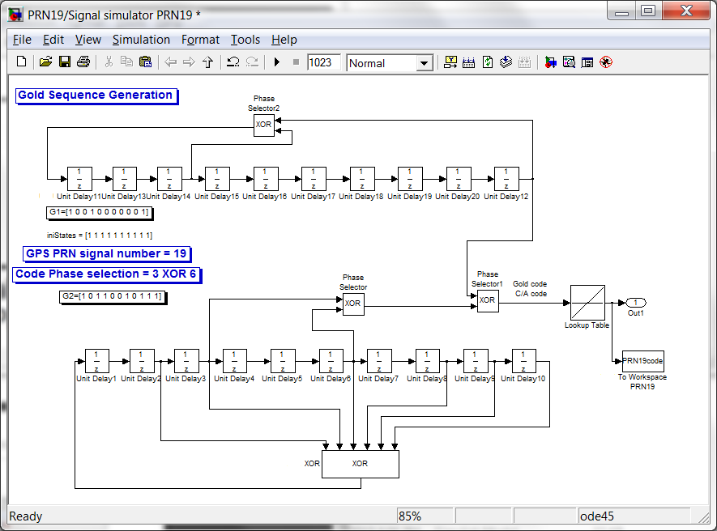

PRN20.mdl

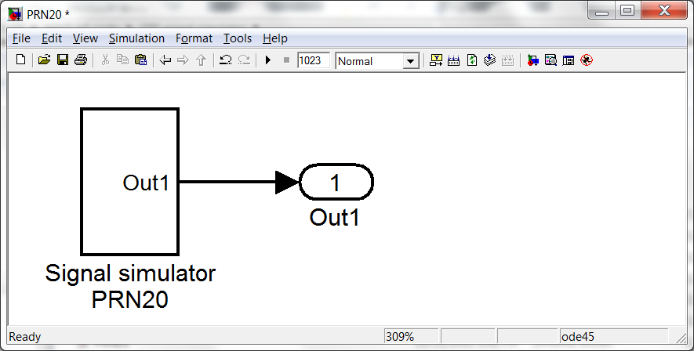

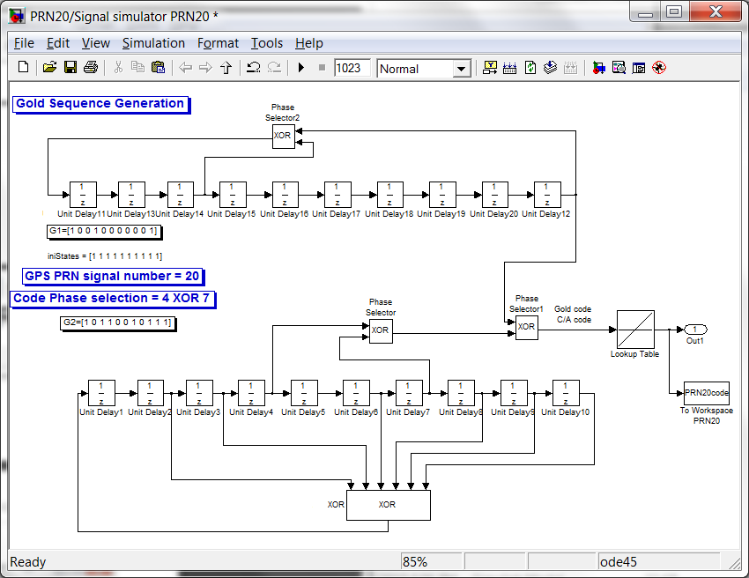

PRN21.mdl

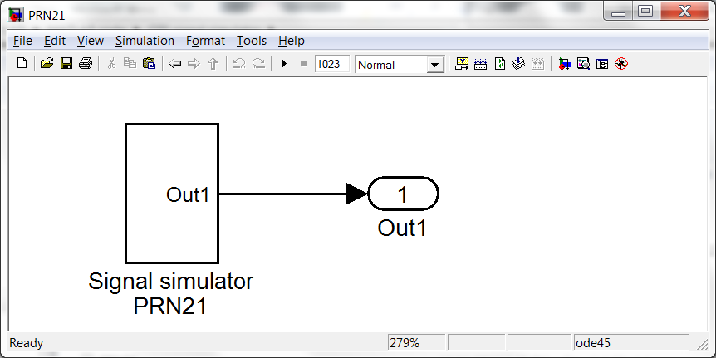 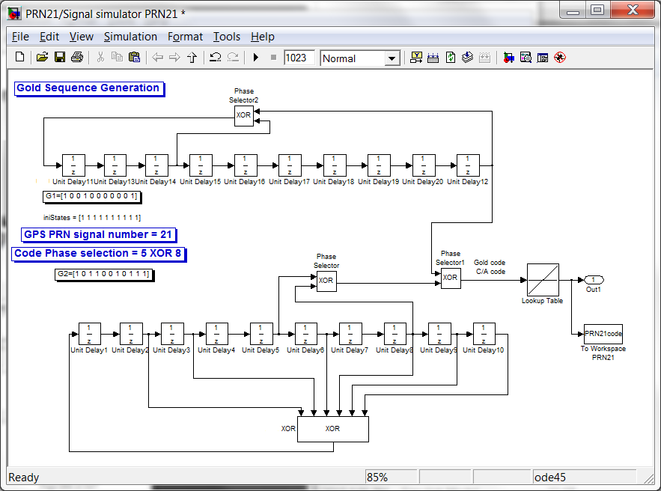

PRN22.mdl

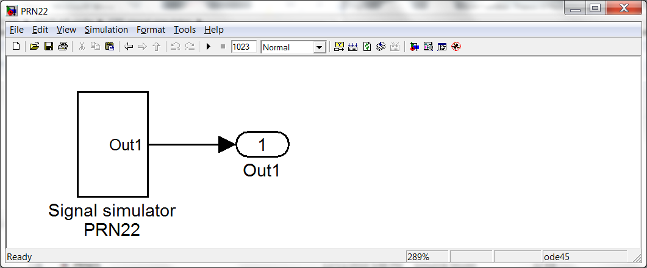 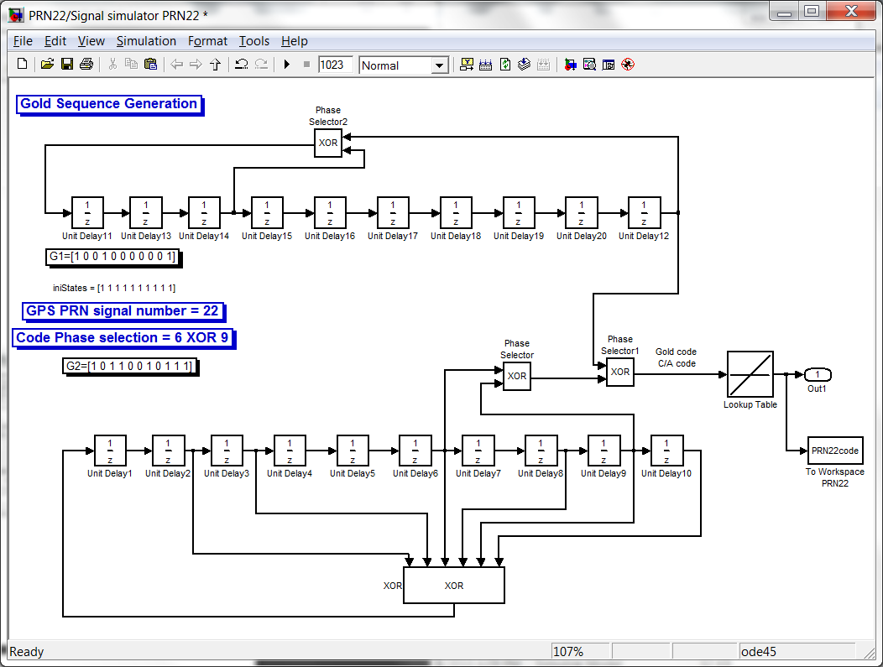

PRN23.mdl

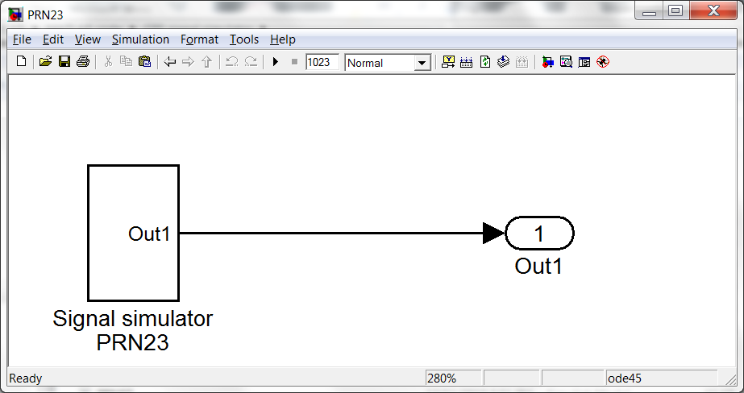 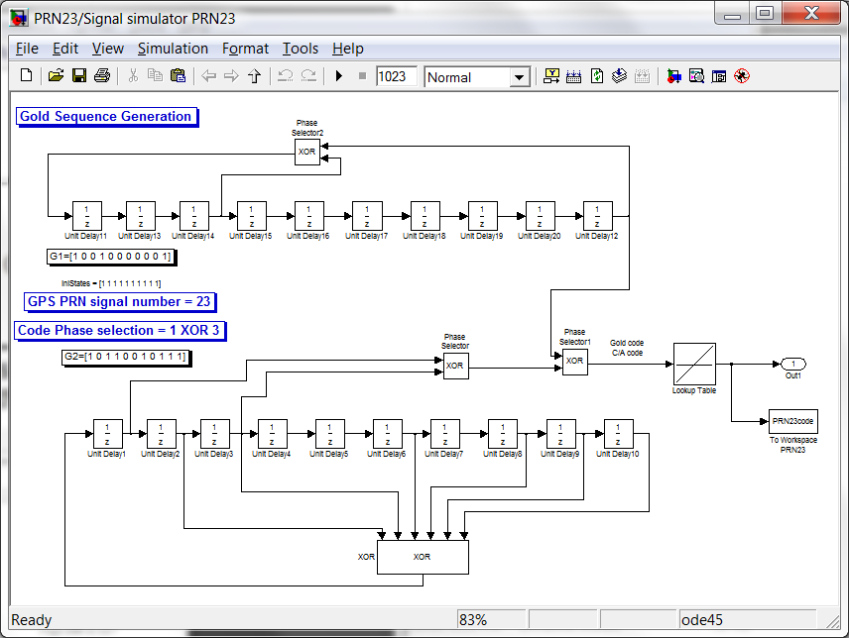

PRN24.mdl

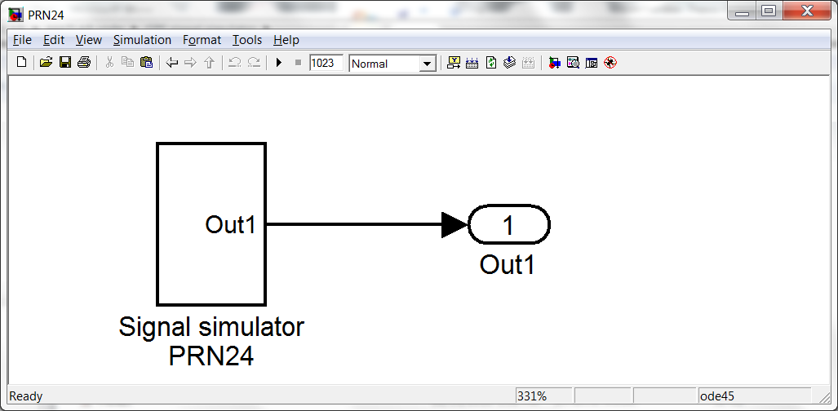 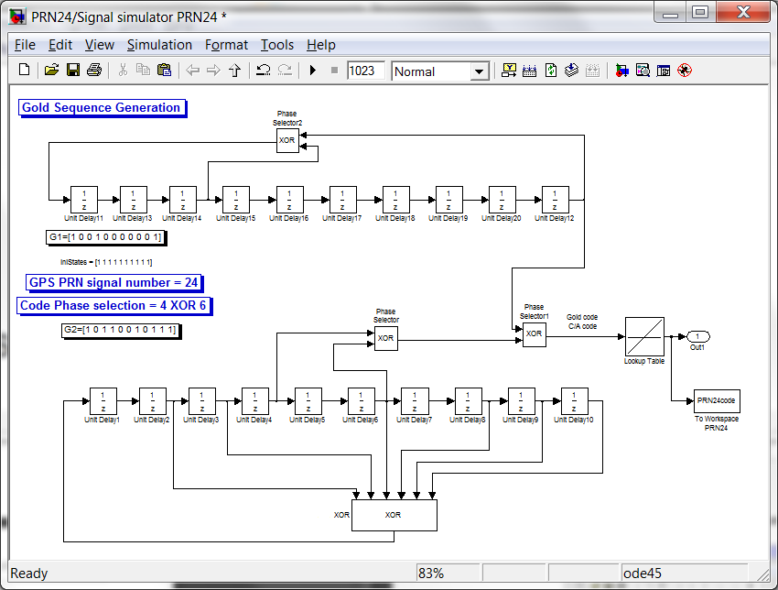

PRN25.mdl

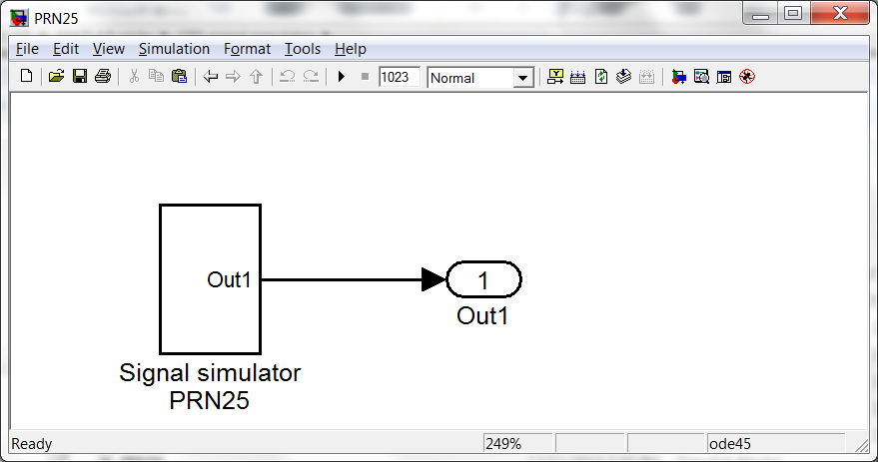 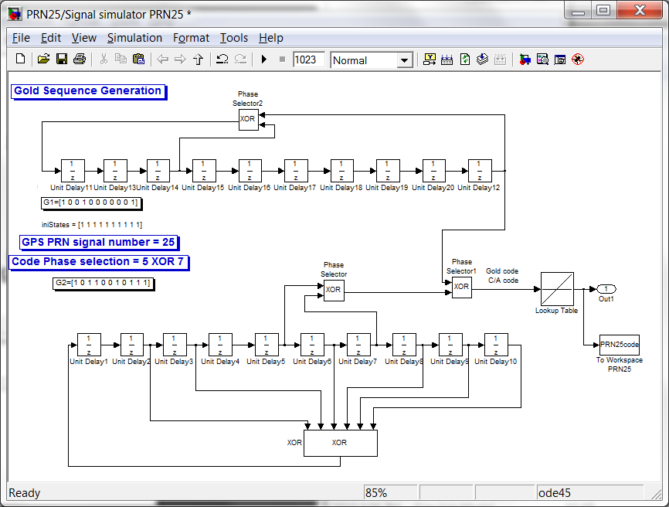

PRN26.mdl

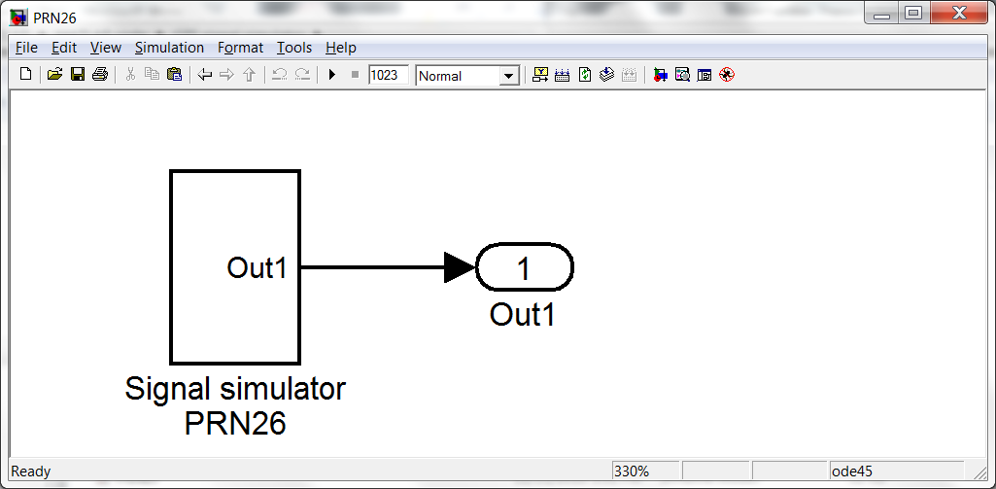 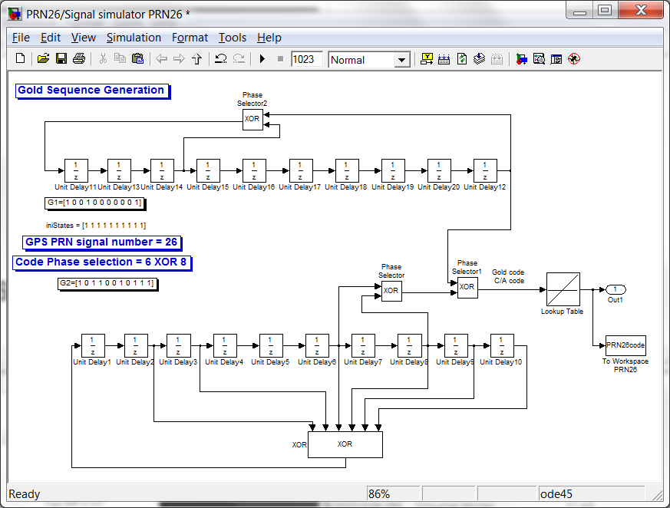

PRN27.mdl

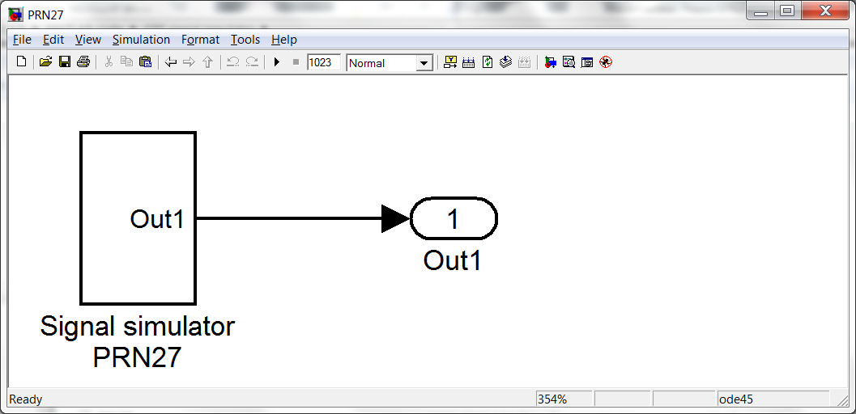 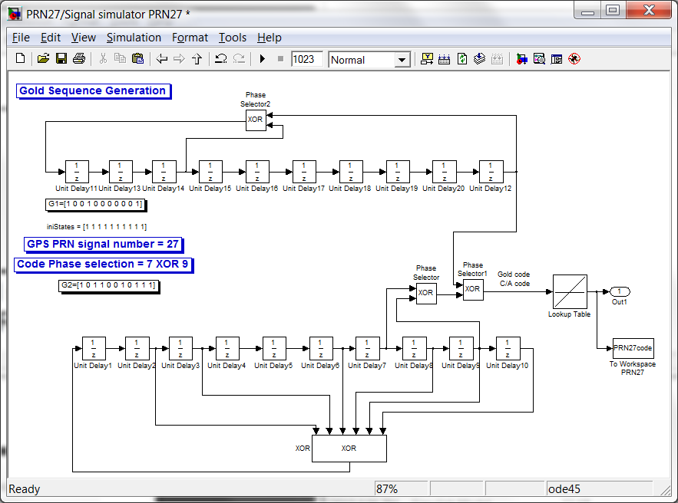

PRN28.mdl

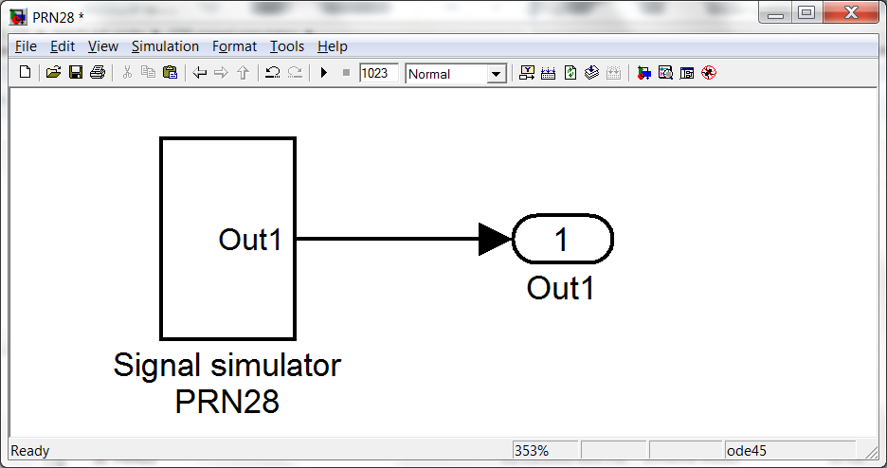

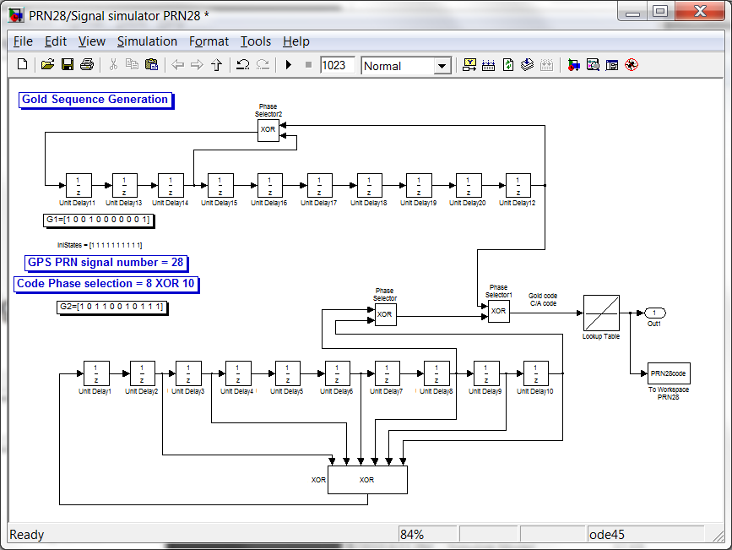

PRN29.mdl

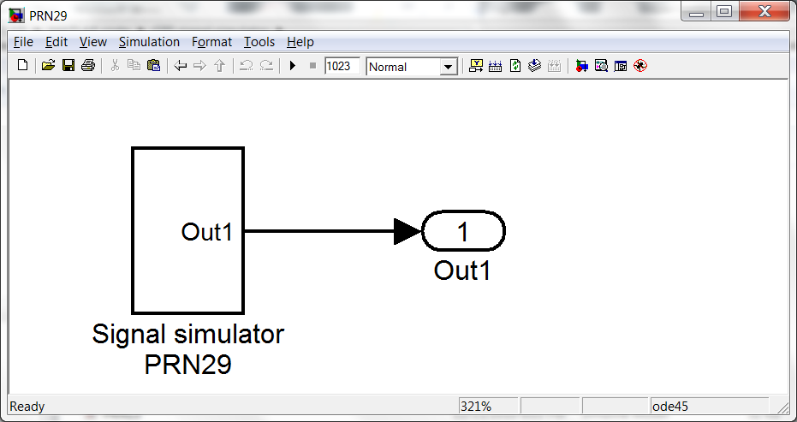

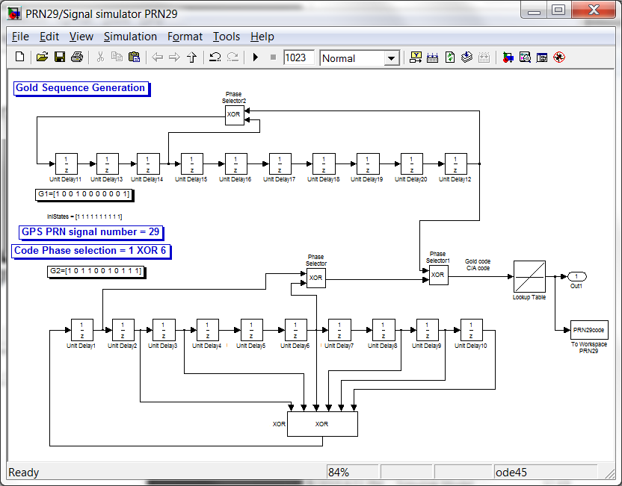

PRN30.mdl

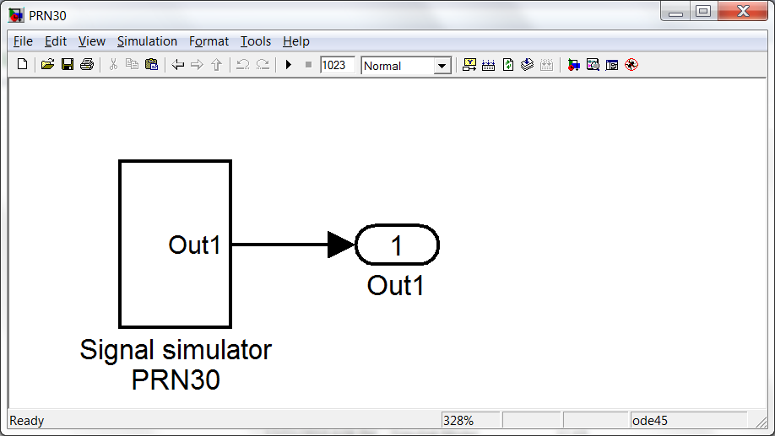 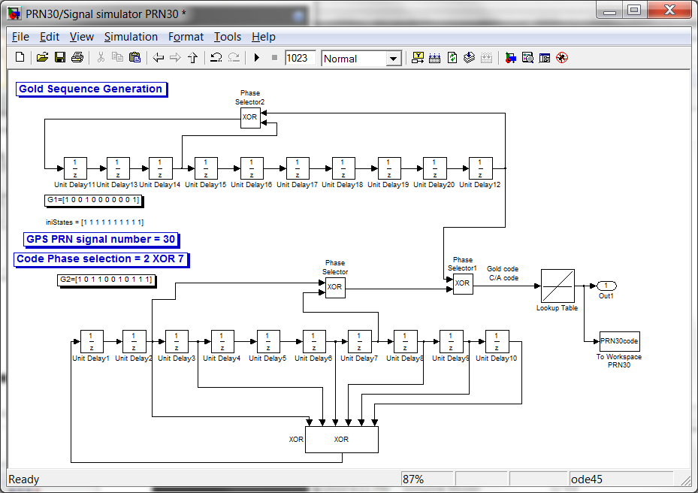

PRN31.mdl

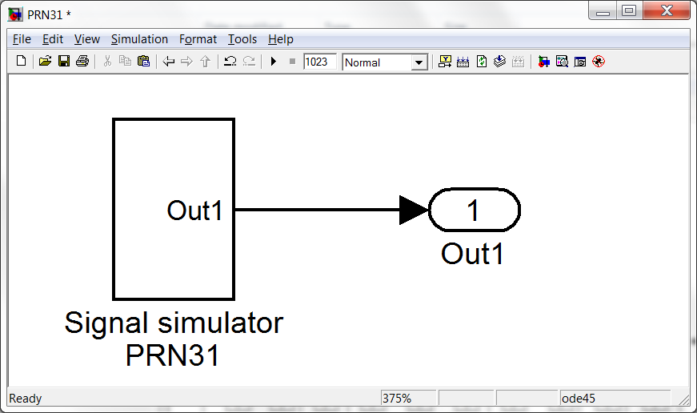 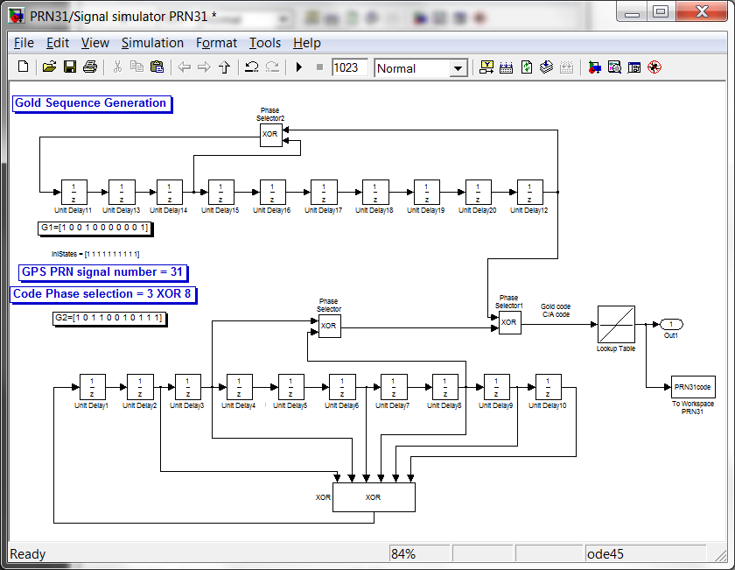

PRN32.mdl

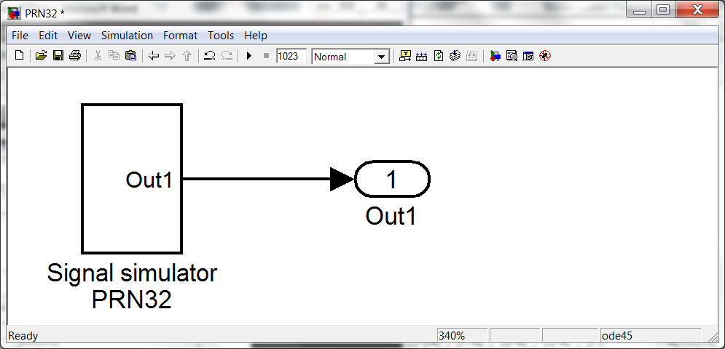

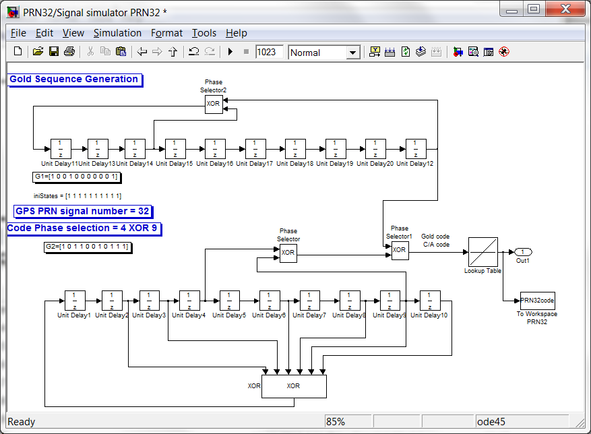

# APPENDIX D

# GANTT CHART

D1

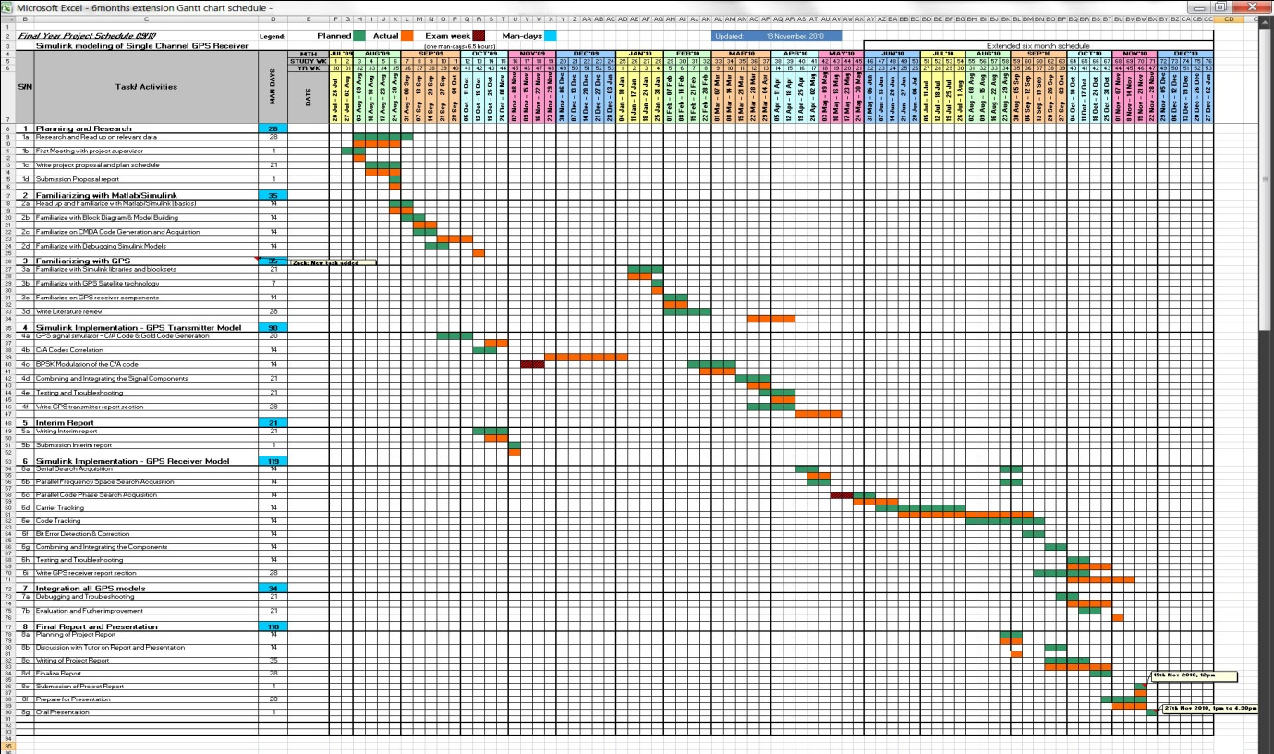

D2

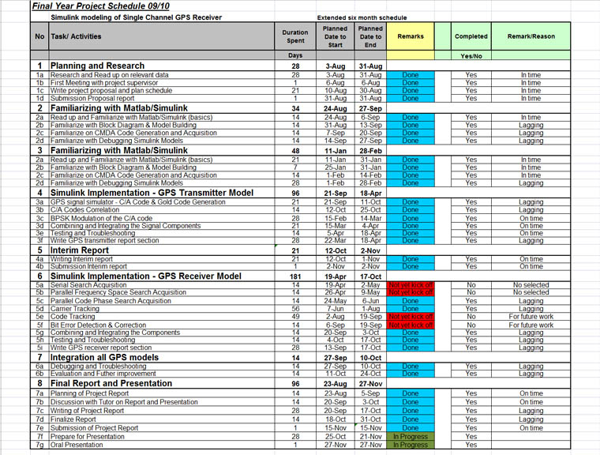

# APPENDIX E

## E1 Meeting Log #01

|  |  |  |
| --- | --- | --- |
| 1 | Date | 06th August 2009 |
| 2 | Time | 1930hrs to 2000hrs |
| 3 | Duration | 30mins |
| 4 | Venue | UNISIM HQ at Clementi Road |
| 5 | Student Name | Lim Tze Wei |
| 6 | Project Name | Simulink Modeling of Single Channel GPS Receiver |
| 7 | Review of Previous Meeting and progress | This is the first meeting. No review of previous meeting and progress |
| 8 | Minutes of current meeting | Minutes of Meeting **Attendee: Wilson Onn and Zack Lim Tze Wei**  **Agenda :**  **1) Brief on project requirement**  **2) Discuss on the project proposal submission**  **3) Meeting log submission after every project meeting**  **4) Next meeting**  1) Brief on project requirement  Mr Wilson has given a brief introduction of what the project required. At the end of the project, I have to deliver GPS transmitter model also GPS receiver model in Matlab/Simulink. There are several references given by project supervisor for read up on the GPS and Simulink. The components in each model have to be built in Simulink. Then after get the results from the Simulink simulation and improve on the results. Was advised to build the transmitter model in order to generate the data for GPS receiver. Correlator is another component that is also able to build in Simulink at the beginning.  Mr Wilson stated his expectation on spending 12-15hours of commitment every week **for capstone project**. He expects me to have an in-depth understanding of GPS.  **2) Discuss on the project proposal submission**  **Base on the dateline (31st Aug 09) of the project proposal submission, I need to come out a plan schedule for achieving the targeted date submission.**  **3) Meeting log submission after every project meeting**  **UNISIM and project supervisor require student to do a meeting log after every project meeting. We are expected to keep updating the logs as the project progresses. I am required to submit my meeting log to supervisor for review and reference.**  **4) Next meeting to be arranged on 22nd Aug 09** |
| **9** | **Action items/ Targets to achieve** | 1. ***To understand the GPS technology and its components of receiver and transmitter*** 2. ***To read up the simulink examples of each GPS component*** 3. ***To build correlator component in simulink as a start*** 4. ***To give a proposal schedule as to how to achieve completion of Capstone Project proposal on time*** |
| **10** | **Other comment/Areas to improve** | **Nil** |
| **11** | **Reference materials** | **1) Mastering SIMULINK 4 by James B. Dabney, Thomas L. Harman, Publisher: Prentice Hall; 2 edition (April 5, 2001)**  2**) Introduction to Simulink with Engineering Applications** by Steven T. Karris, **Publisher:** Orchard Publications; 1 edition (May 26, 2006)  **3)** A Software-Defined GPS and Galileo Receiver: A Single-Frequency Approach **(Applied and Numerical Harmonic Analysis) (Paperback)**  by Kai Borre (Author), Dennis M. Akos (Author), Nicolaj Bertelsen (Author), Peter Rinder (Author), Soren Holdt Jensen (Author) , **Publisher:** Birkhäuser Boston; 1 edition (November 9, 2006)  4) **Fundamentals of global positioning system receivers a software approach** by James Bao-Yen Tsui, **Publisher:** Wiley-Interscience; 2 edition (December 3, 2004) |
| 12 | How did you progress so far?  (10 Excellent, 1 Poor) | Rating 4 |

## E2 Meeting Log #02

|  |  |  |
| --- | --- | --- |
| 1 | Date | 22nd August 2009 |
| 2 | Time | 1345hrs to 1445hrs |
| 3 | Duration | 1 hour |
| 4 | Venue | UNISIM Blk 82, level 1, Clementi Road |
| 5 | Student Name | Lim Tze Wei |
| 6 | Project Name | Simulink Modeling of Single Channel GPS Receiver |
| 7 | Review of Previous Meeting and progress | This is second project meeting. Update of progress status and a review of the project proposal draft |
| 8 | Minutes of current meeting | Minutes of Meeting **Attendee: Wilson Onn and Zack Lim Tze Wei**  **Agenda :**  **1) Review of project proposal report**  **2) Discuss on the GPS transmitter implementation**  **3) Project plan and schedule (Gantt chart)**  **4) Next meeting**  1) **Review of project proposal report**  **Base on the guidelines on the capstone handbook, there are 3 sections to be included in the project proposal. First section - Project Definition. Mr Wilson gave a recap on what are the important points to emphasize in the project objective, what is the reason of this project and also how to approach the project implementation.**  **There are several advices given to begin the writing of project proposal report.**  **-Understanding GPS as much as possible to build the foundation of GPS knowledge.**  **- Understanding GPS signal, primarily the Coarse/Acquisition (C/A) code.**  **- Understanding code acquisitions which are serial search acquisition and parallel search acquisition.**  **- Understanding carrier and code tracking**  **- Understanding data processing**  **He assessed the draft copy of proposal and he suggested putting in more detailed objective to specify the reason for the project.**  **Second Section – Investigation of Project Background. Mr Wilson briefly went through the literature review and had no comment.**  **Third Section – Project Plan. Mr Wilson also touched on the Gantt chart which the work was not ready. Zack explained that he has not work on it due to the time was spent on doing other assignment. He offered his help to comment on the second draft of the proposal if it can be done on 28th Aug 09.**  **2) Discuss on the GPS transmitter implementation**  **Zack showed the reference book [3] with contained the block diagram of GPS signal simulator which GPS signal simulator represented GPS transmitter. Mr Wilson recommended that the diagram is a good start to work on the data generation.**  **3) Project plan and schedule (Gantt chart)**  **Lastly, Mr Wilson highlighted the Gantt chart should have milestones stated the target date of completion. The milestones should have the completion target of both model implementation and report writing. Constantly writing is a good practice to build up the report.**  **4) Next meeting**  He mentioned the third meeting will be on 19th Sept 09 |
| **9** | **Action items/ Targets to achieve** | ***To understand the more GPS technology and its components of receiver and transmitter***  ***To familiarize Matlab/Simulink by doing some topic related tutorials***  ***To build a GPS transmitter in Matlab/Simulink base on the source from reference material***  ***To submit project proposal draft for pre-assessment on 28th Aug 2009 (Friday)*** |
| **10** | **Other comment/Areas to improve** | **To gradually build up the knowledge of GPS and Simulink with more reading and hand on Simulink** |
| **11** | **Reference materials** | **[1] Mastering SIMULINK 4 by James B. Dabney, Thomas L. Harman, Publisher: Prentice Hall; 2 edition (April 5, 2001)**  [2] **Introduction to Simulink with Engineering Applications** by Steven T. Karris, **Publisher:** Orchard Publications; 1 edition (May 26, 2006) |
| 12 | How did you progress so far?  (10 Excellent, 1 Poor) | Rating 3 |

## E3 Meeting Log #03

|  |  |  |
| --- | --- | --- |
| 1 | Date | 19th September 2009 |
| 2 | Time | 1215hrs to 1300hrs |
| 3 | Duration | 45 minutes |
| 4 | Venue | UNISIM Blk 82 at Clementi Road |
| 5 | Student Name | Lim Tze Wei |
| 6 | Project Name | Simulink Modeling of Single Channel GPS Receiver |
| 7 | Review of Previous Meeting and progress | This is third project meeting. A review of the weekly report base on work done |
| 8 | Minutes of current meeting | Minutes of Meeting **Attendee: Wilson Onn and Zack Lim Tze Wei**  **Agenda :**  **1) Proposal comments**  **2) Work direction and Work done**  **3) Grading scheme per week**  **4) Weekly report and meeting minutes**  **5) Next meeting**  1) Proposal comments  Mr Wilson has mentioned the Project proposal needs to be improved for final report. The grade of the proposal was revealed. He expected to see more of mathematic equation in the final report. He also requested to have more detail on the literature review. Gantt Chart should include the schedule on interim submission and should also mention man-hours  2) Work direction & Work done  Zack updated the work done on Simulink. Mr Wilson emphasized on building the knowledge of C/A code (Gold code) and CDMA. Should understand the correlation properties  3) Grading scheme per week  Mr Wilson mentioned about the grading scheme will be given to the weekly work done.  **4) Weekly report and meeting minutes**  He requested the work done to be recorded in the project journal and update to him weekly.  **5) Next meeting**  He mentioned the fourth meeting will be on 03rd Oct 09 |
| **9** | **Action items/ Targets to achieve** | ***To send a amended Gantt chart by 21st Sept 09***  ***To study in depth of C/A codes and Gold codes***  ***To submit weekly report base on the work done by 23rd Sept 09*** |
| **10** | **Other comment/Areas to improve** | **To spend more time on familiarizing the GPS transmitter** |
| **11** | **Reference materials** | Extra notes on CMDA spreading code from project supervisor |
| 12 | How did you progress so far?  (10 Excellent, 1 Poor) | Rating 4 |

## E4 Meeting Log #04

|  |  |  |
| --- | --- | --- |
| 1 | Date | 19th December 2009 |
| 2 | Time | 1145hrs to 1205hrs |
| 3 | Duration | 20 minutes |
| 4 | Venue | MacDonald at Ang Mo Kio Park |
| 5 | Student Name | Lim Tze Wei |
| 6 | Project Name | Simulink Modeling of Single Channel GPS Receiver |
| 7 | Review of Previous Meeting and progress | This is fourth project meeting. Discussion about the requirement to pass the Capstone. |
| 8 | Minutes of current meeting | Minutes of Meeting **Attendee: Wilson Onn and Zack Lim Tze Wei**  **Agenda :**  **1) Understand the situation of capstone progress**  **2) Understand the capstone requirement and effort**  **3) Next meeting**  Wilson discussed some of the points that will contribute to the progress forward, namely  (a) Able to take a few weeks leave to bootstrap your work (b) Able to ascertain your office work will allow you to have >20hours per week of your on time (c) Able to Have the time/energy/commitment to spend the necessary hours to achieve your goal on a weekly basis and do so independently (d) Willing to extend for another six months should you for some reason can't complete the Capstone project by week 42. (e) Cognizant of the fact that I will only be able to support you based the suggested schedule  (Eg. 3x more Meetings etc) by the school  Use the points to consider the decision of whether to continue or withdraw from capstone  He mentioned the fourth meeting will be on 17th Jan 10 |
| **9** | **Action items/ Targets to achieve** | ***To consider how to lighten the personal commitment***  ***To learn to manage and take care of my health in order to continue with the capstone***  ***To plan a schedule that is realistic and feasible*** |
| **10** | **Other comment/Areas to improve** | **To manage and organise the available time to work on what task that is not completed.** |
| **11** | **Reference materials** | Introduction to Simulink with Engineering Applications by Steven T.Karris |
| 12 | How did you progress so far?  (10 Excellent, 1 Poor) | Rating 2 |

## E5 Meeting Log #05

|  |  |  |
| --- | --- | --- |
| 1 | Date | 16th January 2010 |
| 2 | Time | 1440hrs to 1510hrs |
| 3 | Duration | 30 minutes |
| 4 | Venue | UNISIM Blk 83 Level 5 at Clementi Road |
| 5 | Student Name | Lim Tze Wei |
| 6 | Project Name | Simulink Modeling of Single Channel GPS Receiver |
| 7 | Review of Previous Meeting and progress | This is fifth meeting. Review on the possibility to complete capstone in the given timeframe. |
| 8 | Minutes of current meeting | Minutes of Meeting **Attendee: Wilson Onn and Zack Lim Tze Wei**  **Agenda :**  **1) Review of schedule and tasks.**  **2) Discuss on the strategy to handle the capstone**  **3) Advise and guide on how to work on the problem and doubts**  **4) Weekly report and meeting minutes**  **5) Next meeting**  He mentioned the fourth meeting will be on 06th Feb 10 |
| **9** | **Action items/ Targets to achieve** | ***To send 2 revised schedules (current & 6months extenstion)***  ***To submit weekly report base on the work done*** |
| **10** | **Other comment/Areas to improve** | **To gain more knowledge with simulink libraries** |
| **11** | **Reference materials** |  |
| 12 | How did you progress so far?  (10 Excellent, 1 Poor) | Rating 4 |

## E6 Meeting Log #06

|  |  |  |
| --- | --- | --- |
| 1 | Date | 16th January 2010 |
| 2 | Time | 1230hrs to 1300hrs |
| 3 | Duration | 30 minutes |
| 4 | Venue | UNISIM Blk 81 Level 1 at Clementi Road |
| 5 | Student Name | Lim Tze Wei |
| 6 | Project Name | Simulink Modeling of Single Channel GPS Receiver |
| 7 | Review of Previous Meeting and progress | This is sixth meeting. Give update on status. |
| 8 | Minutes of current meeting | Minutes of Meeting **Attendee: Wilson Onn and Zack Lim Tze Wei**  **Agenda :**  **1) Review of staus vs plan.**  **2) Action plan to catch and meet goals**  **3) Work in progress : show the**  **4) Write up plan**  He mentioned to have regular meeting for month of Feb 2010  Send supervisor specific questions to ask and clarify. |
| **9** | **Action items/ Targets to achieve** | ***Work on how to use Lookup table to save***  ***Supervisor will help to give guide on how to have the parameter for the simulink block*** |
| **10** | **Other comment/Areas to improve** | **To complete the GPS transmitter module** |
| **11** | **Reference materials** |  |
| 12 | How did you progress so far?  (10 Excellent, 1 Poor) | Rating 6 |

## E7 Meeting Log #07

|  |  |  |
| --- | --- | --- |
| 1 | Date | 27th February 2010 |
| 2 | Time | 1400hrs to 1530hrs |
| 3 | Duration | 1hour 30 minutes |
| 4 | Venue | UNISIM Blk 82 Level 2 at Clementi Road |
| 5 | Student Name | Lim Tze Wei |
| 6 | Project Name | Simulink Modeling of Single Channel GPS Receiver |
| 7 | Review of Previous Meeting and progress | This is seventh meeting. Able to show how to use lookup table to store data for C/A code and Navigation data. Supervisor provided the sampled signal for IF frequency = 9.548MHz. This frequency will put into the Discrete VCO in simulink block. |
| 8 | Minutes of current meeting | Minutes of Meeting **Attendee: Wilson Onn and Zack Lim Tze Wei**  **Agenda :**  **1) Solving simulink questions**  **- use phase selector to create different C/A codes for Satellite. Create 2 shift registers and exclusive OR.**  **- use PN sequence generation with sign block to create Navigation data.**  **- use ramp, Z.O.H, discrete VCO to simulate waveform result**  **2) Action plan to catch and meet goals**  He mentioned to have regular meeting on every Saturday until end of March  Supervisor will not ask for weekly report. But he offers help if there are specific questions to ask and clarify.  Next meeting is on 06th March 2010. |
| **9** | **Action items/ Targets to achieve** | ***To complete the GPS transmitter module by coming Saturday 6th March 2010***  2) Include P-code portion in the GPS transmitter  3) Work on data acquisition. Choose one method |
| **10** | **Other comment/Areas to improve** | **Have good understanding of the theory to tackle the problem encounter.**  **Able to find solution independently.**  **Use the consultation time with more specific questions.** |
| **11** | **Reference materials** | Book: Applying Signal Processing Techniques with Matlab Simulink P2 Section 6 – create signal processing model |
| 12 | How did you progress so far?  (10 Excellent, 1 Poor) | Rating 6 |

## E8 Meeting Log #08

|  |  |  |
| --- | --- | --- |
| 1 | Date | 06th March 2010 |
| 2 | Time | 1445hrs to 1530hrs |
| 3 | Duration | 45 minutes |
| 4 | Venue | UNISIM Blk 82 Level 2 at Clementi Road |
| 5 | Student Name | Lim Tze Wei |
| 6 | Project Name | Simulink Modeling of Single Channel GPS Receiver |
| 7 | Review of Previous Meeting and progress | This is eighth meeting. Objective for current meeting is to show GPS transmitter with P-code portion added. Review the problems encountered in simulink |
| 8 | Minutes of current meeting | Minutes of Meeting **Attendee: Wilson Onn and Zack Lim Tze Wei**  **Agenda :**  **1) Solving simulink questions**  **- use lookup table to load take in data from gold code and navigation data generation. Able to convert signal and it has to use ‘0’ and ‘1’ for input value and use ‘-1’ and ‘1’ for table data in the lookup table.**  **2) Action plan to catch and meet goals**  **- base on the submission date (17th May 2010) and work back on the date for draft submission.**  **- propose to show report structure on 4th April 2010**  **- propose to show draft report on 25th April 2010**  **3) Discuss on how to spend and use time wisely. If possible, seek help on simulink to expedite the progress.**  Next meeting is on 13th March 2010. |
| **9** | **Action items/ Targets to achieve** | ***~~To complete the GPS transmitter module by coming Saturday 6~~~~th~~ ~~March 2010~~***  ~~2) Include P-code portion in the GPS transmitter~~  1) Work on data acquisition and show it by coming Saturday 13th March 2010  2) Work on code tracking |
| **10** | **Other comment/Areas to improve** | **Seek external help to expedite in solving doubt in simulink**  **Use the consultation time to clear questions which can help to progress faster and simulink problem should solve it independently.** |
| **11** | **Reference materials** |  |
| 12 | How did you progress so far?  (10 Excellent, 1 Poor) | Rating 6 |

## E9 Meeting Log #09

|  |  |  |
| --- | --- | --- |
| 1 | Date | 23th March 2010 |
| 2 | Time | 2045hrs to 2125hrs |
| 3 | Duration | 40 minutes |
| 4 | Venue | MacDonald along Ang Mo Kio Ave 10 |
| 5 | Student Name | Lim Tze Wei |
| 6 | Project Name | Simulink Modeling of Single Channel GPS Receiver |
| 7 | Review of Previous Meeting and progress | This is ninth meeting. Objective for current meeting is to show status of GPS transmitter |
| 8 | Minutes of current meeting | Minutes of Meeting **Attendee: Wilson Onn and Zack Lim Tze Wei**  **Agenda :**  **1) Check and determine on sample rate and sample time for simulink block in Navigation data and C/A code.**  **2) Discuss on how to which acquisition type to use. Parallel code phase acquisition is a better choice**  Next meeting is on 30th March 2010. |
| **9** | **Action items/ Targets to achieve** | ***~~To complete the GPS transmitter module by coming Saturday 6~~~~th~~ ~~March 2010~~***  ~~2) Include P-code portion in the GPS transmitter~~  ~~3) Work on data acquisition and show it by coming Saturday 13~~~~th~~ ~~March 2010~~  1) Send GPS transmitter simulink file to supervisor for checking  2) To work on parallel code phase acquisition  3) Work on code tracking |
| **10** | **Other comment/Areas to improve** | **Seek external help to expedite in solving doubt in simulink**  **If need to check on any questions, email supervisor in advance before the next meet up.** |
| **11** | **Reference materials** | **1)** A Software-Defined GPS and Galileo Receiver: A Single-Frequency Approach **– Chapter 6:Acquisition** |
| 12 | How did you progress so far?  (10 Excellent, 1 Poor) | Rating 6 |

## E10 Meeting Log #10

|  |  |  |
| --- | --- | --- |
| 1 | Date | 28th August 2010 |
| 2 | Time | 1250hrs to 1350hrs |
| 3 | Duration | 60 minutes |
| 4 | Venue | UNISIM Blk 81 Level 1 at Clementi Road |
| 5 | Student Name | Lim Tze Wei |
| 6 | Project Name | Simulink Modeling of Single Channel GPS Receiver |
| 7 | Review of Previous Meeting and progress | This is first meeting after the six month extension. Review of the work done. |
| 8 | Minutes of current meeting | Minutes of Meeting **Attendee: Wilson Onn and Zack Lim Tze Wei**  **Agenda :**  **Summary of work done to date**  **Review of schedule**  **Highlight of possible challenges**  **Current issue**  **AOB**  **1) Review of the progress of work done to date.**  **Show the design of serial search acquisition, parallel code phase search acquisition and carrier tracking on simulink file. Zack mentioned the current work is at doing the carrier tracking.**  **2) Show the gantt chart schedule and highlight the milestone on each task.**  **The report submission is on 15th Nov 2010 @ 12pm and the Oral presentation is on 27th Nov 2010 @ 1pm to 4.30pm. According to schedule, a final draft of the report will submit to supervisor on 17th Oct 2010 for vetting.**  **Four more tentative dates are allocated for meeting and they are all on the Saturdays (11st Sept, 2nd Oct, 23rd Oct, 30th Oct)**  **3) Zack mentioned that there is a high commitment in his full time job which requires travelling for business trip on 13th Sept to 19th Sept 2010.**  4) Demonstrate the result in simulink. The result is not assembled according to the reference material. GPS Tx signal does not show a very distinct carrier of 9.58MHz. There is plenty of noise in the signal. Has tried to remove the AWGN channel and the signal improves very little. Supervisor will email Zack the correct result.  There are some other issues which are not completed due to the results do not produce the autocorrelation. The graph should show a spike (peak) when the signal is correct.  Supervisor highlighted on the sample time has to be correct. Zack has to cross check on the file on tx with the file that is used for demo. Supervisor has sent the file in April 2010.  The acquisition which was demo did not show any spike which can tell the code phase. The scope axis values seemed too low. It should be magnitude 10^7 instead of 10^ minus 11.  Supervisor mentioned to use reference book as a guide and try to replicate the result shown in the book.  Zack has mentioned on the difficulty in plotting the graph and he will require example to follow on how to plot the 3D graph which can show the spike.  5) Supervisor expects to have a bi weekly email update and a write up submission of work done before the project meet up.  Next meeting is on 11st Sept 2010. |
| **9** | **Action items/ Targets to achieve** | 1) Revise schedule and update on the incomplete section  2) Produce the correct result on tx which is according to the reference book  3) Check and incorporate NCO  4) Integrate tx and acquisition rx and show the spike when without code phase delay and show no spike when with code phase delay.  5) Supervisor will email the correct result on the tx signal and also the result on serial search and parallel code phase search acquisition. |
| **10** | **Other comment/Areas to improve** | **Expedite the work and putting in more time to work on the simulink**  **Supervisor hopes to see the receiver can decode message and can integrate all the parts together** |
| **11** | **Reference materials** | **1)** A Software-Defined GPS and Galileo Receiver: A Single-Frequency Approach |
| 12 | How did you progress so far?  (10 Excellent, 1 Poor) | Rating 6 |